Course No:
Plan 332

Course Title:
Rural Planning Studio

Submission Title:
Final Article

Submitted to:
Dr. Md. Musleh Uddin Hasan,
Professor, Dept. of URP, BUET
Ms. Nawshin Tabassum,
Lecturer, Dept. of URP, BUET
Ms. Paromita Shome,
Lecturer, Dept. of URP, BUET

Submitted by
Maria Mehrin
Student ID 1615028


Department of Urban and Regional Planning
Bangladesh University of Engineering and Technology

Measuring Livelihood Resilience of Different Types of Households Based on Their Income Activities: A Study in the Context of COVID 19 in Rural Bangladesh
Maria Mehrinª, Dr. Md. Musleh Uddin Hasan^{b}, Ms. Nawshin Tabassum^{c}, Ms. Paromita Shome^{c}
ª Student, Department of Urban and Regional Planning, BUET
^{b} Professor, Department of Urban and Regional Planning, BUET
^{c} Lecturer, Department of Urban and Regional Planning, BUET

ABSTRACT
Livelihood resilience is an important agenda in the context of the COVID-19 pandemic. The paper intends to explore the impact of COVID-19 on employment status and to measure the livelihood resilience capacity of rural households who are involved in farming, business and service activities in the village for livelihood by developing an indicator-based Resilience Capacity Index (RCI) regarding adaptive capacity and sensitivity with an aim of better understanding of the factors influencing resilience capacity. A structured questionnaire interview was conducted through telephone to collect data. This study reveals that COVID-19 has not affected employment status that much in rural areas. However, business activities have been affected the most compared to farming and service activities. All household types have a low index value indicating low resilience to COVID-19. The adaptive capacity is almost same for the three household types, but households involved in farming activities are most sensitive to the pandemic. The main drivers of resilience capacity include having basic education and skill to shift livelihood strategy, a stable income source and access to financial help when needed. The study could be useful for government agencies and policymakers for taking policies focusing on these factors to support rural households in pandemic in the future.
Keywords: COVID-19 pandemic, Resilience capacity, Adaptive Capacity, Sensitivity, Income Activity.
- Introduction
Since December 2019, coronavirus disease (COVID-19) originating from Wuhan, China, started to spread throughout the world (Wang et al., 2020). Due to its rapid worldwide exposure and the challenges it brought with, World Health Organization (WHO) announced COVID-19 as a global pandemic (Bodruddoza, et al., 2020). The virus was confirmed to have spread to Bangladesh in March 2020 (COVID-19 pandemic in Bangladesh, 2020). Since then, the pandemic has spread over the whole country and the number of affected people has been increasing day by day. The government declared lockdown throughout the nation to control community transmission which held back lives of people especially in terms of income activities. (COVID-19 pandemic in Bangladesh, 2020). The COVID-19 crisis has affected the lives of the people in an unprecedented way. Livelihoods and the wider availability of assets are fundamentally affected by it. However, the impact of the pandemic varies indicating all people are not equally vulnerable to the pandemic. Developing countries like Bangladesh are severely affected by the current outbreak. Rural households in Bangladesh are most susceptible to the impact of COVID-19 as economy of the rural areas is not diversified because of limited livelihood options.
To fight against the challenges brought with the pandemic, understanding how to build livelihood resilience capacity to COVID-19 is a pressing need. Resilience is defined as the capacity of households to effectively cope with and adapt to COVID-19 in such a way that helps to minimalize the loss of life and economic assets (Alam, et al., 2018). Resilience capacity of the households can be influenced by a range of factors. Therefore, the focus of this study is to find out the factors which have influence on resilience capacity of the household during COVID-19. It is identified by assessing the resilience of households engaged in different income activities from socio-economic perspectives by developing an indicator-based Resilience Capacity Index. There are two research questions to be answered:
1. What is the impact of COVID-19 on employment status of earning members in rural households?
2. What factors are influencing the resilience capacity of different types of households regarding their income activities to fight back COVID-19?
The study will help the stakeholders to take policies to address the factors which will make people more adaptive during any pandemic in the future. Because of the ongoing COVID situation the study has some limitations as small sample size, unregulated selection of study areas and inability of the verification of collected data. Despite the impediments, it expects to contribute to the field of livelihood resilience with its derived outcome.
2. Literature Review
2.1 Covid-19 as Shocks in Vulnerability Context
Sustainable Livelihood Framework is used to understand aspects of rural life focusing livelihood patterns and strategies at individual, household, and rural community level. Vulnerability context is a component of sustainable livelihood framework. It refers to the seasonality, trends, and shocks that affect people’s livelihoods. Understanding this context is important as it has direct impact on people’s asset status and livelihood outcomes. As COVID-19 has direct impact on human, physical, social and financial capitals of the people, it can be classified as a vulnerability context.
2.2 Concept of Livelihood Resilience
Livelihood resilience can be defined as the process of households and communities responding to, recovering, and learning from changes and disturbances, and transforming their livelihood patterns to adapt to changes and challenge (Sina, 2019). It is an integrated function of adaptive, absorptive and transformative capacity which reduces the vulnerability (Sarkar et al., 2020). Change is happening all around us and resilience is about enhancing capacity proactively and positively to manage this change. Three types of resilience capacity are needed to be enhanced to achieve desired outcome. Adaptive capacity is one of them. Adaptive capacity is about having the capacity to make appropriate changes to cope better with existing external stresses (Jeans, et al., 2017). COVID-19 has created an adverse situation in all aspects of life and making changes on the ongoing basis is the only way available to tackle the situation.
Shock (COVID-19)

(
Livelihood pattern household
Making changes to cope
Wellbeing of household maintained

Figure 1: Framework of livelihood resilience (Béné, 2020)
2.2 Livelihood Resilience Studies
Several studies have focused on the livelihood resilience of rural people in Bangladesh because of the significance of the concept. Alam, et al., (2018) developed an indicator-based Resilience Capacity Index aimed at a better understanding of the factors influencing resilience capacity of riparian rural households in Bangladesh regarding climate change. He suggests the main drivers of the resilience capacity include livelihood strategies, level of education, and access to food, water and health services.
Sina, et al., (2019) developed a framework for measuring livelihood resilience of post-disaster displacement with a view to providing appropriate livelihood support in these events in future. Smith, et al., (2020) investigated the short-term impacts of the COVID-19 pandemic on commercial fishers in the Northeast U.S. to understand the effects of the pandemic on fishers’ economic outcomes. The research also assesses characteristics of those fishers who continued fishing to understand their adaptive strategies to the changing circumstances. The study revealed a loss of income, largely driven by disruptions of export markets, the loss of restaurant sales, and a resulting decline in seafood prices. However, despite economic losses, the fishers demonstrated resilience in the face of the pandemic by continuing to fish and implementing other adaptation strategies rather than switching to other livelihoods.
3. Study Area Profile
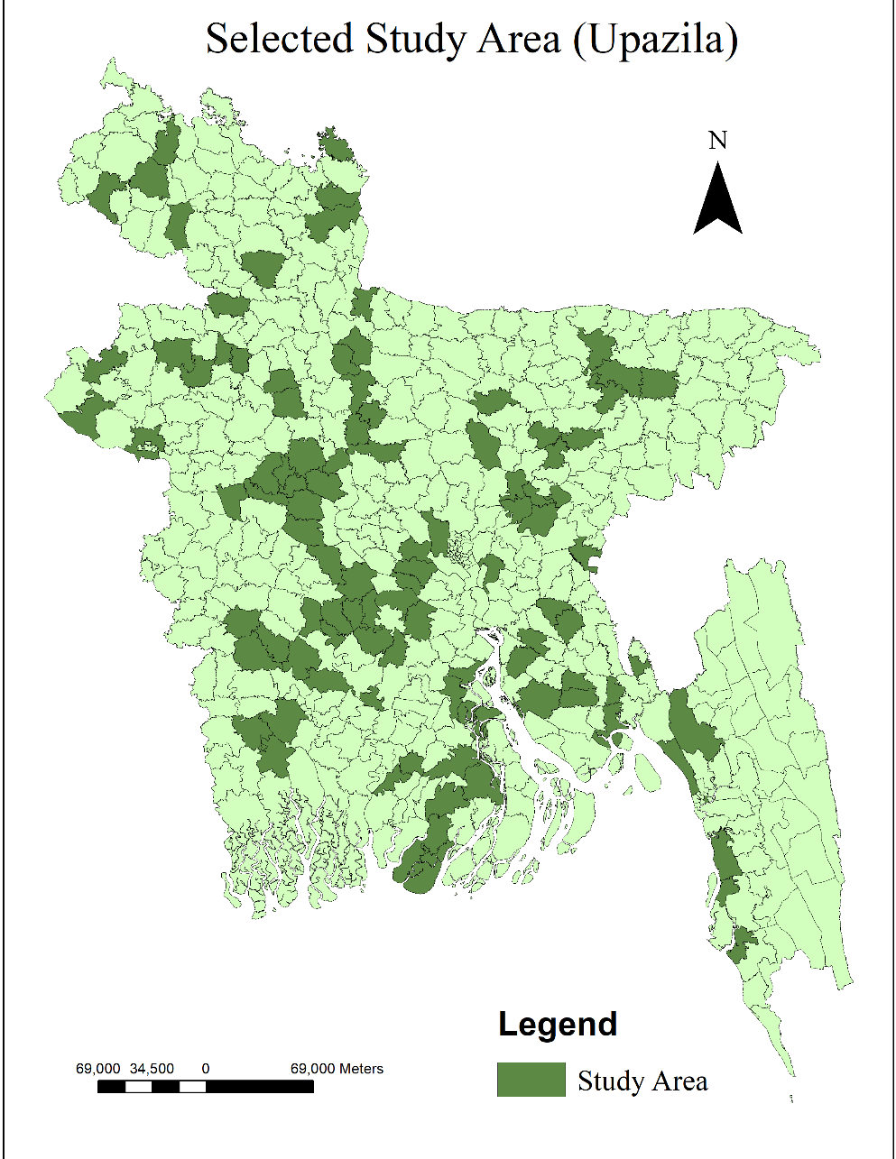
As whole Bangladesh has been going through widespread community transmission of COVID-19 and is largely affected by it, randomly 119 villages from 102 upazilas, from 48 different districts, under all 8 divisions are selected as study area to represent the complete COVID-19 situation of rural areas (Figure 2).

Figure 2: Map showing the selected upazilas for the study
(Source: Bangladesh Subnational Administrative Boundaries, 2013)
Average 67% of people of these villages are involved in agricultural activities for their livelihood (Bangladesh Bureau of Statistics, 2015). Again, the average percentage of people involved in service and industry activities are 20% and 9% respectively (Bangladesh Bureau of Statistics, 2015). COVID-19 cases were identified in about 34.4 % of the selected villages. From March to August, when the transmission of COVID-19 was at its peak, lockdown was declared in about 90% of these upazilas by the government. As a result, lives of the people in all aspects were held back. Availability of labor in farming and market was dropped down at 50% causing distress in income activities
4. Methodology
4.1 Data Collection
Structured questionnaire interviews were conducted with randomly selected 119 households through telephone as response to the COVID-19 safety measures. Appropriate timing of calls was set and lengthy conversation at a time was avoided to ensure ability of respondents to answer freely and to get quality data. All respondents were asked questions related to COVID-19 focusing on income activities and various components of livelihood resilience of the households.
This study has led us to divide the households into three groups according to the income activities undertaken by the household head before COVID-19.
Group A: Group A represents 35 households whose household heads are engaged in farming activities in the village for their livelihood.
Group B: Group B represents 34 households whose households heads are engaged in business activities in the village for their livelihood.
Group C: Group C represents 50 households whose household heads are engaged in service activities in the village for their livelihood.
4.2 Approach to Measure Livelihood Resilience
A livelihood resilience framework was adopted for this study based on the work of Alam et al. (2018). He has referred to resilience as a function of sensitivity and adaptive capacity as follows:
Resilience=f (Sensitivity, adaptive capacity)
Sensitivity and adaptive capacity are composed of different components that have various indicators. The selection of indicators depends mostly on an intensive review of literature. We have selected 19 indicators and gave score to them according to Alam et al. (2018) for this study (Appendix A). Index value of each indicator is calculated by using the equation as follows: Index_{a}=$\frac{∑In(a)}{n}$
Where Index_{a} is index value of indicator a, In(a) represents the total score of indicator a, and n indicates the number of households. After getting an index value of indicators, the next step was to estimate the index value of each component which was calculated using the equation as follows: C_{b}=$\frac{∑Index(b)}{m}$
Where C_{b} is index value of component b, Index(b) represents total value of the indicators under component b and m indicates number of indicators under the component. Once the index value of each component was calculated, they were then used to calculate the index value of sensitivity and adaptive capacity giving equal weighting to all components.
Sensitivity index = index value of (health + food)/2
Adaptive capacity index = index value of (socio-demographic profile+ Income + non- agricultural assets+ social safety nets)/4
RCI= (Adaptive capacity-Sensitivity)
The higher the value of the RCI, the higher the resilience capacity and vice versa. The results are expressed in relative terms and are assessed at the scale of 1 (most resilient) to 0 (least resilient).
5. Impact of COVID-19 on Employment Status and Assessing Livelihood Resilience
The findings of impact of COVID-19 on employment status and Resilience Capacity Index (RCI) are interpreted in this section.
5.1 Impact on COVID-19 on Employment Status
COVID-19 pandemic has not affected employment status that much in rural areas. However, business activities have been affected the most compared to farming and service activities (Figure 3).
.

Figure 3: Impact on COVID-19 on employment status (Source: Telephone survey, 2020)
(Author, 2020)

5.2 Resilience Capacity Index
The overall RCI of Group A is significantly less than compared to RCI value of group B and C (Table 1). This indicates that households with farming activities are relatively less resilient to the outbreak than households with business and service activities. However, three of them have a low index value indicating households have low capacity to be resilient to COVID-19. The capability to change is almost same for the three household types, but households involved in farming activities are most sensitive or vulnerable to COVID-19. (Figure 4)

Figure 4: Index dimension of resilience (Source: Telephone Survey, 2020)

Table 1 deals with the influencing factors of livelihood resilience. It shows the values of major components of RCI which vary regarding income activities of households. The index value of food access and social safety nets vary significantly compared to other components (Figure 5)
Table 1: The index value of major components of resilience capacity index
Components of livelihood resilience | Index value of each component
Components of livelihood resilience | Group A | Group B | Group C
Socio-demographic profile | 1.38 | 1.3 | 1.58
Food Access | .467 | .167 | .15
Health Access | .60 | .615 | .645
Income | 0.24 | .191 | .186
Non-Agricultural Asset | .67 | .73 | .68
Social safety net | .33 | .32 | .215
Resilience Capacity Index | 0.09 | .23 | .25
(Source: Telephone survey, 2020)

Figure 5: Index Dimension of Resilience (Source: Telephone survey, 2020)

6. Major Components of Livelihood Resilience
The variation in the RCI indicates that the resilience capacity of all households varies at both an overall level and, more dramatically, in relation to the particular components and indicators.
6.1 Adaptive Capacity
Adaptive capacity focuses on the ability of the households to cope with the stresses of the COVID-19 pandemic. The major components of adaptive capacity are household’s socio-demographic profile, household’s income access, household's non-agricultural assets, social networks (Alam et al. 2018). The adaptive capacity of households engaged with service activities (0.65) was only slightly higher than households with farming (.63) and business activities (.62), indicating that all the groups have a moderate adaptive capacity to cope with the adverse effect of COVID-19. The variation in the index value of adaptive capacity shows variation causing due to the variation in index value of components
6.1.1 Socio-demographic Condition
The socio-demographic condition includes the indicators- dependency ratio, education level of the household head, preventive knowledge about COVID-19, having skill to shift livelihood strategy (Alam, et al., 2018). Index value of education level is lowest for farming households which leads to low preventive knowledge about COVID-19 and high dependency ratio (Figure 6). They do not understand the importance of family planning because of lack of education. High dependency ratio makes them less resilient to the pandemic. However, the index value of having skill to shift livelihood strategy is higher for farming households indicating that they have practical knowledge of life more than others which enables them to recover from the shock of COVID-19.

Figure 6: Comparison of socio-demographic condition (Source: Telephone survey, 2020)

6.1.2 Income Access
The component income access includes change in income during pandemic, lending money to other people, borrowing money from neighbor, taking loan from bank, borrowing goods from local market (Sarkar et al., 2020). Index value of change in income during COVID-19 is lowest for the households involved in service activities (Figure 7) which means they have a stable income source which that makes them resilient to COVID-19. Their income is more than sufficient for them, so they have lent to others during the pandemic. On the other hand, farming households had to borrow money and goods from their neighbors and local shops to survive during the pandemic.

Figure 7: Comparison of Income index (Source: Telephone survey, 2020)

6.1.3 Non-Agricultural Asset
Non-agricultural assets involve ownership of land, ownership of house, ownership of sewing machine (Sarkar et al., 2020). The index values of these indicators are almost same for all households (Figure 8). Ownership of durable assets indicates resilience to COVID-19 as these items can be sold when necessary to cope with the adverse situation.

Figure 8: Comparison of non-agricultural assets index (Source: Telephone survey, 2020)
6.1.4 Social Safety Nets
Social safety Nets cover getting training from NGO and GO, getting any financial help from NGO and GO (Sarkar et al., 2020). Training and financial help enhance resilience. Farming households having highest index value for social safety nets (table 1) indicate that they get training and financial help during the pandemic make them resilient to some extent.
6.2 Sensitivity
Sensitivity describes how much and how strongly households react to the circumstances created by COVID-19 (Whittlestone, 2018). Change in eating habits, change in health service access and current health condition are the reaction of the rural households for COVID-19. Households with farming activities are most sensitive to the adverse situation caused by COVID-19 compared to households who are engaged in business and service activities. The index value of change in eating habits is significantly higher for farming households which makes all the difference in resilience index (Figure 4).
7. Policy Implications
In the face of unanticipated pandemic-driven shocks and stresses, building resilience is a worthy strategy to adopt. This study indicates proper policy planning is required in different aspects to help the rural households to be resilient to COVID-19 and any other pandemic in future. Firstly, introducing basic education programs for farmers in rural areas to make them more resilient. Giving technical skill building training to all households so that they can be able to alter in any other profession when necessary. Institutionalizing the process of accessing loan is required as a long term development plan. Policymakers should focus on these factors to support rural households in pandemic in the future.
8. Conclusion
This study enhances our understanding of the socio-economic factors affecting the resilience capacity of the different occupational rural households in Bangladesh through developing an indicator based index. The identified key factors include having basic education, having skill to shift livelihood strategy, a stable income source and access to financial help when needed. Although farming households display high sensitivity to COVID-19 than other households, all of the households have moderate resilience capacity to cope with the COVID-19 outbreak. Such information can assist in better planning of resources, more appropriate allocating of
finances, and earmarking resilience-building projects and programs aimed for pandemic situation in rural areas.

Reference
Alam, G. M. M., Alam, K., Mushtaq, S., & Filho, W. L. (2018). How do climate change
andassociated hazards impact on the resilience of riparian rural communities in Bangladesh? Policy implications for livelihood development. Environmental Science and Policy, 84, 7-8. doi: 10.1016/j.envsci.2018.02.012
Bangladesh Bureau of Statistics. (2015). Bangladesh Population and Housing Census 2011,
COMMUNITY REPORT. Dhaka, Bangladesh: Bangladesh Bureau of Statistics (BBS). Retrieved from http://203.112.218.65:8008/PageWebMenuContent.aspx?MenuKey=337&fbclid=Iw
AR0d7pB8KSDqntt6iSXOXHswRazvOGEs-LdfZWqhxRlyO-b5BEwpBejzX4k
Bangladesh Subnational Administrative Boundaries. (2013). Retrieved from-
https://data.humdata.org/dataset/administrative-boundaries-of-bangladesh-as-of-2015
Béné, C. (2020). Resilience of local food systems and links to food security – A review of
some important concepts in the context of COVID-19 and other shocks. Food Sec. 12, 805–822. https://doi.org/10.1007/s12571-020-01076-1
Bodruddoza, M., Shammi, M., Bahlman, L., Islam, A. R. M. T., and Rahman, M. M. (2020).
Psychosocial and Socio-Economic Crisis in Bangladesh Due to COVID-19 Pandemic: A Perception-Based Assessment. Frontiers in Public Health, 8, 341. Retrieved from https://www.readcube.com/articles/10.3389/fpubh.2020.00341
COVID-19 pandemic in Bangladesh. (2020). Retrieved December 9, 2020 from Wikipedia:
https://en.wikipedia.org/wiki/COVID-19_pandemic_in_Bangladesh
Jeans, H., Gina, E., Castillo, & Thoma, S. (2017). The Future is a Choice. Retrieved from
https://www.oxfam.org/en
Sarker, M. N. I., Wu, M., Alam, G. M., & Shouse, R. C. (2020). Livelihood resilience of
riverine island dwellers in the face of natural disasters: Empirical evidence from
Bangladesh. Land Use Policy, 95. https://doi.org/10.1016/j.landusepol.2020.104599
Sina, D., Chang-Richards, A. Y., Wilkinson, S., & Potangaroa, R. (2019). A conceptual
framework for measuring livelihood resilience: Relocation experience from Aceh,
Indonesia. World Development, 117, 253-265.
Smith, S. L., Golden, A., Ramenzoni, V., Zemeckis, D. R., & Jensen, O. P. (2020, August 18).
Adaptation and resilience of commercial fishers in the Northeastern United States during the early stages of the COVID-19 pandemic. https://doi.org/10.31235/osf.io/z3v2h
Whittlestone, J. (2018). Sensitivity and Resilience. Jess Whittlestone. Retrieved from
https://jesswhittlestone.com/blog/2018/1/29/sensitivity-resilience#:~:text=Sensitivity%20describes%20how%20much%20we,about%20what%20we%20actually%20feel.
Wang, Y., Di, Y., Ye, D., & Wei, W. (2020). Study on the public psychological states and its
related factors during the outbreak of coronavirus disease 2019 (COVID-19) in some
regions of China. Psychology, Health & Medicine. DOI: 10.1080/13548506.2020.1746817

Appendix A. Components and indicators comprising the Resilience Capacity Index (RCI) developed for the study areas
Component | Indicator | Score | Comments
Socio-demographic  profile | Dependency ratio | If 1:3 score = 1  if > 1.3  score= 0 | Higher dependency will reduce the resilience capacity. One earning member can lead a family of 3 members properly.
Socio-demographic  profile | Education level | illiterate = 0  Level 1–5 = 1  5–10 = 2  10–12 = 3  > 12 = 4 | Education level of household head can increase family income and enhance resilience capacity.
Socio-demographic  profile | Preventive knowledge about COVID-19 | Yes=1  No=0 | Having Preventive knowledge about COVID-19 increases resilience
Socio-demographic  profile | Having any skill to shift your livelihood strategy | Yes=1  No=0 | Having skill increases resilience
Income | Change in income during pandemic | Yes=1  No=0 | Stable income resource indicates resilience
Income | Lending money to other people | Yes=1  No=0 | Lend money focuses resilience
Income | Borrowing money from neighbor | Yes=1  No=0 | Borrowing money indicates non-resilient
Income | Take loan from bank | Yes=1  No=0 | Taking loan indicates non-resilient
Income | Borrowing goods from local shop | Yes=1  No=0 | Borrowing goods indicates non-resilient
Non-Agricultural Asset | Ownership of land | Yes=1  No=0 | Having durables indicate resilience
Non-Agricultural Asset | Ownership of house | Yes=1  No=0 | Having durables indicate resilience
Non-Agricultural Asset | Indicator  Component | Score | Comments
Non-Agricultural Asset | Ownership of sewing machine | Yes=1  No=0 | Having durables indicate resilience
Social Safety nets | Getting training from NGO | Yes=1  No=0 | Training increases resilience
Social Safety nets | Getting any financial help from NGO | Yes=1  No=0 | Financial help enhances resilience
Social Safety nets | Getting any financial help from GO | Yes=1  No=0 | Financial help enhances resilience
Social Safety nets | Getting training from NGO | Yes=1  No=0 | Training increases resilience
Sensitivity | Change in eating habits | Yes=1  No=0 | It focuses resilience
Sensitivity | Health service access | Yes=1  No=0 | Unavailability to health service increase the vulnerability.
Sensitivity | Health condition of family members | Infected=1  Non-infected=0 | Households with infected members will increase the vulnerability.
(Alam, et al., 2018)

