ESTIMATION OF CARBON STORAGE CAPACITY OF DIFFERENT WARDS THROUGH MAJOR CARBON ABSORBING SINKS USING REMOTE SENSING AND GIS TECHNIQUES: A CASE STUDY ON KHULNA CITY, BANGLADESH

ABSTRACT
In recent decades with the rapid growth of urbanization, the amount of carbon emission in urban areas has been accelerated globally. In this study, the carbon storage capacity of different small administrative regions (wards) of Khulna city has been estimated based on four major sinks types- trees, vegetations, soils, and water bodies. To estimate carbon storage capacity, the total coverage area of each of the sink’s types has been estimated by Sentinel-II satellite image data of 2019 through supervised image classification of remote sensing techniques. A comparison of more carbon-absorbing capacities between the wards has been assessed through GIS techniques as well. Results show that the north-west part of Khulna city has some extent of carbon sinks. However, the lower portion at the southern part is highly congested with built-up areas and has a huge lacking of carbon sinks. The obtained amount of carbon about 9306992 kg, 7733698 kg, 7328298 kg, and 6030692 kg have been absorbed through respective trees, vegetations, soils, and water bodies which is about 31%, 25%, 24%, and 20% of total absorption respectively. Moreover, the result indicates that carbon absorption capacity is very high in ward no 3 whereas ward no 1, 2, 4, 6, 9, 14, 16, and 31 are high carbon-absorbing wards. Furthermore, ward no 8, 13, 15, 17, 18 and 24 are moderate, ward no 5, 10, 12, 21, 22, 25, 26, 27, 28, 29 and 30 are lower and ward no 7, 11, 19, 20 and 23 are very lower carbon-absorbing wards of Khulna city. The findings of this study opt to provide valuable insights amongst significant stakeholders, i.e., local people, urban planners, policy-makers, and non-government organizations regarding the emission and absorption of carbon.
Keywords: Carbon Storage, Sinks Types, Storage Capacity, High Carbon Absorbing Wards.

1. Introduction
Globally the urban population has been expanded rapidly in recent decades, with more than half of the people are now living in towns and cities (Seto et al., 2012). Urbanization is a major cause of worldwide land-use changes. However, this has been accompanied by high rates of land conversion to urban areas (Jiang et al., 2012). Several plans to alleviate the consequences of global environmental change propose large-scale plantations to minimize greenhouse emissions and improve carbon sequestration (Deng et al., 2017; Havlík et al., 2011; Yang et al., 2020). The estimate of the sequestration of carbon by plantations depends on how various management methods, disturbances, age and structure of stands on a landscape scale influence them (Cao et al., 2018; Masera et al., 2003; Stockmann et al., 2013; Wang et al., 2013). Previous studies have traditionally based on carbon storage figures on multiple tree species in homogeneous pedoclimatic conditions (Kanowski & Catterall, 2010; Laungani & Knops, 2009; Trum et al., 2011; Zhang & Wang, 2010). However, regional uncertainty associated with spatial variability can prevent accurate estimates of carbon storage (Houghton, 2005; Sierra et al., 2007; Weishampel et al., 2009). Detailed awareness of carbon conservation by numerous plantations is limited to regional-scale assessment of the carbon balance.
The perspective on urban areas is often shifted towards the negative impacts that they have on ecosystems, from local to global scale, and in fact, many aspects of global change have their origins there (Grimm et al., 2008; Strohbach & Haase, 2012). For example, a high proportion of the greenhouse gas like carbon dioxide is emitted from urban areas with most emissions being related to the activities of urban dwellers that require fossil fuel, industrial production, excessive traffic, heating, or cement production, but also to the disturbance and alteration of soils and vegetation through urbanization(Churkina, 2012; van Bueren et al., 2012; Zhou & Wang, 2018). Therefore, many aspects of global changes, including carbon dioxide emissions, have been attributed to urban areas. Conversely, cities have been found to provide valuable ecosystem services such as carbon storage. In the public discourse over accountability and mitigation action against the threat of global climate change, carbon absorption trough carbon sinks has become a major concern (Sohi, 2012).
In this study, the carbon storage capacity of different small administrative regions (wards) of Khulna city has been estimated based on four major sinks types- trees, vegetations, soils, and water bodies as major carbon storages which produce explicit carbon storage map. Spatial variability will be regarded and carbon storage variations dependent on sinks forms will be analyzed, allowing for a precise analysis of carbon storage inside the city boundary. As the bulk of carbon emissions can be attributed to urban areas the policies and actions of the local authorities that administer towns and cities are central to meeting the required cuts (Dhakal, 2010; C. Kennedy et al., 2011; Christopher Kennedy et al., 2010; Lankao, 2007). However, in order to achieve measurable reductions in the long-term, reliable baseline assessments of carbon stocks need to be available. Only then it can be established whether interventions such as tree planting strategies and land development policies can be advocated as effective tools that go some way to offsetting the emissions of urban inhabitants (Davies et al., 2013; Obersteiner et al., 2010). The goal of this paper is to investigate the carbon storage capacity of different small administrative regions (wards) of Khulna city based on four major sinks types- trees, vegetations, soils, and water bodies. In order to achieve the goal, two specific objectives have been considered which are: to assess the existing carbon absorption capacity of Khulna city based on the four major carbon sinks- tree, water bodies, vegetation and soil and to identify the higher carbon absorbing wards and select wards to take under action policy to increase the carbon absorption capacity.
2. Literature Review
Over the past decade, global climate change has become a topic of great international significance, and several climate reports have indicated that Bangladesh could be the worst target of global warming and subsequent sea-level rises. Bangladesh ratified the Framework Convention on Climate Change, which was signed at the United Nations Conference on Environment and Prosperity in June 1992, in response to environmental issues (Mahabub et al., 2007). A very limited proportion of global CO₂ emissions are emitted by Bangladesh. Yet the country's carbon situation has shown that CO₂ emissions have risen steadily over time. With the growing trend, CO₂ emissions and per capita CO₂ emissions in Bangladesh have risen. In 2011, the gross production of CO₂ was measured at 57.07 million tons, which was 140.67 percent more than the 1991 emission of 15.94 million tons. This suggests an annual rise of 6.70 percent in CO₂ emissions over the 1991-2011 timeframe (Sarkar et al., 2018).
According to the International Society of City and Regional Planners (ISOCARP), in the recent time the world is focusing on low carbon city and the carbon neural city. Most of the developed countries already have made their vision for 2030 or 2050 from making their city as carbon free (Liang, 2010). So as a developing country we have to grow our concern on this vibrant issue. Because of our rapidly growing population we are already moving towards this global problem. So, we have to think and made appropriate policy and actions based on our existing resources from now for the future.
A carbon sink is an artificial or natural reservoir that accumulates and stores atmospheric carbon (Ali et al., 2018). Sequestration is known as the mechanism by which carbon sinks extract carbon dioxide (CO₂) from the atmosphere (Peng et al., 2008). The Kyoto Protocol, which encourages research, has expanded general understanding of the importance of CO₂ sinks. Their usage as a form of mitigation for carbon. The three primary carbon traps are trees, water bodies and soils, as these take a large volume of CO₂ from the atmosphere (Batjes, 2019). Carbon stocks in forests, bodies of water bodies and soils which change in two ways, owing, on the one hand, to changes in their area and, on the other hand, to changes in stock concentration in the current area (Kaipainen et al., 2004). Several plans to alleviate the consequences of global environmental change propose large-scale plantations to minimize greenhouse emissions and improve carbon sequestration (S. Wang & Huang, 2020). Policymakers are profoundly mindful that, by fixing, storing and emitting large volumes of carbon from the environment, world forests play a vital role in the global carbon cycle (Murray et al., 2000). One of the main problems in environmental studies on transition is the global and regional carbon cycle. It is not only statistically relevant to estimate the size of carbon sinks and their spatial and temporal trends, but also to target widespread public interest because it is closely linked to the ambitious Kyoto Protocol aimed at reducing atmospheric fossil fuel emissions (Roulet, 2000).
Two wide-ranging techniques are ground measurement and remote sensing. The physical field measuring method is the most common method implemented at the project level. For small-scale project fields, this is a low-cost and realistic strategy. Remote sensing is particularly useful for obtaining area forecasts for various forms of land cover and divisions of land use. In addition, remote sensing can help locate and classify relatively homogeneous areas that can direct the process of sampling (Chauhan et al., 2004). Remote sensing is a technique which has tremendous potential to track improvements in the area and carbon reserves in the long term. For large projects, remote sensing methods are now widely being used and will also be applicable for small-scale projects (DeFries et al., 2007).
3. Materials and Methods
3.1 Study area
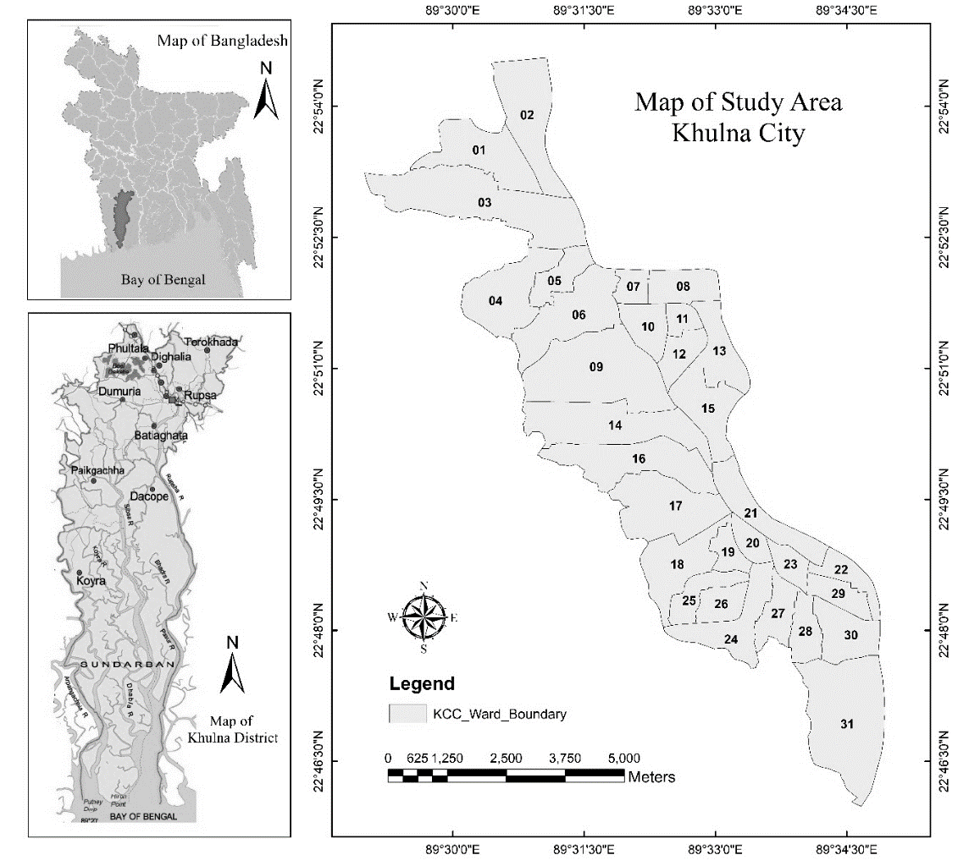
Khulna city has been selected as the study area in this research (Map-1). It is the third-largest city in Bangladesh, which is located in the south-western part of Bangladesh at 22°49′0″N and 89°33′0″E. It covers a total area of 59.57 sq.-km and has about 1.3 million populations (BBS, 2014). The population density of Khulna city is increasing day by day, resulting in rapid urban sprawl in the city fringes. This urban sprawl is correlated with increased energy use and causes pollutions (Johnson, 2001). Different anthropogenic activities as well as the rapid expansion of commercial areas and increased industrial activities are making Khulna city environmentally polluted day by day with an increasing amount of CO₂ in the atmosphere.
Map 1: Study Area
3.2 Satellite image processing and classification
For this study, Sentinel-II satellite data of the year of 2019 has been used. Having the image geo-referenced and geometrically rectified, image clipping has been performed and subset from the full image on the basis of a frame covering the study area. These preprocessing tasks allowed to export the classification and land cover information from satellite image. Using reference images (e.g. Google Earths, Google Maps); training samples have been gathered as signatures for each class. The training points were proportionally distributed to each cover types with at least 20 points per sinks type. From the supervised classification methods in ERDAS IMAGINE 2014, the Para-ML classification algorithm was used to produce the land cover maps which combines parallelepiped and maximum likelihood classification methods using a decision rule to evaluate each pixel. The parallelepiped classification is based on a set of lower and upper threshold reflectance determined for a signature on each band. To be assigned to a particular class, a pixel must exhibit reflectance within this reflectance range for every band considered. Pixels that are assigned to more than one class are then passed to the maximum likelihood decision rule for assignment to a single class. Then the area of each sink’s types (trees, vegetations, soils, and water bodies) have been calculated (Dorendorf, 2014).
3.3 Calculating carbon storage
Since the goal of this study is to assess the existing carbon storage capacity of Khulna city, carbon storage factors (kg C/sq. m) of respective storages have been considered for trees, vegetations, soils, and water bodies (Dorendorf, 2014). The carbon storage of Khulna city has been calculated by using Equation (1):
$$CS =\sum_{i=1}^{n}{CSi}……………………(1)$$
Where, CS is the total carbon storage of the Khulna city; i is the individual storage category; n is the total number of storage categories (here, n = 4 in this study- i) trees, ii) vegetations, iii) soils, and iv) water bodies. Then, CSi is calculated using Equation (2):
$$CSi =\sum{ASi ×Ei}…………………(2)$$
Where ASi is the total existing area of individual storage type; Ei is the equivalence factor. Integrating Equations (1) and (2), CS is calculated using Equation (3) as follows:
$$CS =\sum_{i=1}^{n}{(\sum{ASi ×Ei})}………………(3)$$
By using these equations, the exiting carbon storage of Khulna city has been calculated and carbon storage intensities map has been prepared.
Table-1: Values of Absorption Factors
Sink Type | Values of Absorption Factors (kgCO₂/Sq. m) | Sources
Tree | 1.66 | (Nowak & Crane, 2002; Dorendorf, 2014)
Water bodies | 1.28 | (Taylor et al., 2019)
Vegetation | 0.67 | (Bardhan et al., 2007)
Soil | 0.83 | (Bardhan et al., 2007)

4. Result and Discussion
In this paper, we have come up with several findings those demonstrate the precise information regarding the estimation of carbon storage capacity and its absorption. This section sums up the major findings of this study.
4.1 Existing landuse classification of Khulna city
Major four types of carbon sinks (tree, vegetation, soil and water bodies) have been classified here through supervised image classification (Map-2). From the findings, it is clear that the north-west part of Khulna city has some extent of carbon sinks. However, the lower portion at the southern part is highly congested with built-up area which has a huge lack of carbon sinks.
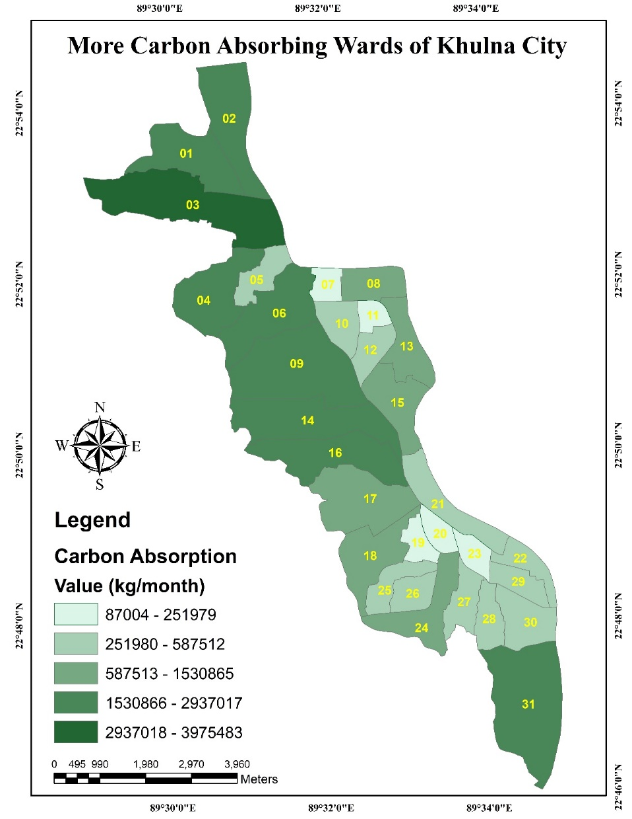
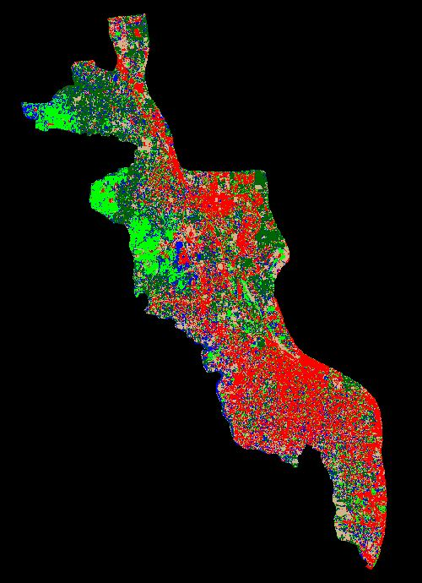
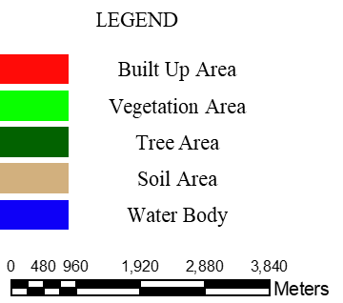

Kg per year

Map 2: Existing landuse classification of Khulna city

Figure 01 shows the existing areas of classified groups. Interestingly, the built-up area has the largest share of space than the other group. It is alarming for future as the amount of major carbon sink’s area is negligible in present time which has been decreasing day by day. As a result, carbon absorption capacity of overall city is insignificant which will be a challenging matter with the rapid changing climatic condition.
Figure-1: Existing areas of classified groups

The pie diagram demonstrates the percentage of existing carbon sink areas, which are - tree area is about 31%, water bodies body is 20%, vegetation area is 25% and soil area is 24%. The percentage for each sinks area is very insufficient comparing with the total amount of carbon, producing each month from different landuse types within the city.
Figure- 2: Carbon Absorption Percentage by Existing Carbon Sinks

4.2 Ward Wise Carbon Absorption
Spatial variation of carbon sinks and their capacity to storage carbon of Khulna city have been analyzed based on four different major types of carbon sinks. Based on the amount of existing carbon sinks, the following map (Map-9) shows the more carbon absorbing wards. From the findings it can be illustrated that at present tree is the most dominant carbon source in Khulna city as it has an absorption capacity of 15511653 kg carbon per year, and then the other contributors’ water bodies, soil and vegetations has 7729337, 6106915 and 5155799 kg carbon per year respectively. Where carbon absorption capacity is very high only in ward no 3. Ward no 1, 2, 4, 6, 9, 14, 16 and 31 are high carbon absorbing ward. As well as, ward no 8, 13, 15, 17, 18 and 24 are moderate, ward no 5, 10, 12, 21, 22, 25, 26, 27, 28, 29 and 30 are lower and ward no 7, 11, 19, 20 and 23 are very lower carbon absorbing wards.
Figure- 3: Ward Wise Carbon Absorption Percentage of Khulna city

Table-2: Ward Wise Carbon Absorption Capacity and Percentage
Ward No | Sink Type | Area (sq. meter) | Area % | Sink Wise Absorption | Absorption %
Ward No. 1 | Tree | 953299 | 3.14 | 1588832 | 4.60
Ward No. 1 | Water bodies | 351099 | 1.15 | 449992 | 1.30
Ward No. 1 | Vegetation | 204600 | 0.67 | 136400 | 0.40
Ward No. 1 | Soil | 202500 | 0.67 | 168750 | 0.49
Ward No. 2 | Tree | 614099 | 2.02 | 1023499 | 2.97
Ward No. 2 | Water bodies | 253400 | 0.83 | 324774 | 0.94
Ward No. 2 | Vegetation | 225500 | 0.74 | 150333 | 0.44
Ward No. 2 | Soil | 497099 | 1.64 | 414249 | 1.20
Ward No. 3 | Tree | 1232399 | 4.05 | 2053999 | 5.95
Ward No. 3 | Water bodies | 638999 | 2.10 | 818984 | 2.37
Ward No. 3 | Vegetation | 1010999 | 3.33 | 673999 | 1.95
Ward No. 3 | Soil | 514201 | 1.69 | 428501 | 1.24
Ward No. 4 | Tree | 704598 | 2.32 | 1174331 | 3.40
Ward No. 4 | Water bodies | 263500 | 0.87 | 337719 | 0.98
Ward No. 4 | Vegetation | 808498 | 2.66 | 538999 | 1.56
Ward No. 4 | Soil | 151600 | 0.50 | 126333 | 0.37
Ward No. 5 | Tree | 152200 | 0.50 | 253666 | 0.74
Ward No. 5 | Water bodies | 103900 | 0.34 | 133165 | 0.39
Ward No. 5 | Vegetation | 126900 | 0.42 | 84600 | 0.25
Ward No. 5 | Soil | 99100 | 0.33 | 82583 | 0.24
Ward No. 6 | Tree | 442499 | 1.46 | 737499 | 2.14
Ward No. 6 | Water bodies | 333399 | 1.10 | 427306 | 1.24
Ward No. 6 | Vegetation | 634500 | 2.09 | 423000 | 1.23
Ward No. 6 | Soil | 293699 | 0.97 | 244750 | 0.71
Ward No. 7 | Tree | 45200 | 0.15 | 75333 | 0.22
Ward No. 7 | Water bodies | 36400 | 0.12 | 46653 | 0.14
Ward No. 7 | Vegetation | 61600 | 0.20 | 41067 | 0.12
Ward No. 7 | Soil | 78500 | 0.26 | 65417 | 0.19
Ward No. 8 | Tree | 341000 | 1.12 | 568334 | 1.65
Ward No. 8 | Water bodies | 43800 | 0.14 | 56137 | 0.16
Ward No. 8 | Vegetation | 124900 | 0.41 | 83267 | 0.24
Ward No. 8 | Soil | 141400 | 0.47 | 117833 | 0.34
Ward No. 9 | Tree | 577099 | 1.90 | 961831 | 2.79
Ward No. 9 | Water bodies | 603799 | 1.99 | 773869 | 2.24
Ward No. 9 | Vegetation | 1039600 | 3.42 | 693067 | 2.01
Ward No. 9 | Soil | 609901 | 2.01 | 508251 | 1.47
Ward No. 10 | Tree | 63900 | 0.21 | 106500 | 0.31
Ward No. 10 | Water bodies | 55200 | 0.18 | 70748 | 0.21
Ward No. 10 | Vegetation | 93900 | 0.31 | 62600 | 0.18
Ward No. 10 | Soil | 95300 | 0.31 | 79417 | 0.23
Ward No. 11 | Tree | 63400 | 0.21 | 105667 | 0.31
Ward No. 11 | Water bodies | 37500 | 0.12 | 48062 | 0.14
Ward No. 11 | Vegetation | 60500 | 0.20 | 40333 | 0.12
Ward No. 11 | Soil | 69500 | 0.23 | 57917 | 0.17
Ward No. 12 | Tree | 96100 | 0.32 | 160167 | 0.46
Ward No. 12 | Water bodies | 61500 | 0.20 | 78823 | 0.23
Ward No. 12 | Vegetation | 94800 | 0.31 | 63200 | 0.18
Ward No. 12 | Soil | 123200 | 0.41 | 102667 | 0.30
Ward No. 13 | Tree | 522499 | 1.72 | 870832 | 2.52
Ward No. 13 | Water bodies | 72600 | 0.24 | 93049 | 0.27
Ward No. 13 | Vegetation | 130600 | 0.43 | 87067 | 0.25
Ward No. 13 | Soil | 208300 | 0.69 | 173583 | 0.50
Ward No. 14 | Tree | 670600 | 2.21 | 1117666 | 3.24
Ward No. 14 | Water bodies | 451399 | 1.48 | 578543 | 1.68
Ward No. 14 | Vegetation | 577200 | 1.90 | 384800 | 1.12
Ward No. 14 | Soil | 391899 | 1.29 | 326582 | 0.95
Ward No. 15 | Tree | 456099 | 1.50 | 760166 | 2.20
Ward No. 15 | Water bodies | 179900 | 0.59 | 230572 | 0.67
Ward No. 15 | Vegetation | 162700 | 0.54 | 108467 | 0.31
Ward No. 15 | Soil | 318701 | 1.05 | 265584 | 0.77
Ward No. 16 | Tree | 548300 | 1.80 | 913834 | 2.65
Ward No. 16 | Water bodies | 363199 | 1.19 | 465500 | 1.35
Ward No. 16 | Vegetation | 327701 | 1.08 | 218467 | 0.63
Ward No. 16 | Soil | 527899 | 1.74 | 439916 | 1.27
Ward No. 17 | Tree | 273700 | 0.90 | 456166 | 1.32
Ward No. 17 | Water bodies | 391000 | 1.29 | 501132 | 1.45
Ward No. 17 | Vegetation | 274101 | 0.90 | 182734 | 0.53
Ward No. 17 | Soil | 469000 | 1.54 | 390834 | 1.13
Ward No. 18 | Tree | 151900 | 0.50 | 253167 | 0.73
Ward No. 18 | Water bodies | 233200 | 0.77 | 298885 | 0.87
Ward No. 18 | Vegetation | 155300 | 0.51 | 103533 | 0.30
Ward No. 18 | Soil | 303800 | 1.00 | 253167 | 0.73
Ward No. 19 | Tree | 31300 | 0.10 | 52167 | 0.15
Ward No. 19 | Water bodies | 42900 | 0.14 | 54984 | 0.16
Ward No. 19 | Vegetation | 57000 | 0.19 | 38000 | 0.11
Ward No. 19 | Soil | 48500 | 0.16 | 40417 | 0.12
Ward No. 20 | Tree | 12100 | 0.04 | 20167 | 0.06
Ward No. 20 | Water bodies | 19600 | 0.06 | 25121 | 0.07
Ward No. 20 | Vegetation | 39200 | 0.13 | 26133 | 0.08
Ward No. 20 | Soil | 18700 | 0.06 | 15583 | 0.05
Ward No. 21 | Tree | 85000 | 0.28 | 141667 | 0.41
Ward No. 21 | Water bodies | 97500 | 0.32 | 124962 | 0.36
Ward No. 21 | Vegetation | 195200 | 0.64 | 130133 | 0.38
Ward No. 21 | Soil | 228900 | 0.75 | 190750 | 0.55
Ward No. 22 | Tree | 116700 | 0.38 | 194500 | 0.56
Ward No. 22 | Water bodies | 43300 | 0.14 | 55496 | 0.16
Ward No. 22 | Vegetation | 76300 | 0.25 | 50867 | 0.15
Ward No. 22 | Soil | 88400 | 0.29 | 73667 | 0.21
Ward No. 23 | Tree | 36600 | 0.12 | 61000 | 0.18
Ward No. 23 | Water bodies | 35500 | 0.12 | 45499 | 0.13
Ward No. 23 | Vegetation | 54600 | 0.18 | 36400 | 0.11
Ward No. 23 | Soil | 32900 | 0.11 | 27417 | 0.08
Ward No. 24 | Tree | 134500 | 0.44 | 224166 | 0.65
Ward No. 24 | Water bodies | 203300 | 0.67 | 260563 | 0.76
Ward No. 24 | Vegetation | 129400 | 0.43 | 86267 | 0.25
Ward No. 24 | Soil | 271099 | 0.89 | 225916 | 0.65
Ward No. 25 | Tree | 101500 | 0.33 | 169167 | 0.49
Ward No. 25 | Water bodies | 98900 | 0.33 | 126757 | 0.37
Ward No. 25 | Vegetation | 87300 | 0.29 | 58200 | 0.17
Ward No. 25 | Soil | 121200 | 0.40 | 101000 | 0.29
Ward No. 26 | Tree | 61200 | 0.20 | 102000 | 0.30
Ward No. 26 | Water bodies | 94600 | 0.31 | 121245 | 0.35
Ward No. 26 | Vegetation | 65700 | 0.22 | 43800 | 0.13
Ward No. 26 | Soil | 91800 | 0.30 | 76500 | 0.22
Ward No. 27 | Tree | 43100 | 0.14 | 71833 | 0.21
Ward No. 27 | Water bodies | 99300 | 0.33 | 127269 | 0.37
Ward No. 27 | Vegetation | 60400 | 0.20 | 40267 | 0.12
Ward No. 27 | Soil | 109800 | 0.36 | 91500 | 0.27
Ward No. 28 | Tree | 103600 | 0.34 | 172667 | 0.50
Ward No. 28 | Water bodies | 116900 | 0.38 | 149827 | 0.43
Ward No. 28 | Vegetation | 83300 | 0.27 | 55533 | 0.16
Ward No. 28 | Soil | 136600 | 0.45 | 113833 | 0.33
Ward No. 29 | Tree | 73000 | 0.24 | 121666 | 0.35
Ward No. 29 | Water bodies | 67100 | 0.22 | 86000 | 0.25
Ward No. 29 | Vegetation | 90000 | 0.30 | 60000 | 0.17
Ward No. 29 | Soil | 78800 | 0.26 | 65667 | 0.19
Ward No. 30 | Tree | 94900 | 0.31 | 158167 | 0.46
Ward No. 30 | Water bodies | 116400 | 0.38 | 149186 | 0.43
Ward No. 30 | Vegetation | 141400 | 0.47 | 94267 | 0.27
Ward No. 30 | Soil | 178800 | 0.59 | 149000 | 0.43
Ward No. 31 | Tree | 504600 | 1.66 | 840999 | 2.44
Ward No. 31 | Water bodies | 521600 | 1.72 | 668518 | 1.94
Ward No. 31 | Vegetation | 540000 | 1.78 | 360000 | 1.04
Ward No. 31 | Soil | 827201 | 2.72 | 689334 | 2.00

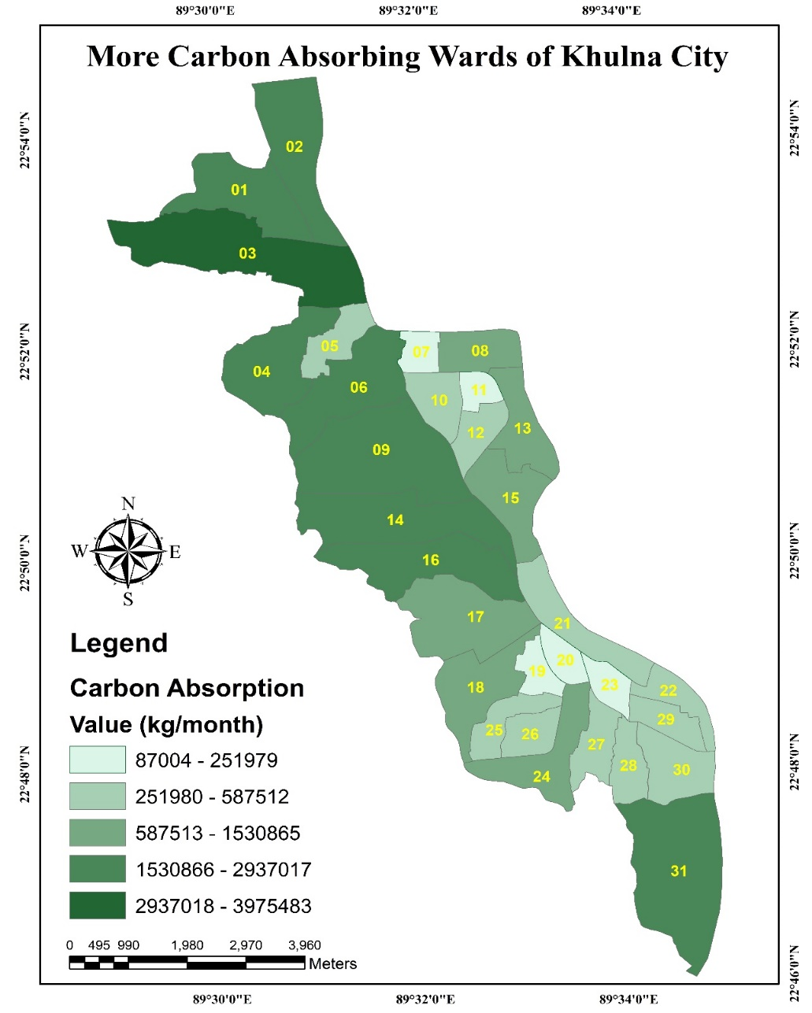
Kg per year
Map 3: More Carbon Absorbing Wards of Khulna city

4.3 Accuracy Assessment
4.3.1 Kappa Statistics
Kappa statistics has been computed for the classified map to measure the accuracy of the results. The resulting classification of land cover map of 2019 had a Kappa statistic of 80%. Kappa accounts for all elements of the confusion matrix and excludes the agreement that occurs by chance. Consequently, it provides a more rigorous assessment of classification accuracy. The Kappa coefficient has been calculated according to the formula given by (Thomas et al., 2003) in ERDAS IMAGINE.
Accuracy Totals with Conditional Kappa for each Category
Table-3: Values of Conditional Kappa for Each Categorical Class

Class Name | Kappa
Tree | 0.7622
Soil | 0.6920
Vegetation | 0.7721
Water bodies | 0.7937
Built-up | 0.9103

Table-4: Accuracy Assessment of Image Classification

Class Name | Reference Totals | Classified Totals | Number Correct | Producers Accuracy | Users Accuracy
Tree | 49 | 52 | 42 | 85.71% | 80.77%
Soil | 33 | 41 | 30 | 90.91% | 73.17%
Vegetation | 47 | 43 | 35 | 74.47% | 81.40%
Water bodies | 37 | 34 | 28 | 75.68% | 82.35%
Built-up | 90 | 86 | 81 | 90.00% | 94.19%
Totals | 256 | 256 | 216
Overall Classification Accuracy = 84.38%

In accuracy assessment, kappa coefficient of all class is about 0.7977 and the overall classification accuracy is 84.38%, which indicated a better overall classification.
5.Conclusion
Urban-area carbon sinks play an important role with a view to reducing the levels of ambient carbon dioxide. Due to accelerated growth rates, increased proportions of big trees, and potential secondary effects of decreased building energy usage and consequent carbon emissions from power plants, urban forestry, farm land, water bodies and bare soil have a higher influence. The findings reveals that the southern part (lower part) of Khulna City is extremely congested with built-up regions with a massive lack of carbon sinks. In Khulna city, highest amount of carbon has been absorbed by tress and vegetation which is approximately 56% together. Furthermore, among 31 wards of Khulna city, only 8 wards have high carbon absorption capacity while others are moderate to low carbon absorbing wards. However, some of the pollution savings produced by urban carbon sinks can be replaced by urban carbon emissions. The estimates given in this paper are based on restricted field and secondary data, as they refine from national to regional and state estimates, they become more unpredictable. To better enhance carbon accounting and other functions of urban forest environments, further field observations are required in urban areas. In addition, study needs to develop improved absorption potential calculations for urban carbon sinks, boost estimates of decomposition and maintenance emissions of sinks, and analyze the effects of other urban carbon sinks on urban carbon storage and flux. In order to create management strategies and national policy that will dramatically enhance environmental sustainability and human health around the country, a deeper understanding and accounting of urban environments can be used.

References
Ali, M. U., Liu, G., Yousaf, B., Abbas, Q., Ullah, H., Munir, M. A. M., & Zhang, H. (2018). Compositional characteristics of black-carbon and nanoparticles in air-conditioner dust from an inhabitable industrial metropolis. Journal of Cleaner Production, 180, 34–42. https://doi.org/10.1016/j.jclepro.2018.01.161
Bardhan, S., Roy, S., & Ghosh, K. (2007). An Assessment of the Annual Carbon Sequestration Potential of Urban and Peri-urban Water Bodies and Wetlands. International Advanced Research Journal in Science, Engineering and Technology ISO, 3297. https://doi.org/10.17148/IARJSET.2017.4714
Batjes, N. H. (2019). Technologically achievable soil organic carbon sequestration in world croplands and grasslands. Land Degradation & Development, 30(1), 25–32. https://doi.org/10.1002/ldr.3209
Cao, J., Zhang, X., Deo, R., Gong, Y., & Feng, Q. (2018). Influence of stand type and stand age on soil carbon storage in China’s arid and semi-arid regions. Land Use Policy, 78, 258–265. https://doi.org/10.1016/j.landusepol.2018.07.002
Chauhan, P. S., Chauhan, P. S., Manhas, R. K., Bhandari, D., & Negi, J. D. S. (2004). CARBON STOCK ASSESSMENT IN OLD GROWTH PINUS ROXBURGHII SPRENG. PLANTATION OF FOREST RESEARCH INSTITUTE, NEW FOREST, DEHRA DUN, INDIA Ethnomedicine View project Floral biodiversity and bio-resources View project CARBON STOCK ASSESSMENT IN OLD GROWTH PINUS ROXBURGHII SPRENG. PLANTATION OF FOREST RESEARCH INSTITUTE, NEW FOREST, DEHRA DUN, INDIA. https://www.researchgate.net/publication/295772171
Churkina, G. (2012). Carbonization of urban areas. In Recarbonization of the Biosphere: Ecosystems and the Global Carbon Cycle (pp. 369–382). Springer Netherlands. https://doi.org/10.1007/978-94-007-4159-1_16
Davies, Z. G., Dallimer, M., Edmondson, J. L., Leake, J. R., & Gaston, K. J. (2013). Identifying potential sources of variability between vegetation carbon storage estimates for urban areas. Environmental Pollution, 183, 133–142. https://doi.org/10.1016/j.envpol.2013.06.005
DeFries, R., Achard, F., Brown, S., Herold, M., Murdiyarso, D., Schlamadinger, B., & de Souza, C. (2007). Earth observations for estimating greenhouse gas emissions from deforestation in developing countries. Environmental Science and Policy, 10(4), 385–394. https://doi.org/10.1016/j.envsci.2007.01.010
Deng, L., Liu, S., Kim, D. G., Peng, C., Sweeney, S., & Shangguan, Z. (2017). Past and future carbon sequestration benefits of China’s grain for green program. Global Environmental Change, 47, 13–20. https://doi.org/10.1016/j.gloenvcha.2017.09.006
Dhakal, S. (2010). GHG emissions from urbanization and opportunities for urban carbon mitigation. In Current Opinion in Environmental Sustainability (Vol. 2, Issue 4, pp. 277–283). Elsevier. https://doi.org/10.1016/j.cosust.2010.05.007
Dorendorf, J. U. (2014). Urbanization and the Terrestrial Carbon Cycle Pools, Processes and Implications for Ecosystem Services in the City of Hamburg.
Grimm, N. B., Foster, D., Groffman, P., Grove, J. M., Hopkinson, C. S., Nadelhoffer, K. J., Pataki, D. E., & Peters, D. P. (2008). The changing landscape: ecosystem responses to urbanization and pollution across climatic and societal gradients. Frontiers in Ecology and the Environment, 6(5), 264–272. https://doi.org/10.1890/070147
Havlík, P., Schneider, U. A., Schmid, E., Böttcher, H., Fritz, S., Skalský, R., Aoki, K., Cara, S. De, Kindermann, G., Kraxner, F., Leduc, S., McCallum, I., Mosnier, A., Sauer, T., & Obersteiner, M. (2011). Global land-use implications of first and second generation biofuel targets. Energy Policy, 39(10), 5690–5702. https://doi.org/10.1016/j.enpol.2010.03.030
Houghton, R. A. (2005). Aboveground Forest Biomass and the Global Carbon Balance. Global Change Biology, 11(6), 945–958. https://doi.org/10.1111/j.1365-2486.2005.00955.x
Jiang, L., Deng, X., & Seto, K. C. (2012). Multi-level modeling of urban expansion and cultivated land conversion for urban hotspot counties in China. Landscape and Urban Planning, 108(2–4), 131–139. https://doi.org/10.1016/j.landurbplan.2012.08.008
Johnson, M. P. (2001). Environmental Impacts of Urban Sprawl: A Survey of the Literature and Proposed Research Agenda. Environment and Planning A: Economy and Space, 33(4), 717–735. https://doi.org/10.1068/a3327
Kaipainen, T., Liski, J., Pussinen, A., & Karjalainen, T. (2004). Managing carbon sinks by changing rotation length in European forests. Environmental Science and Policy, 7(3), 205–219. https://doi.org/10.1016/j.envsci.2004.03.001
Kanowski, J., & Catterall, C. P. (2010). Carbon stocks in above-ground biomass of monoculture plantations, mixed species plantations and environmental restoration plantings in north-east Australia. Ecological Management & Restoration, 11(2), 119–126. https://doi.org/10.1111/j.1442-8903.2010.00529.x
Kennedy, C., Pincetl, S., & Bunje, P. (2011). The study of urban metabolism and its applications to urban planning and design. In Environmental Pollution (Vol. 159, Issues 8–9, pp. 1965–1973). Elsevier. https://doi.org/10.1016/j.envpol.2010.10.022
Kennedy, Christopher, Steinberger, J., Gasson, B., Hansen, Y., Hillman, T., Havranek, M., Pataki, D., Phdungsilp, A., Ramaswami, A., & Mendez, G. V. (2010). Methodology for inventorying greenhouse gas emissions from global cities. Energy Policy, 38(9), 4828–4837. https://doi.org/10.1016/j.enpol.2009.08.050
Lankao, P. R. (2007). How do local governments in Mexico City manage global warming? Local Environment, 12(5), 519–535. https://doi.org/10.1080/13549830701656887
LAUNGANI, R., & KNOPS, J. M. H. (2009). The impact of co-occurring tree and grassland species on carbon sequestration and potential biofuel production. GCB Bioenergy, 1(6), 392–403. https://doi.org/10.1111/j.1757-1707.2009.01031.x
Liang, T. (2010). The Vision of Urban Spatial Planning Based on the Concept of Low-Carbon City.
Mahabub, G., Mamunul, S. /, & Khan, H. (2007). Sea Level Rise A Threat to the Coast of Bangladesh. In Internationales Asienforum (Vol. 38, Issue 4).
Masera, O. R., Garza-Caligaris, J. F., Kanninen, M., Karjalainen, T., Liski, J., Nabuurs, G. J., Pussinen, A., De Jong, B. H. J., & Mohren, G. M. J. (2003). Modeling carbon sequestration in afforestation, agroforestry and forest management projects: The CO2FIX V.2 approach. Ecological Modelling, 164(2–3), 177–199. https://doi.org/10.1016/S0304-3800(02)00419-2
Murray, B. C., Prisley, S. P., Birdsey, R. A., & Sampson, N. R. (2000). Carbon sinks in the Kyoto Protocol: Potential relevance for US forests. Journal of Forestry, 98(9), 6–11. https://doi.org/10.1093/jof/98.9.6
Nowak, D. J., & Crane, D. E. (2002). Carbon storage and sequestration by urban trees in the USA. Environmental Pollution, 116(3), 381–389. https://doi.org/10.1016/S0269-7491(01)00214-7
Obersteiner, M., Böttcher, H., & Yamagata, Y. (2010). Terrestrial ecosystem management for climate change mitigation. In Current Opinion in Environmental Sustainability (Vol. 2, Issue 4, pp. 271–276). Elsevier. https://doi.org/10.1016/j.cosust.2010.05.006
Peng, Y., Thomas, S. C., & Tian, D. (2008). Forest management and soil respiration: Implications for carbon sequestration. In Environmental Reviews (Vol. 16, pp. 93–111). https://doi.org/10.1139/A08-003
Roulet, N. T. (2000). PEATLANDS, CARBON STORAGE, GREENHOUSE GASES, AND THE KYOTO PROTOCOL: PROSPECTS AND SIGNIFICANCE FOR CANADA. In WETLANDS (Vol. 20, Issue 4). Springer. https://doi.org/10.1672/0277-5212(2000)020[0605:PCSGGA]2.0.CO;2
Sarkar, M. S. K., Sadeka, S., Sikdar, M. M. H., & Badiuzzaman. (2018). Energy Consumption and CO2 Emission in Bangladesh: Trends and Policy Implications. Asia Pacific Journal of Energy and Environment, 5(1), 41–48. https://doi.org/10.18034/apjee.v5i1.249
Seto, K. C., Güneralp, B., & Hutyra, L. R. (2012). Global forecasts of urban expansion to 2030 and direct impacts on biodiversity and carbon pools. Proceedings of the National Academy of Sciences of the United States of America, 109(40), 16083–16088. https://doi.org/10.1073/pnas.1211658109
Sierra, C. A., del Valle, J. I., Orrego, S. A., Moreno, F. H., Harmon, M. E., Zapata, M., Colorado, G. J., Herrera, M. A., Lara, W., Restrepo, D. E., Berrouet, L. M., Loaiza, L. M., & Benjumea, J. F. (2007). Total carbon stocks in a tropical forest landscape of the Porce region, Colombia. Forest Ecology and Management, 243(2–3), 299–309. https://doi.org/10.1016/j.foreco.2007.03.026
Sohi, S. P. (2012). Carbon storage with benefits. In Science (Vol. 338, Issue 6110, pp. 1034–1035). American Association for the Advancement of Science. https://doi.org/10.1126/science.1225987
Stockmann, U., Adams, M. A., Crawford, J. W., Field, D. J., Henakaarchchi, N., Jenkins, M., Minasny, B., McBratney, A. B., Courcelles, V. de R. de, Singh, K., Wheeler, I., Abbott, L., Angers, D. A., Baldock, J., Bird, M., Brookes, P. C., Chenu, C., Jastrow, J. D., Lal, R., … Zimmermann, M. (2013). The knowns, known unknowns and unknowns of sequestration of soil organic carbon. In Agriculture, Ecosystems and Environment (Vol. 164, pp. 80–99). Elsevier B.V. https://doi.org/10.1016/j.agee.2012.10.001
Strohbach, M. W., & Haase, D. (2012). Above-ground carbon storage by urban trees in Leipzig, Germany: Analysis of patterns in a European city. Landscape and Urban Planning, 104(1), 95–104. https://doi.org/10.1016/j.landurbplan.2011.10.001
Taylor, S., Gilbert, P. J., Cooke, D. A., Deary, M. E., & Jeffries, M. J. (2019). High carbon burial rates by small ponds in the landscape. Frontiers in Ecology and the Environment, 17(1), 25–31. https://doi.org/10.1002/fee.1988
Thomas, N., Hendrix, C., & Congalton, R. G. (2003). A comparison of urban mapping methods using high-resolution digital imagery. In Photogrammetric Engineering and Remote Sensing (Vol. 69, Issue 9, pp. 963–972). American Society for Photogrammetry and Remote Sensing. https://doi.org/10.14358/PERS.69.9.963
Trum, F., Titeux, H., Ranger, J., & Delvaux, B. (2011). Influence of tree species on carbon and nitrogen transformation patterns in forest floor profiles. Annals of Forest Science, 68(4), 837–847. https://doi.org/10.1007/s13595-011-0080-4
van Bueren, E., van Bohemen, H., Itard, L., & Visscher, H. (2012). Sustainable urban environments: An ecosystem approach. In Sustainable Urban Environments: An Ecosystem Approach. Springer Netherlands. https://doi.org/10.1007/978-94-007-1294-2
Wang, S., & Huang, Y. (2020). Determinants of soil organic carbon sequestration and its contribution to ecosystem carbon sinks of planted forests. Global Change Biology, 26(5), 3163–3173. https://doi.org/10.1111/gcb.15036
Wang, W., Wei, X., Liao, W., Blanco, J. A., Liu, Y., Liu, S., Liu, G., Zhang, L., Guo, X., & Guo, S. (2013). Evaluation of the effects of forest management strategies on carbon sequestration in evergreen broad-leaved (Phoebe bournei) plantation forests using FORECAST ecosystem model. Forest Ecology and Management, 300, 21–32. https://doi.org/10.1016/j.foreco.2012.06.044
Weishampel, P., Kolka, R., & King, J. Y. (2009). Carbon pools and productivity in a 1-km2 heterogeneous forest and peatland mosaic in Minnesota, USA. Forest Ecology and Management, 257(2), 747–754. https://doi.org/10.1016/j.foreco.2008.10.008
Yang, H., Huang, J., & Liu, D. (2020). Linking climate change and socioeconomic development to urban land use simulation: Analysis of their concurrent effects on carbon storage. Applied Geography, 115, 102135. https://doi.org/10.1016/j.apgeog.2019.102135
Zhang, Q. Z., & Wang, C. K. (2010). Carbon density and distribution of six Chinese temperate forests. Science China Life Sciences, 53(7), 831–840. https://doi.org/10.1007/s11427-010-4026-0
Zhou, C., & Wang, S. (2018). Examining the determinants and the spatial nexus of city-level CO2 emissions in China: A dynamic spatial panel analysis of China’s cities. Journal of Cleaner Production, 171, 917–926. https://doi.org/10.1016/j.jclepro.2017.10.096

