Assessing Spatial Extent of Flood Risk in Sirajganj District of Bangladesh

Tasin Islam Himel ¹
Sumya Naz ²
Rukaya Islam ³
Taufiqur Rafi ⁴

- Undergraduate, Urban and Rural Planning Discipline, Khulna University, Khulna-9208, Bangladesh
Email: tasinislam946@gmail.com
- Undergraduate, Urban and Rural Planning Discipline, Khulna University, Khulna-9208, Bangladesh
Email: sumyadhew.ku@gmail.com
- Undergraduate, Urban and Rural Planning Discipline, Khulna University, Khulna-9208, Bangladesh
Email: noboni381@gmail.com
- Undergraduate, Urban and Rural Planning Discipline, Khulna University, Khulna-9208, Bangladesh
Email: taufiqur1996@gmail.com

15th April 2021
Abstract
This article explores spatial extension and level of flood risk in Sirajganj District of Bangladesh where socioeconomic vulnerability and flood hazard are two keys. Collecting desiring data from BBS-11, socioeconomic vulnerability has been calculated following equal weight indexing method based on 15 indicators within three major components: 'Socio-demographic', 'Economic', 'Physical and Infrastructure'. And the flood hazard has been assessed using ArcGIS following a weighted overlay of the reclassifying images of 6 factors; ‘distance from river’, ‘land cover’, ‘elevation’, ‘slope’, ‘drainage area’, ‘distance from the coastline’. Multiplying the socioeconomic vulnerability index and hazard score, flood risk has been evaluated at five different levels of intensity (very low, low, moderate, high, very high). Here, the unit of analysis is union and somewhere it is at Upazila for better understanding. The result reveals that more than 365 sq km area of Sirajganj district lies at 'high' to 'very high level of risk of flooding. Findings also evidence Cauhali and Shahjadpur Upazila as higher risky regions where maximum area of lower risk is founded in Ullapara, Sirajganj Sadar, and Tarash Upazila. Economic component, physical and infrastructure component in the aspect of socioeconomic vulnerability and closer distance from the river, lower elevation, slope, and vegetation density in the aspect of hazard are the major causes intensifying the level of flood risk. This is how the article might help policymakers to identify the regions with their level of intensity of vulnerability, hazard, and risk for flooding which may lead a way to proper flood risk management.
Keywords: Spatial Extent, Socioeconomic Vulnerability, Hazard Assessment, Risk Assessment, Union and Upazila.

1. Introduction
In the field of climate change and disaster studies, Bangladesh is revealed as one of the most natural disaster-prone countries in the world that are imposed to the geographical setting of the country, which makes it more vulnerable to natural hazards (i.e., flood, cyclone, drought, tidal surge, tornado, earthquake, river erosion, etc.) (Barua, Akhter, & Ansary, 2016). In addition to extreme hydrological events, various anthropogenic activities such as massive urbanization and land use play an important role in producing catastrophic floods, which may frequently disrupt local inhabitants' existence by damaging their economy, agriculture, property, infrastructure, and overall livelihood (Gain, Mojtahed, Biscaro, Balbi, & Giupponi, 2015). Thus, it is important to promote and propagate an integrated methodology to explore the spatial extent and level of flood risk in the Sirajganj District of Bangladesh according to socio-economic vulnerability indexing and flood hazard analysis. Therefore, this study concentrates on applying an equal weight indexing method to analyze socio-economic vulnerability, GIS-based integrated methodology for flood hazard mapping, and the final outcome, risk, can be gained through raster calculation.
Risk can be defined as the probability that a loss will be incurred given a particular environment (Alexander, 2000). Risk is strongly and proportionally related to vulnerability and hazard exposure. However, in most cases, risk-reduction strategies at the household-level are inadequate for ensuring a livelihood resilient to floods. This is because riverine people are exposed to frequent floods, which increases their vulnerability to floods (Mondal, Murayama, & Nishikizawa, 2020). That is why we need to assess and map the associated socioeconomic vulnerability to natural hazards to analyze flood risk levels in a selected area. Vulnerability can be defined as the human dimension of disasters and the result of the range of social, economic, political, institutional, cultural, and psychological factors that shape people's lives and the environment that they live in (John Twigg, 2004). To assess the socio-economic vulnerability, different attributes are needed to be covered, such as well-being, education, social class, density, age, race, employment, ethnicity, working age population, elderly population, etc. and quantifying social vulnerability can help identify which places are most vulnerable, and which dimensions of social vulnerability are the key drivers (Rufat, Tate, Burton, & Maroof, 2015). The techniques for measuring vulnerability to natural hazards, preparedness strategy, disaster, emergency recovery, risk response, and planning studies have blended around mapping and describing environmental risks (Ran, MacGillivray, Gong, & Hales, 2019). Multi-hazard and vulnerability maps provide information of the threat extent associated with risks and details of the extent of geographical effects, risk level, and geographical data such as the extent of human settlements, capital, and impacted infrastructure. This is the research's focus and is being conducted in a realistic approach to reach cognitive discussions on socio-economic vulnerability using an evidence-based methodology.
The vulnerability may be measured using various techniques that analyze the relationship between physical and social structures (Sahana, Rehman, Paul, & Sajjad, 2019). Flood vulnerability and risk mapping are used along with the AHP (Analytical Hierarchy Process) decision-making approach to combine multiple flood-related variables (Feloni, Mousadis, & Baltas, 2019). In order to estimate the flood risk in an urbanized area of Kenya, Ouma and Tateishi (Ouma & Tateishi, 2014) used different spatial and socioeconomic parameters. Ozcan & Musaoglu (Ozcan & Musaoglu, 2010) develops a flood risk vulnerability map for an urban area near riverside (Ayamama River in Istanbul) centered upon a digital terrain model, land slope, aspect, land use distribution, and geography.
In this study, a GIS-based mapping tool considering multi-criteria decision analysis (MCDA) has been developed and applied to help assess the spatial extent of flood risk in the Sirajganj of Bangladesh by analyzing different scenarios regarding socio-economic vulnerability, hierarchy and estimate weighting variables. Therefore, this research will help to identify the most and least vulnerable and hazardous unions of Sirajganj and indicate that risk assessment is critical for assessing the degree of vulnerability for various locations in Sirajganj District and collecting information that can help researchers, policymakers, private and public stakeholders develop site-specific adaptation strategies and prioritize adaptation measures in the most vulnerable areas.

2. Materials and Methods
2.1 Study Area
Sirajganj, a district of the northern region of Bangladesh under the Rajshahi division, one of the major flood-prone districts of Bangladesh has been taken as our study area. The district Sirajganj lies between 24º01’ and 24º47’ north latitudes and between 89º15’ and 89º59’ east longitudes. It has an area of 2402.056 square kilometers. (Bangladesh Population and Housing Census 2011, 2014) having a population of 30,97489 with a total household of 7,149741 and a density of 1290 per km. (Bangladesh Population and Housing Census 2011, 2014) The zila consists of 9 upazilas, 82 unions, 1379 mauzas, 2016 villages, 6 paurashavas, 60 wards, and 160 mahallas. So, It contains 88 numbers of admin four boundary means 88 number of unions and paurashavas (figure 1) under nine Upazila. As we know municipal hold urban characteristics whereas unions hold rural, to avoid conflict and to bring homogeneity, all six paurashavas (Sirajganj Sadar, Belkuchi, Royganj, Kazipur, Shahjadpur, and Ullahpara Paurashava) have been excluded from the study area which means all 82 unions have been taken as our final study area (figure 1). The nine upazilas and the unions included into are : Belkuchi containing six, seven belonging to Chauhali, four for Kamarkhanda, twelve to Kazipur, nine to Royganj, Shahjadpur and Ullahpara both holding as equal as thirteen, ten for Sirajganj Sadar and lastly, Tarash, having a total number of eight unions. The 82 unions of our study area comprise a total area of 2429.11 sq. km which is actually more than the district area of 2402 sq. km. It is because of the mighty river Jamuna, all 2429.11 sq. km area is not livable. But the shapefile includes the enormous Jamuna as well.

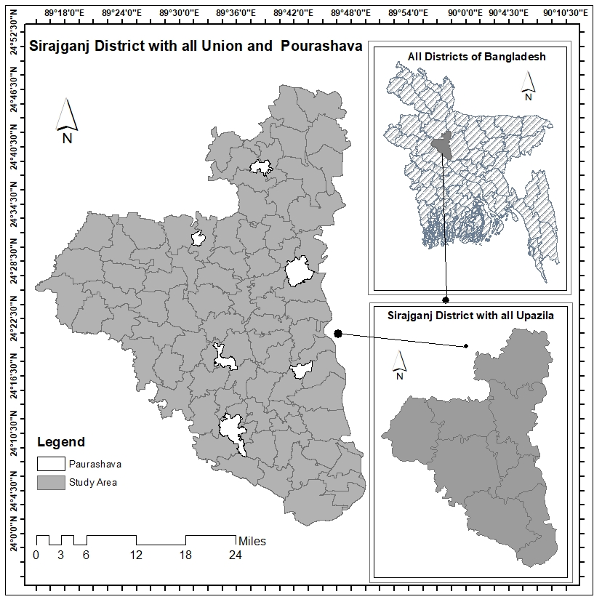
Figure 1: Study Area

2.2 Data Collection and Data Preparation
Phase:1
Conceptualization

Socio Economic Vulnerability Index
3 Dimension
15 indicators

Hazard Assessment
6 factors
Develop necessary weighting index method
Understanding ‘Socio-Economic Vulnerability’, ‘Flood Hazard’, ‘Flood Risk’
Review necessary Articles relevant to flood risk assessment
Phase: 2
Data Collection and Processing
Collecting Community Series data of 2011
Population and Housing Census and input it into excel for Socio Economic Vulnerability Index
Collecting USGS data and necessary data from different source for the Hazard Assessment
Taking one of the flood prone district study area
Generating Necessary Maps of Vulnerability and Hazard
Phase: 3
Manufacturing
Calculating Socio-Economic Vulnerability Index and take it to ArcGIS
Hazard Assessment (scoring)
Phase: 4
Output
Risk Assessment (normalized)
Most contributed factors to vulnerability, Hazard and ultimate risk

Figure 2: Schematic Diagram of Steps followed in this Paper

The adapted set of methods contains four major phases (figure 2): ‘conceptualization’, ‘data collection and processing’, ‘manufacturing’ ‘output’. All the data used here are secondary and collected from various source which are metioned in the later part. The unit of analysis is union at initial stage, later it is done both at union and upazila level for better presentation. Some steps followed to complete the analysis process are metioned here.

2.2.1 Socioeconomic Vulnerability Index and Mapping
Three major components taken for the socioeconomic vulnerability Index (SoVI) are socio- demographic component, economic component, physical and infrastructure component. Total of fifteen indicators under these three have been selected for indexing (Table 1) which are freely available data from BBS (Bangladesh Bureau of Statistics, 2011).
Table 1: Factors Considered for Socioeconomic Vulnerability Assessment
Major Components (3) | Indicator (15) | Unit of Measurement | Functional Relationship
Socio-demographic component (7) | Population density | Person/km | Positive
Socio-demographic component (7) | Percentage of young children | Percentage | Positive
Socio-demographic component (7) | Percentage of senior citizen (above 65 years) | Percentage | Positive
Socio-demographic component (7) | Illiterate persons | Percentage | Positive
Socio-demographic component (7) | Households live in rented house | Percentage | Positive
Socio-demographic component (7) | Floating population | Count per 10000 | Positive
Socio-demographic component (7) | Population with disability | Percentage | Positive
Economic component (4) | Employment in agriculture | Percentage | Positive
Economic component (4) | Working age population | Percentage | Negative
Economic component (4) | Unemployment rate | Percentage | Positive
Economic component (4) | Service & industry employment | Percentage | Negative
Physical and Infrastructure component (4) | Households with tube-well as water source | Percentage | Negative
Physical and Infrastructure component (4) | Households with non-sanitary toilet | Percentage | Positive
Physical and Infrastructure component (4) | Households without electricity connection | Percentage | Positive
Physical and Infrastructure component (4) | Katcha/Jhupri housing structure | Percentage | Positive

Equal weight has been provided for developing socio-economic vulnerability index which means each of the indicator will get the weight of 1/15 means each of the indicator will contribute to the overall SoVI (Socio-economic vulnerability index) equally. (Mudasser, Hossain, Rahaman, & Ha-Mim, September 2020) (Ha-Mim, Hossain, Rahaman, & Mallick, July 2020). To compensate the complexity and conflict with the different scale of measurement, normalization has been conducted as per following equations.
$Index N_{x}= \frac{H_{x}-H_{min}}{H_{max }–H_{min}}$ …………………………………………(i)
$Index N_{x}= \frac{H_{max }-H_{x}}{H_{max }-H_{min}}$ …………………………………........(ii)

Here, Index N_{x} is the normalized index value and H_{x} is the original value of the indicator for household x, X_{max} and X_{min} are the maximum and minimum values of the indicator at the household level. Equation (i) is to normalize the indicators who have the positive functional relationship with the vulnerability and Equation (ii) for the negative functional relationship. After normalization, values of each indicator are ready to get into Equation (iii) to calculate the value of major components for each household.
${MC}_{x}=\frac{\sum_{i=1}^{n}{Index Nx^{i}}}{n}$………………………. (iii)

Where, MC_{x} represents the value of one of the major components for household X (Socio-demographic Component (SDC), Economic Component (EC), Physical and Infrastructure Component (PIC)), Index N_{X}^{i} is the normalized value of the i^{th} indicator for household X, and n is the number of indicators under each major component.
Once major components value for each of the household is calculated, Equation (iv) is used to calculate Socioeconomic Vulnerability Index (SoVI).

SoVI = (SDC × Wi) + (EC × Wii) + (PIC × Wiii) …………(iv)

Where, for Equation (iv), SoVI= Socioeconomic vulnerability index, SDC = value of major component 'Socio-demographic Component', EC = value of major component of 'Economic Component', PIC= value of major component of 'Physical and Infrastructure component'. For each indicator, W refers to the weight that has been applied to each major component where Wi = 0.47, Wii = 0.267, Wiii = 0.267 (as per equal weight).
Matching the union code defined in the attribute table of shapefile of unions with the value founded in the excel of vulnerability index, we exported the csv to ArcGIS and joined it with the attribute table (according to the code) and necessary map of vulnerability index has been generated.

2.2.2 Hazard Assessment and Mapping
The relationship between the influence of the hazardous factor with the chances of flood occurrance is explored based on related literature reviews. We considered 6 factors (distance from the river, distance from the coastline, elevation, slope, land cover and, drainage area) for assessing the flood hazard which is freely available online. The data for Elevation and slope is collected from DEM (23rd September 2014) from Earth explorer on the USGS website. Land cover data is prepared by image classification of Sentinel 2 data (25th January 2020) from Earth explorer of the USGS website, distance from the river also measured based on the Sentinel 2 images, The shapefile of the drainage area and water bodies data are collected from the HDX website (data.humdata.org/dataset/Bangladesh-water-bodies).
ArcGIS and Erdas Imagine have been used frequently to conduct the process. River and land-use are generated from the image classification. From the DEM data, using extract by mask tool we have got elevation and later using slope tool, we have produced slope data. The area of the higher amount of drainage area and distance from drainage area is highlighted by the euclidean distance tool. Euclidean distance is a type of tool which is used for measuring the distance from certain objects like drainage area. Distance from river and distance from the coastline is measured by the Multi ring buffer tool.
Table 2: Classifying the attribute of each factor and assign the weight
Factor of Hazard | Reclassifying Method | Attribute | Hazard Value | Weight
Distance from River (Miles) | Equal Interval | 0-6 | 5 | 18%
Distance from River (Miles) | Equal Interval | 9-12 | 4 | 18%
Distance from River (Miles) | Equal Interval | 12-18 | 3 | 18%
Distance from River (Miles) | Equal Interval | 18-24 | 2 | 18%
Distance from River (Miles) | Equal Interval | 24-30 | 1 | 18%
Land Cover | Manual Interval | Dense Vegetation | 1 | 18%
Land Cover | Manual Interval | Moderate Dense Vegetation | 2 | 18%
Land Cover | Manual Interval | Light Green Vegetation | 3 | 18%
Land Cover | Manual Interval | Barren soil /Non-Vegetation | 4 | 18%
Land Cover | Manual Interval | Wet land and River | 5 | 18%
Elevation (Meter) | Natural Breaks (Jenk) | <6 | 5 | 18%
Elevation (Meter) | Natural Breaks (Jenk) | 6-11 | 4 | 18%
Elevation (Meter) | Natural Breaks (Jenk) | 11-14 | 3 | 18%
Elevation (Meter) | Natural Breaks (Jenk) | 14-17 | 2 | 18%
Elevation (Meter) | Natural Breaks (Jenk) | 17-85 | 1 | 18%
Slope (Degree) | Natural Breaks (Jenk) | 0 - 1.47 | 5 | 18%
Slope (Degree) | Natural Breaks (Jenk) | 1.47 – 2.84 | 4 | 18%
Slope (Degree) | Natural Breaks (Jenk) | 2.84-4.5 | 3 | 18%
Slope (Degree) | Natural Breaks (Jenk) | 4.5-7.71 | 2 | 18%
Slope (Degree) | Natural Breaks (Jenk) | 7.71-45.8 | 1 | 18%
Drainage Area  (Euclidean Distance from drainage area) | Natural Breaks (Jenk) | 0 - 0.026371 | 1 | 18%
Drainage Area  (Euclidean Distance from drainage area) | Natural Breaks (Jenk) | 0.026371 - 0.060016 | 2 | 18%
Drainage Area  (Euclidean Distance from drainage area) | Natural Breaks (Jenk) | 0.060016 - 0.107302 | 3 | 18%
Drainage Area  (Euclidean Distance from drainage area) | Natural Breaks (Jenk) | 0.060016 - 0.107302 | 4 | 18%
Drainage Area  (Euclidean Distance from drainage area) | Natural Breaks (Jenk) | 0.161862 - 0.231881 | 5 | 18%
Distance from Coastline (Miles) | Equal Interval | <141 | 5 | 10%
Distance from Coastline (Miles) | Equal Interval | 141- 152 | 4 | 10%
Distance from Coastline (Miles) | Equal Interval | 152-163 | 3 | 10%
Distance from Coastline (Miles) | Equal Interval | 163-174 | 2 | 10%
Distance from Coastline (Miles) | Equal Interval | 174-185 | 1 | 10%
 | Total |  |  | 100%

(Adopted Source: (Hoque, Pradhan, Ahmed, & Roy, 2019); (Rahman, et al., 2019); (Rahmati, Zeinivand, & Besharat, 2015); (Islam & Sado, 2000))
Lower elevation and lower slope of an area increase the risk of flood occurrance compared to higher elevation and higher slope. Again, the factors distance from the river and distance from the coastline are also disproportionate to flood risk. The higher density of vegetation decreases the flood risk more than light vegetation and non-vegetation areas. A place with a lower number of drainage areas enhances the flood risk compared with a proper amount of drainage channels and areas. (Rahman, et al., 2019)
To assign the hazard value, 5 score indicates the very high hazard, and 1 score indicates very low hazard. Where 4,3 and 2 indicate subsequently high, moderate, low hazard. The sum of the weight of all the factors should be 100%. Here, we have assigned 18% weight to each of the factor except the last one. The factor distance from coastline has been assigned with 10% weight only as the influce of this factor is low to create flood occurrance compared with the other five.
The reclassified raster images of all the hazard factors are overlaid by the weighted overlay tool in Model Building. The weight of each factor is assigned in this stage. After running the model of hazard, the score of flood hazard is 1 to 5 on the hazard map. On the map, the greater score indicates the area of higher flood hazard.

2.2.3 Risk Assessment and Mapping
Changing vector to raster in ArcGIS using ‘feature to raster’ tool, socioeconomic vulnerability index map has been converted and after that socioeconomic vulnerability index has been multiplied by the Hazard score which is actually a multiplication between two rasters of vulnerability map and hazard map.
$Initial Risk Map=Vulnerability Map×Hazard Map$……(y)
$Normalized Risk Map= \frac{Initial Risk Map-Minimum value of Initial Risk Map}{Maximum value of Initial Risk Map –Minimum Value of Initial Risk Map}$………. (z)

Following the equation (y) the risk map (raster) has been generated which has ranges of values from 0 to 5 (vulnerability 0 to1 & Hazard 1 to 5). At this point, we named it initial risk map and it is an unnormalized map. To make it normalized, equation (z) has been followed. The normalized risk map gives the risk value having a range from 0 to 1 with five classes created with equal intervals (very low, low, moderate, high, very high). (Hoque, Pradhan, Ahmed, & Roy, 2019)

3. Result
3.1 Socioeconomic Vulnerability
Table 3: Area according to different Intensity of 'Socioeconomic Vulnerability' Index

Level | Very Low | Low | Moderate | High | Very High
Index Value | 0.246-0.309 | 0.309-0.372 | 0.372- 0.435 | 0.435-0.498 | 0.498-0.561
Count | 7 | 34 | 24 | 13 | 4
Area | 182.426 | 880.8375 | 776.1662 | 437.3739 | 152.7367
Percentage | 7.51% | 36.26% | 31.95% | 18% | 6.29%
Table 4: Union count with the level of 'Socioeconomic Vulnerability' according to Upazila

Upazila Name | 'Very Low' (Count) | ‘Low’  (Count) | 'Moderate' (Count) | ‘High’ (Count) | ‘Very High' (Count) | Total Union (Count)
Belkuchi | 2 | 2 | 0 | 2 | 0 | 6
Chauhali | 0 | 2 | 1 | 2 | 2 | 7
Kamarkhanda | 2 | 2 | 0 | 0 | 0 | 4
Kazipur | 0 | 4 | 5 | 3 | 0 | 12
Royganj | 0 | 5 | 3 | 1 | 0 | 9
Shahjadpur | 0 | 7 | 3 | 1 | 2 | 13
Sirajganj S. | 3 | 4 | 1 | 2 | 0 | 10
Tarash | 0 | 2 | 6 | 0 | 0 | 8
Ullah para | 0 | 6 | 5 | 2 | 0 | 13
Total | 7 | 34 | 24 | 13 | 4 | 82

As per the adopted method, the maximum SoVI (Socioeconomic Vulnerability Index) value we found is 0.56125, and the lowest one is 0.24685. The average SoVI value of all 82 unions is 0.38175. The equal interval from minimum to maximum five classes was made (very low, low, moderate, high, very high). From the above Table 3 and Table 4, we see maximum unions belong to the 'low' and 'moderate' class. Jointly this two occupy more than 68% percent of the total area. Nevertheless, unions with a 'high-level of SoVI is not of a small number. Thirteen Upazilas carrying 18% of the total area, which is the third-highest. Among 2429.5 sq.km area, 152.7 sq.km are in 'very high level of vulnerability which is 6.3% of the total.
Now, if we look at the Upazilas among four unions that are carrying a very high vulnerability level, two from Shahjadpur and two from Chauhali, it is also seen that three unions with a high level of vulnerability are from Kazipur, which is maximum among all nine Upazilas. In comparison, Upazila Kamarkhanda and Sirajganj Sadar are in a comfortable position.
The union scores the lowest Socioeconomic vulnerability index (SoVI) is Shialkul. The score of 0.24685 is under Sirajganj Sadar Upazila, and the union that scored highest in the socioeconomic vulnerability index is Sonatani, with the score of 0.56165 is under Shahjadpur Upazila.

Figure 3: Vulnerability from different Components

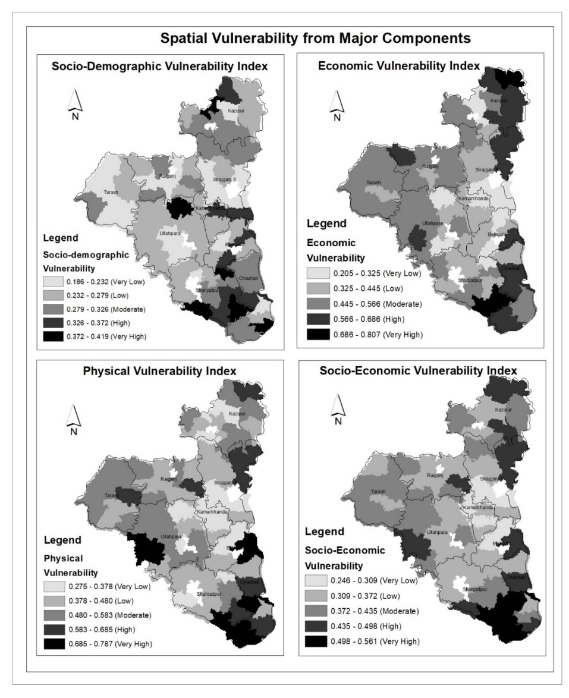
Figure 4: Spatial SoVI from major Components

Vulnerability from all fifteen Indicators
Table 5: Aveage vulnerability index of each indicator at Upazila Level

Vulnerability  Indicators | Upazila level of Sirajganj Districts |  |  |  |  |  |  |  |  | Avg.  index
Vulnerability  Indicators | Bel-  kuchi | Chau-  hali | Kamar-  khanda | Kazi-  pur | Roy-  ganj | Shahjad-pur | Siraj-  ganj S. | Tarash | Ulla-  para | Avg.  index
Population density (person/km) | 0.42 | 0.15 | 0.32 | 0.14 | 0.23 | 0.37 | 0.28 | 0.28 | 0.25 | 0.27
Percentage of young children (0-4 years) (%) | 0.56 | 0.65 | 0.28 | 0.24 | 0.22 | 0.43 | 0.33 | 0.39 | 0.30 | 0.38
Percentage of senior citizen (above 65 years) (%) | 0.36 | 0.41 | 0.66 | 0.71 | 0.70 | 0.48 | 0.45 | 0.54 | 0.67 | 0.55
Illiterate persons (%) | 0.29 | 0.44 | 0.17 | 0.42 | 0.42 | 0.46 | 0.31 | 0.36 | 0.29 | 0.35
Households live in rented house (%) | 0.11 | 0.22 | 0.05 | 0.07 | 0.04 | 0.19 | 0.11 | 0.11 | 0.03 | 0.10
Floating population (per 10,000) | 0.04 | 0.00 | 0.15 | 0.09 | 0.02 | 0.08 | 0.01 | 0.05 | 0.11 | 0.06
Population with disability (%) | 0.08 | 0.25 | 0.32 | 0.39 | 0.15 | 0.17 | 0.29 | 0.24 | 0.14 | 0.23
Employment in agriculture (%) | 0.29 | 0.57 | 0.35 | 0.68 | 0.68 | 0.51 | 0.41 | 0.50 | 0.57 | 0.51
Working age population (%) | 0.59 | 0.71 | 0.41 | 0.39 | 0.27 | 0.48 | 0.44 | 0.47 | 0.34 | 0.46
Unemployment rate (%) | 0.23 | 0.12 | 0.15 | 0.22 | 0.26 | 0.39 | 0.22 | 0.23 | 0.14 | 0.23
Service & industry employment (%) | 0.39 | 0.73 | 0.55 | 0.79 | 0.77 | 0.52 | 0.57 | 0.62 | 0.76 | 0.63
Households with tube-well as water source (%) | 0.18 | 0.17 | 0.10 | 0.14 | 0.20 | 0.19 | 0.13 | 0.16 | 0.26 | 0.17
Households with non-sanitary toilet (%) | 0.48 | 0.56 | 0.20 | 0.10 | 0.28 | 0.41 | 0.42 | 0.35 | 0.55 | 0.37
Households without electricity connection (%) | 0.48 | 0.76 | 0.28 | 0.63 | 0.63 | 0.38 | 0.34 | 0.50 | 0.48 | 0.50
Katcha/Jhupri housing structure (%) | 0.83 | 0.95 | 0.78 | 0.93 | 0.86 | 0.88 | 0.88 | 0.87 | 0.80 | 0.86
Average index | 0.36 | 0.45 | 0.32 | 0.40 | 0.38 | 0.40 | 0.35 | 0.38 | 0.38 | 0.38
The socio-demographic component has seven indicators, economic component and physical and infrastructure component has as equal as four. As per the method, the average individual vulnerability index from each component is demonstrated in the figure 3. The average socio-demographic vulnerability index among all unions is 0.237, which is the lowest among all three. The average economic vulnerability index is 0.596. Lastly, the highest index value among all three components is found in the physical and infrastructure component, and the index value is 0.7535. As the economic component contains the most number of indicators, the overall socioeconomic vulnerability index is found to be 0.38175. The scenario is the reflection of the deprivation among all unions under the study area. The physical and Infrastructure component scores the highest, indicating the community's water source, sanitation, electricity, and household structure are terribly vulnerable. Economic vulnerability is also far ahead of the overall socioeconomic vulnerability, indicating a similar deprivation scenario. The unemployment rate and the life with agriculture rate are very high, and moreover, service and industrial occupation are shallow indeed. The socio-demographic component is quite stable and well behind the overall vulnerability as well as the other two major components. So, it can be said the two components, ‘economic’ and ‘physical and infrastructure’ are found to contribute most to the overall socioeconomic vulnerability.

Socio-demographic Component
It is understandable the indicators within the socio-demographic component have a significant influence on the overall vulnerability index as it has the largest number of indicators among all three. As the average index of each indicator of this component is less than 0.5 except for the indicator percentage of senior citizen. The percentage of senior citizen found larger in the unions under Kazipur and Royganj Upazila and the average index is more than 0.7. The value is greater than 0.5. in Tarash, Ullapara, and Kamarkhanda in the same indicator. In terms of parcentage of young children, the index score is found to be greater than 0.5 in Cauhali and Belkuchi. It is clear evidence in the context of demographic profile, the district is vulnerable from these two indicators.
Economic Component
The average index of percentage of working age population is apparent to be highest in Cauhali with the average index of 0.7 which demonstrate their less number of working age population whereas, service and industrial employment seems to be the highest scorer among all four indicators within the economic component and second-highest among all fifteen indicators within the three major components. The average index of the indicator among all nine is 0.63 and except the Upazila Belkuchi all passed the score of 0.5 which certify that the percentage of employees of service and industrial sector is lower in the district. A good number of Upazila (all Upazila except Belkuci, Sirajganj Sadar, and Karmakhanda Upazila) proven their affiliation with agricultural work at a higher rate by their higher index value.
Physical Infrastructure Component
The indicator ‘percentage of kacha and jhupri housing structure’ is apparent to be the most vulnerable indicator not only among physical and infrastructure component but also among all three. Where the average index of all nine unions is 0.88 and except kamarkhanda, the remaining eight Upazila scored well over 0.8. The average index of the indicator 'household without electricity connection (%)' is also high. Especially, in Cauhali it is 0.76 and Kazipur, Royganj, and Tarash got more than 0.5. Household with non-sanitary toilet is also higher (greater than 0.5) in Cauhali and Ullapara Upazila.

3.2 Flood Hazard Analysis
The flood hazard map within Upazila boundaries (figure 6) portrays most of the area under Chauhali Upazila. More than half of the portion under Kazipur Upazila appeared to be high hazard zone. A wee bit of area under Belkuci Upazila and Sahjadpur Upazila holds high hazard as well. But most of the region of the Sirajganj belongs to moderate flood hazard zone, where a few of Tarash, Ullapara, Royganj, Kamarkhandi, and Sirajganj Sadar Upazila seems to be lower flood hazard zone.
Higher Flood Hazard Areas
The first large portion of the higher flood hazard region falls within Cauhali Upazila, where Kazipur Upazila contains the second large portion of the higher flood hazard region. Maximum unions including Khas Pukuria, Omarpur, Bagutia, Gharjan, Khas Kaulia, Sthal, Sadia Chandpur under Chauhali and Chargirish, Subhagacha, Tekani, Nishcintapur, Natua Para, Khash Rajbari, Kazipur, Mansur Nogor under Kazipur Upazila get a high hazard score due to the closeness to the river. Lower elevation, lower slope, less vegetation density also results in making those areas a higher flood hazardous region in the district. The higher flood hazard regions contain 19% of the total area. The union Sonatani, Jalalpur, Kaijuri, and Gala under Shahjadpur Upazila also have a high flood hazard score. Some portions of Pujana, Rupabati, and Potajia Union under Shahjadpur Upazila obtain higher hazard scores also. Baradhul union under Belkuci Upazila and Kaoakola Union under Sirajganj Sadar Upazila also appeared to be at a higher hazard of the flood.

Figure 5: Bar Graph of the area of different classification of flood hazard area in Sirajganj District

Moderate Flood Hazard Areas
Most of the area under Sirajganj Sadar, Belkuci, Kamarkhanda, Ullapara, Tarash, Royganj, Kamarkhanda, and Shahjadpur Upazila obtained moderate flood hazard score. The area under the moderate level of hazard is higher than the other four classes of the intensity level of hazard, more than 70% of the total area of Sirajganj district are in the moderate class.
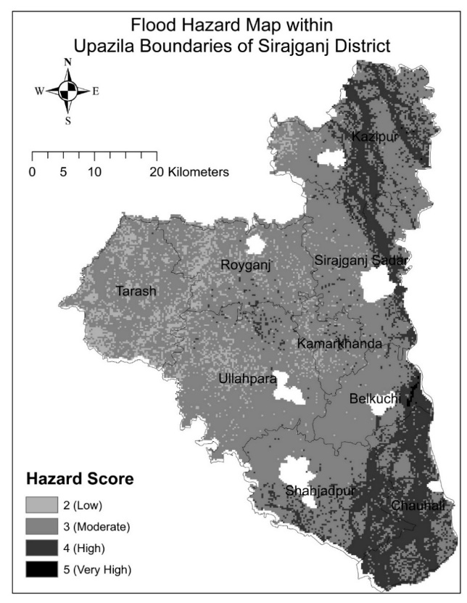
Figure 6: Flood Hazard of Sirajganj District

Lower Flood Hazard Areas
A few portions of the unions under the Tarash, Royganj, Ullapara, and Kamarkhanda are appeared to be low to very low level of intensity of flood hazard. In fact, no place exists in the district having a very low level of hazard, rather a wee bit of area of 9.6% of total belongs to a low level of intensity.
Hazard level from different views of Hazard factors
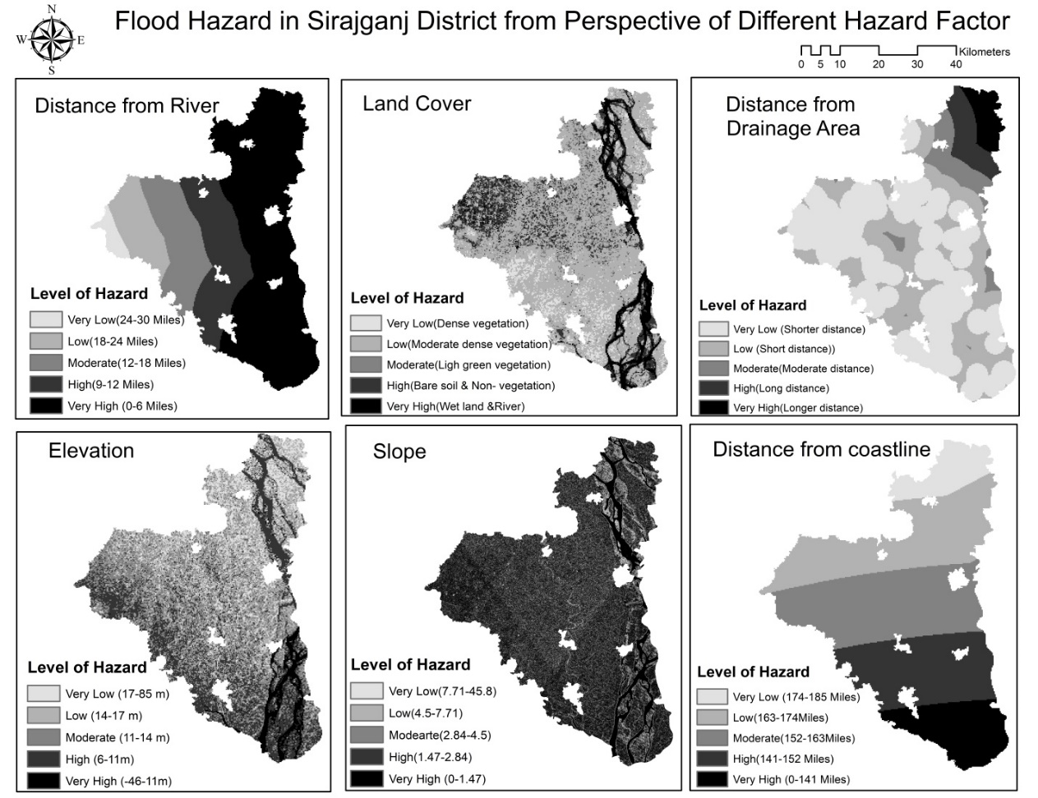
Figure 7: Hazard level from different views of Hazard factors

Different factor shows the variation of hazard score, in the same area. So, each point of our study area got six types of hazard scores in the context of these six factors. The area under Chauhali, Belkuchi, Sirajganj Sadar, and Kazipur Upazila hold a high to very high level of hazard intensity. From the aspect of distance from the river, the mentioned Upazilas got the score of five as the region located significantly closer (only six miles) to the river Jamuna. The area under Tarash Upazila obtains a 1 to 2 hazard score which is considerably less. But when the hazard is assessed in the context of land cover, it claims the most of the area within Chauhali, Kazipur, and Tarash Upazila is registered as a higher hazard zone compared to other areas due to less vegetation density. The area under Sahjadpur and Ullapara lies between lower to moderate hazard scores because of higher vegetation density than other regions in the Sirajganj district. In terms of elevation, a preeminent region within Chauhali Upazila and some regions within Kazipur Upazila, get a higher hazard score due to the lower altitude. Where most of the areas under Shahjadpur, Ullapara, and Tarash Upazila hold an average hazard score. Nevertheless, the maximum portion of the northern part of Sirajganj district shows a lower hazard score due to higher altitude. Most of the areas within Kazipur Upazila obtain a higher hazard score than other regions in the context of drainage area because the region under Kazipur Upazila has not sufficient drainage. But the other areas hold on to lower hazard scores due to the adequate amount of drainage channel. Coming to the factor slope, most of the areas in the district obtain a score of 3 to 4 which indicates moderate to high hazard due to lower slope value. A considerable portion within Chauhali and Kazipur Upazila gains the highest hazard value from this case. Because of the lower distance from the coastline compared to other regions, areas within Chauhali and Shahjadpur Upazila get the highest hazard.

3.3 Risk Assessment

Table 6: Area with Flood Risk Intensity at Upazila Level
Upazila | 'Very Low'  Area (%) | 'Low'  Area (%) | 'Moderate'  Area (%) | 'High'  Area (%) | 'Very High'  Area (%) | 'Total'  Area (%)
Belkuchi | 53.88 (2.22%) | 53.88 (2.22%) | 27.81 (1.14%) | 20.53 (0.85%) | 1.12 (0.05%) | 157.23 (6.47%)
Chauhali | 0.12 (0.01%) | 21.96 (0.90%) | 104.10 (4.28%) | 47.91 (1.97%) | 67.82 (2.79%) | 241.92 (9.96%)
Kamarkhanda | 13.25 (0.55%) | 83.56 (3.44%) | 1.68 (0.07%) | 0.00 (0%) | 0.00 (0%) | 98.50 (4.05%)
Kazipur | 10.89 (0.45%) | 113.49 (4.67%) | 139.94 (5.76%) | 97.62 (4.02%) | 0.12 (0.01%) | 362.06 (14.90%)
Royganj | 50.90 (2.09%) | 140.18 (5.77%) | 72.18 (2.97%) | 0.31 (0.01%) | 0.00 (0.0%) | 263.57 (10.85%)
Shahjadpur | 0.00 (0%) | 148.90 (6.13%) | 54.75 (2.25%) | 56.37 (2.32%) | 40.75 (1.68%) | 300.78 (12.38%)
Sirajganj S. | 74.91 (3.08%) | 127.43 (5.24%) | 61.60 (2.54%) | 32.54 (1.34%) | 0.00 (0.0%) | 296.48 (12.20%)
Tarash | 91.15 (3.75%) | 158.60 (6.53%) | 52.95 (2.18%) | 0.00 (0.0%) | 0.00 (0.0%) | 302.71 (12.46%)
Ullah para | 49.71 (2.05%) | 287.40 (11.83%) | 69.13 (2.85%) | 0.06 0.0%) | 0.00 (0.0%) | 406.30 (16.72%)
Total | 344.83 (14.19%) | 1135.41 (46.73%) | 584.13 (24.04%) | 255.35 (10.51%) | 109.82 (4.52%) | 2429.54  (100%)

High-Risk Region
A significant portion of the southern part of Sirajganj district (figure 8) is at higher risk of flooding. These regions are within some parts of Cauhali Upazila and some of Shahjadpur Upazila. Omarpur, Gharjan union under Chauhali Upazila, and Sanatani, Gala union under Shahapur Upazila fall within the very high-risk flood region. About 109.82 sq km of the total area of the district is in a very high-risk region. Besides the high-risk region such Kaijuri, Jalalpur under Shahjadpur and Khaspukuria, Bagutia and Sthal union under Chauhali Upazila have been seen in the high-risk region of flooding. Again, some areas besides the river and the north eastern parts of Sirajganj districts are also in the high-risk region. These regions are Belkuci and Baradhul under Belkuci upazila, Kaokhola, Mechara union under Sirajganj upazila, Subhagucha,Tekani, Nishcintapur, Gargarish, Khas Rajbari, Mansur Nogor union under Kazipur Upazila.
Moderate Risk region
Some north-eastern part of the district falls within moderate to high-risk flood region where the significant portion of south-east and southern part falls within the medium to high-risk region. About 584.13 sq km area, 24.04% of the district holds reasonable risk value. Kazipur Upazila has, on the maximum part of the moderate risk level. According to this findings, the second-highest of moderate risk areas fall within Cauhali Upazila, most of the areas within Cauhali Upazila are found to be in the medium to higher risk level of intensity.

Low-Risk Region
1480.24 sqkm area gains the risk more minor than the moderate level where most of the Sirajganj district's portion holds on low-risk value which is about 1135.41 sq.km which is 46.7% of the total area of the district, and 344.843 sq.km areas are appeared as very low-risk area. The mid-region and a significant portion of the whole western part of the Sirajganj district fall within the low-risk region for flooding. Most of the area of Bangabari and Rajapur union under Belkuci Upazila and Bahuli, Shialkul, Kalia Haripur under Sirajganj Sadar upazila are seemed to be very low risk areas. There are some shallow flood risk regions in the eastern part of the district as well.
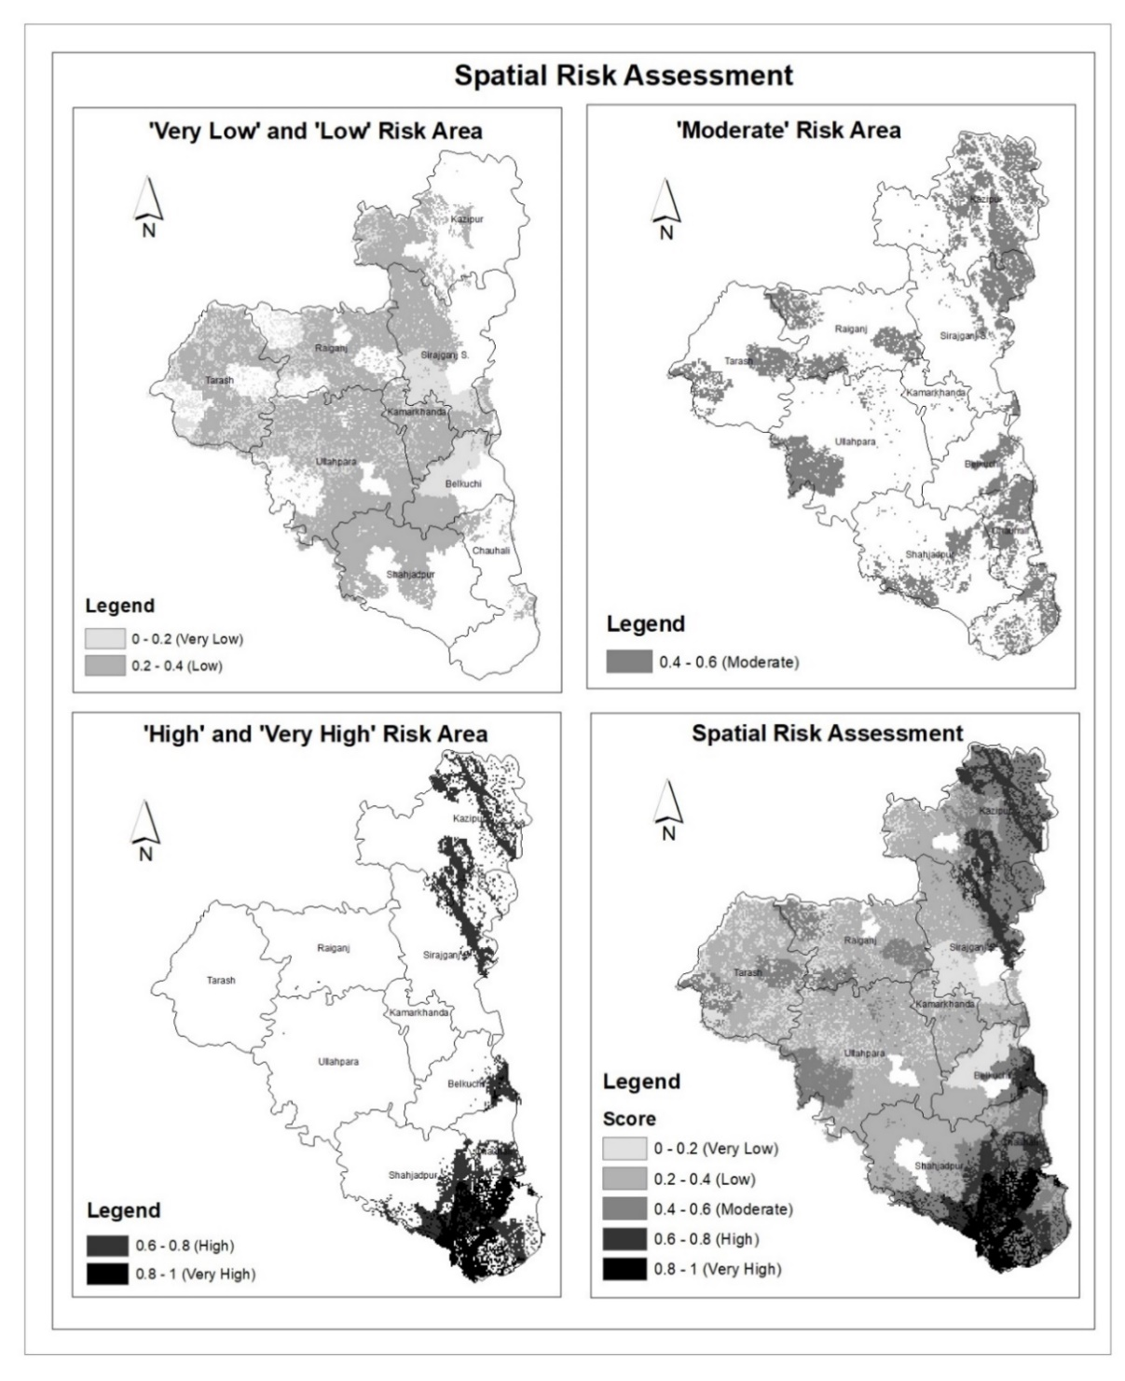
Figure 8: Spatial Risk Assessment at a different level of intensity

4. Discussion

Figure 9: Comparison among all three major components of SoVI at Upazila level

In the overall risk of the Sirajganj district, the physical and infrastructure component contributes most. ‘Percentage of katcha and jhupri housing structure', an indicator of the same component, has the highest impact on the overall socioeconomic vulnerability. The number of kacha/ jhupri housing has appeared to be higher in the District which decreases the coping capacity of the people during floods. Again the number of households without electricity connection is also higher in some Upazilas including Cauhali, Kazipur, Royganj. Lack of electricity keeps people deprived of several facilities which result in failure to cope with the situation during the disaster. The number of service and industry employment is lower in most of the Upazilas. Horseheads of service and industry employee is more economically capable to deal with the situation emerged during the flood and have more adaptive capacity than the agrarian people. Again the number of senior citizens is greater in the Upazila Kazipur, Royganj, Tarash, and Ullapara. People above 65 have lower mitigation and adaptive capacity to deal the flood risk management than younger people. The indicator katcha and jhupri housing, indicators affiliated to the employment sector, and the number of senior citizens are the major indicators to make the region vulnerable and increase the overall risk of the District.
The findings of the study demonstrate that the maximum area of Cauhali and Shahjadpur Upazila belong to 'high to very high level of risk where the maximum area of Kazipur belongs to 'high' risk region. Cauhali and Kazipur are highly vulnerable because of a large number of household with katcha and jhupri housing structures, lack of electricity, not having proper sanitation, greater affiliation with the agricultural sector, senior citizen, percentage of young children, and going with a lower number of employees in the industrial and service sector. On the other hand, Shahjadpur Upazila in the context of katcha and jhupri housing structure, percentage of employment in the industry, service, and agriculture sector has appeared to be highly vulnerable. The unions under Cauhali Upazila are in a threatenig situation from the physical infrastructure aspect, on the contrary, the economic component enhances the risk for the unions under Shahjadpur and Kazipur Upazila.
According to this study, the factors of flood hazard also influence the flood risk of Sirajganj district. From hazard analysis, the region near to the Jamuna river especially Cauhali and Kazipur upazila are mentioned as a high hazard area of flooding. The location of the Unions within these Upazilas have a greater impacts of the Jamuna river on enhancing the flood risk. The chances of the Fluvial flooding (River flood) occurs quickly in those regions due to the shorter distance from the Jamuna River. Fluvial flooding causes when the water level of river exceeds than the capacity due to heavy rainfall over longer period, the river water overflow to the surrounding closest region from the river. It results that the households specially Kacha and Jhupri Structure in the regions of closer distance from Jamuna river are highly vulnerable by damaging their house, properties and service facilities in their livelihood due to fluvial and rainfall flooding. Lack of drainage channels and lower elevation also added the hazard to increase duration of flooding over the extended period in the Shahjadpur Upazila. Moreover, Lower slope of these high risk regions influence to downstream the water to the low lying region Cauhali and Kazipur upazila . Moreover the less vegetation density hinders the water absorptive capacity of the earth surface and these factors also become responsible to contain the water over long period and make those regions a high risk area of flooding.

5. Conclusion
This study assessed the spatial extention of flood risk in Sirajganj district based on socioeconomic vulnerability and flood hazard. We see many of similar work in the country like Bangladesh, though most of them are in the context of climatic disaster in the coastal regions. And we often see methods like indexing, site suitability analysis and many like these. But integrating both of these to give a new dimension in making a roubst approach to risk assessment, especially flood risk, we do not see too many in Bangladesh. Besides a wide use of GIS and remote sensing data here reminds us about its ample oppurtunity in application in the field like these.
Unions and Upazilas adjacent to or nearby the river appeared to be at more risk relative to others. Economic component and physical and infrastructure component contribute most to socioeconomic vulnerability. The higher number of kacha jhupri housing structure noticably results in physical vulnerablity whereas lower number of employment in service and industry sector contributes most in economic vulnerablity. The shorter distance from jamuna river, lower elevation and lack of drainage facilities are the major factors that enhance the threats of high hazard and the ultimate risk.
The implication of the study is effective for the policymakers to identify the high flood risk region and the regions which are in highly need of proper flood risk management. Authority will be able to bring government assistance, subsidies or aid as well.
Besides so many goods happened in this study, there have some limitations also. Relative to the data used for hazard assessment, data for SoVI is much older. The data of socioeconomic vulnerability index is from the year 2011, as the census are held at the regular interval of ten years, so no way of getting latest data before 2021. It is understandable when unit of analysis is union, there is no way but depending on secondary data for conducting such work.
This study always gives a way of doing things with more latest data, and thus, changes can be well percieved with the statistical evidendence, evaluation and validation.

6. References

Alexander, D. (2000). Confronting Catastrophe- New Perspectives on Natural Disasters. Oxford University Press, 282.
Bangladesh Population and Housing Census 2011. (2014, August). Retrieved from Bangladesh Bureau of Statistics: http://www.bbs.gov.bd/
Barua, U., Akhter, M. S., & Ansary, M. A. (2016). District-wise multi-hazard zoning of Bangladesh. Natural Hazards. 82, pp. 1895–1918. Retrieved from Nat Hazards. 82: https://doi.org/10.1007/s11069-016-2276-2
Feloni, E., Mousadis, I., & Baltas, E. (2019). Flood vulnerability assessment using a GIS‐based multi‐criteria approach—The case of Attica region. Flood Risk Management.
Gain, A. K., Mojtahed, V., Biscaro, C., Balbi, S., & Giupponi, C. (2015). An integrated approach of flood risk assessment in the eastern part of Dhaka City. Natural Hazards. 79, pp. 1499-1530.
Ha-Mim, N. M., Hossain, M. Z., Rahaman, K. R., & Mallick, B. (July 2020). Exploring Vulnerability–Resilience–Livelihood Nexus in the Face of Climate Change: A Multi-Criteria Analysis for Mongla, Bangladesh. MDPI, 7-8.
Hoque, M. A.-A., Pradhan, B., Ahmed, N., & Roy, S. (2019, July). Tropical cyclone risk assessment using geospatial techniques for the eastern coastal region of Bangladesh. ELSEVIER, 12-19.
Islam, M., & Sado, K. (2000, February 22). Flood hazard assessment in Bangladesh using NOAA AVHRR data with geographical information system. 605-620.
John Twigg. (2004). Disaster Risk Reduction: Mitigation and Preparedness in Development and Emergency Programming.
Mondal, M., Murayama, T., & Nishikizawa, S. (2020). Assessing the flood risk of riverine households: A case study from the right bank of the Teesta River, Bangladesh. International Journal of Disaster Risk Reduction .
Mudasser, M., Hossain, M. Z., Rahaman, K. R., & Ha-Mim, N. M. (September 2020). Investigating the Climate-Induced Livelihood Vulnerability Index in Coastal Areas of Bangladesh. MDPI, 155-156.
Ouma, Y. O., & Tateishi, R. (2014). Urban Flood Vulnerability and Risk Mapping Using Integrated Multi-Parametric AHP and GIS. Methodological Overview and Case Study Assessment, 1515-1545.
Ozcan, O., & Musaoglu, N. (2010). Vulnerability Analysis of Floods in Urban Areas Using Remote Sensing and GIS. Remote Sensing for Science, Education,and Natural and Cultural Heritage.
Rahman, M., Ningsheng, C., Islam, M. M., Dewan, A., Iqbal, J., Washakh, R. M., & Shufeng, T. (2019). Flood Susceptibility Assessment in Bangladesh Using Machine Learning and Multi-criteria Decision Analysis. Springer.
Rahmati, O., Zeinivand, H., & Besharat, M. (2015, May 19). Flood hazard zoning in Yasooj region, Iran, using GIS and multi-criteria decision analysis. Taylor & Francis, 1000-1017.
Ran, J., MacGillivray, B. H., Gong, Y., & Hales, T. C. (2019). The application of frameworks for measuring social vulnerability and resilience to geophysical hazards within developing countries: A systematic review and narrative synthesis. Science of The Total Environment.
Rufat, S., Tate, E., Burton, C. G., & Maroof, A. S. (2015). Social vulnerability to floods: Review of case studies and implications for measurement. International Journal of Disaster Risk Reduction, 470–486.
Sahana, M., Rehman, S., Paul, A. K., & Sajjad, H. (2019). Assessing socio-economic vulnerability to climate change-induced disasters: evidence from Sundarban Biosphere Reserve, India. Geology, Ecology, and Landscapes, 40-52.

