Environmental and livelihood assessment of handmade clay tiles from Kolaroa Upazila for sustainable development
Sk. Kabir Ahmed¹, Md. Noor Un Nabi², Fatema Tuj Zohora³, Imran Hossain Foishal⁴*, Rumana Asad⁵, Farzana Akter⁶
¹ Associate professor, Architecture Discipline, Khulna University, Khulna-9208, Bangladesh, Email: kahmed_ku@yahoo.com;
² Professor, Business Administration Discipline, Khulna University, Khulna-9208, Bangladesh, Email: nnabi.m@ku.ac.bd;
³ Business Administration Discipline, Khulna University, Khulna-9208, Bangladesh, Email: fatematujzohora16@gmail.com ;
⁴ Assistant Professor, Architecture Discipline, Khulna University, Khulna-9208, Bangladesh, Email: imranhossain@ku.ac.bd;
⁵ Associate professor, Architecture Discipline, Khulna University, Khulna-9208, Bangladesh, Email: ria_arch@yahoo.com;
⁶ Business Administration Discipline, North Western University, Khulna-9208, Bangladesh, Email: farzana.sept@gmail.com;
*Corresponding Author Email: imranhossain@ku.ac.bd

Abstract
Handmade clay tiles from the south-western part of Bangladesh initially found a new market in the European construction industry. Traditional pottery product has been integrated into the global construction industry with few local entrepreneurs and agents. This international integration has produced an immediate standard set of economic and social outcomes in the form of increased income, reduced migration, and reduced decay of the culture of the potter communities. Recently, the development of more durable and cheaper mass-produced alternatives to traditional potteries has pushed the traditional pottery industry, the livelihood, and the potter communities' cultures almost to the brink of extinction the potters of Bangladesh. This research aims to assess the environmental and livelihood aspect of the export-oriented handmade clay tiles of Kolaroa Upazila its significance in local economic development. For this purpose, the economic and social contributions of clay tiles toward the livelihood of the potter communities have been analysed and in contrast environmental issues of this industry are highlighted. The results of this study explore the upgrading aspects for the sustainable development of the handmade clay tiles industry.
Keywords: Handmade Clay Tiles, Livelihood, Sustainable Development, Local Economic Development.

Research Background
In recent times, a radical transformation in the world’s economy has been observed due to the development of science and technology and rapid urbanization. Neo-liberalization fueled globalization has encouraged the rapid development of mass production of commodities and services and the emergence of mass markets all over the world. The living and occupations of culturally and socially distinct groups are threatened by such devouring nature of globalization. On the other hand, globalization has facilitated the emergence of niche markets around the world for many products and services from artisans and craftsmen. Handmade clay tile is such kind of product of Bangladesh which industry was first developed in Muralikati Palpara area in Kolaroa Upazila of Satkhira. It was founded by Rafael Aldo, an Italian citizen. He started to export this indigenous product to Italy. At first, there were six tiles’ factories. The owners of the factories had expanded their business by exporting tallies to Italy. That is why; the area took the name, 'Italy City'. The products here had captured largely the markets of Italy, Portugal, Korea, UK and the USA. With the rise in the demand of those, clay-made tiles factories grew in the district in an increasing number day by day. Now there are 50 factories in the district which employ 5,000 people. Expansion of this sector has initially contributed positively to the upgrading of the livelihood of the potter communities not only through increasing their income but also by preserving their cultural heritage and traditions. But at present, it has plummeted to a dreary state of the business from its past glory for various reasons. The arrival of inexpensive, durable, and user-friendly mass-produced substitutes has pushed the traditional clay tiles industry to the brink of extinction. Including lack of government patronization, non-availability of loans on the easy term, non-cooperation from the authorities in creating market abroad, want of modern machinery and increased production cost is also among the reasons to be blamed for the setback the industry is facing. Most of the clay-made terracotta tiles factories in Muralikati, Srirampur and Mirzapur areas in Kolaroa Upazila are facing closure for the abovementioned reasons. Sub sequentially; it leads to the disappearance of the potter communities and their cultures and badly affects their livelihood. As a result, sustainable development is facing numerous obstructions.
Sustainability focuses more on intergenerational justice and the pursuit of a combination of economic and environmental efficiency. The necessity to sustain economic growth and progress while protecting the environment is strengthened by this. The objective of the concept of sustainability in development is to develop the economy in a manner that produces quality employment without damaging the environment and thus eliminating poverty and injustice (Anne & Mason, 2009).
The most difficult aspect of this process is that the main role they play in pursuing sustainable policies varies in terms of variation in business and their role(Kamali & Hewage, 2017). The sector must also address the natural, economic and social facets of sustainability in accordance with the three foundations of sustainability.
- Indices of environmental sustainability (Singhal, et al., 2004): Consumption of energy, global warming, human toxicity, air pollution, loss of ozone, depletion of resources, etc.
- Indices of economic performance (Pissourios, 2013): sales revenues, added value, gross operating profit and financial position, etc.
- Indices of social status (Del Mar Alonso, Llach, & Marimon, 2014): Community involvement, access to resources, social responsibility, fair pay, working hours and so on.
The word 'sustainable livelihood' applies to a broad range of topics addressing the discussion of poverty-environment ties. Sustainable livelihood definitions are usually ambiguous, inconsistent, and very limited. (Carswell, 1997). Scholars describe this without a clarification: a livelihood consists of the power, assets (including both material and social resources) and the activities needed for livelihoods (Conway., 1985). Another focus on livelihoods is integrating labour and employment problems, poverty reduction with broader topics of adequacy, protection, health, and power. Some of the elements introduce the component of sustainable development on the durability of livelihoods and the foundation of natural resources. One of the main livelihood facets is employment.
In the framework of DFID’s sustainable livelihood, some core dimensions need to be taken care of: 1)Leveraging the potentials of the communities and increasing their capacity and skillsets to manage their livelihood successfully, 2) ensuring that the people don't hurt other people's livelihood, 3) maintaining the linkage between the macro and micro factors to ensure the full potential of sustainable: addressing and taking into account the macro-economic issues like GDP growth, inflation, government interventions in changing the life scenario of people at the micro-level. One of the important dimensions of the sustainable livelihood approach is the focus on poverty alleviation. To serve this purpose, the risk mitigation capacity of the households is given utmost priority to cope up with environmental, natural, and economic hazards such as cyclones, floods, earthquakes, and economic recession. In a bid to facilitate livelihood, a coordinated effort is required between the public and private sectors so that the people can gain necessary resources such as human capital, social capital, and financial capital. Moreover, the emphasis is increasingly given on increasing the institutional capacity and reforms of institutional processes to bring a culture of inclusive development for improving sustainable livelihood options. Various livelihood frameworks have been built behind this theory as stated above, of which DFID's Sustainable Livelihoods System (SLF) remains influential, and the most widely-used and conceptually advanced(Pain, 2003).

Objectives and Scope
- To assess the level of community participation and the socio-economic sustainability of the handmade clay tiles industry.
- To analysis the environmental issues of the local clay industry for sustainable development
- To explore an inclusive community-level local economic development framework.
Evaluate the economic, environmental, community-level, social, technological sustainability and explore the upgrading aspects of the handmade clay tiles industry.

Methodology
This study is a qualitative exploratory research based on an ethnographic approach. Ethnography is the systematic study of people in a community where the researcher examines society from the point of view of the subject (Jones & Smith, 2017).To be acquainted with the intense perception of the communal environment persuaded by their means of livelihood, i.e., ‘clay tiles market’, an ethnographic study was conducted which requires rich and thick understanding and insights. Two-phased field work was conducted for gathering information and data for the realization of the research objectives. Field work was conducted in the in the Kolaroa Upazila in the location where the handmade clay tile markers and related communities are located. They include artisanal craft workers, other workers, suppliers, and community members and leaders in the locations where the clay tile making activities take place. In the first phase of the fieldwork, 08 Key Informant Interviews (KII) was conducted with the clay tiles markers. Snowball approach was followed in order to locate and include the respondents. In-depth interview techniques were applied along with an interview guide developed for interviewing the particular group. Interviews were recorded with the respondent’s preapproval. The records were transcribed and content analysis was performed. 08 KIIs were performed for including the artisanal worker and suppliers relating to clay tiles making.07 KIIs were performed with the other kind of workers and suppliers associated with clay tiles making. 04 KIIs were performed with community and industry leaders. In determining the number and length of KISS principle of theoretical (data) saturation was followed. Data saturation is a point when new information stops coming and additional respondents keep revealing repetition of the information that appeared in the previous interviews. Vasileiou et al. (2018) identified saturation as the most suggested justification for smaller sample size in qualitative research (Braun and Clarke, 2021). Each of the interviews from the different groups was recorded, transcribed, and used for a content analysis. In the second phase of the fieldwork two validation meetings were conducted with the representative of the different groups included in the interviews in the first phase. Each of such meetings was participated by 05 representatives from the 03 groups interviewed. Based on the outcomes of the validation meetings findings of the content analysis were reviewed before arriving at the final findings of this study.

Results and Discussions
The development of new products is described as the transformation of business demand and a collection of product technology assumptions into a product available for sale (Buyukozkan & Feyzioglu, 2004). It is an interdisciplinary method that involves nearly all the roles of an organization to be involved, from product design to marketing (Haque, 2000). As a result, industries can receive a product or service that is new to the business, new to the market (in this situation, it may be called a revolutionary innovation), or a massive improvement (an improvement of an existing good either in the firm or in the market, i.e., incremental innovation). The correspondence between concepts such as product development process and product invention process (BUIJS, 2008) are two strong examples of the reciprocal dependency between NPD and innovation. In nature, they are intangible and immutable, and the advantages are commonly gained in the long term (Beugelsdijk, 2009). The aspect that might help explain these systems, from our point of view, is complexity (Emmanuelides, 1993). The product characteristics, consumer preferences, niche market characteristics, promotion mechanisms, etc. are all undefined aspects of NPD processes. In clay tiles manufacturing, it was made only for local bases. The situation is shifted and discovered its commercial potential to sell. So, the basic new product development process includes opportunity identification, design and development, testing, introduction to the market, product life cycle management (Matheson, 1998). The manufacturing of clay tiles is continued to produce as the foreign consumer demand. It is now manufactured for the architecture firm, household owner, building company, in the development process, testing the international market with clay roofing tiles, environmentally friendly certification product testing. In the Consumer Market, the major inputs of materials are clay, water, and fuels manufactured using grid electricity. To have an overall conception of the procedure it can be stated in eight stages at large starting from the collection of soil and other raw materials up to the categorizing and packaging of the finished products (Figure 01).
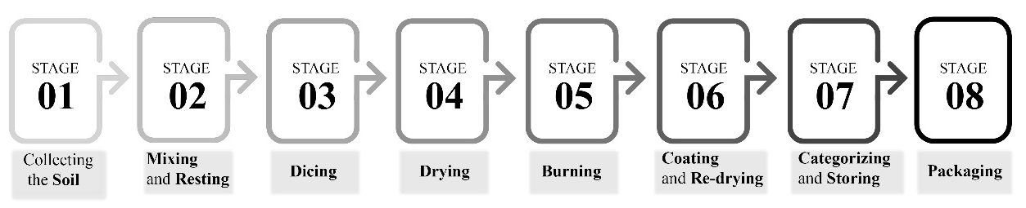
Figure 1: Eight stages process of handmade tiles production, Source: Authors Own Compilation
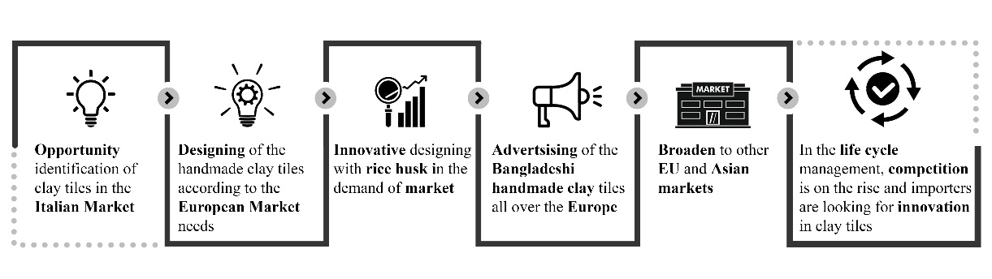
Figure 2: Tiles Product Development Process, Source: Authors Own Compilation
For the traditional production method of clay tile, the main raw material, clay or soil, was collected by digging suitable clay accessible land and transported to the factory. In comparison, more power was used traditionally because of the less productive rise of the system and the behaviour of the workers towards saving energy. The modern process is an advanced, sustainable and partly integrated process where more emphasis has been paid to energy-saving initiatives. In addition to the pre-processing phase, all the other phases are identical in the two clay tile systems and market product development is interminable. Clay roofing tiles have become one of the prominent industrial products over time. It has also developed phase by phase by retaining its core benefits. It is considered the most common roofing method due to its resilience, aesthetic appearance, and ease of maintenance. When the indigenous clay tiles tend to export to the foreign market, they passed some of the phases of NPD process (Figure 02). A one-time product innovation took place, and clay tiles become more and more popular to the foreign market. Export-oriented clay tiles product development has some distinct stages that can easily be understandable from the above framework.
In this clay tiles industry, a large number of the stakeholders and the Kolaroa community are entangled. These studies indicate that the value chain "farm to fork" can be understood as a "practice landscape" (Wenger, 2006; Wenger et al., 2015). Individual practice groups that exist within the various partners and organizations should be put together. Inside each practice group, main players may help foster linkages with the value chain landscape. Another practice group is among government ministries, academics, project officers, and policy advisors. Regarding their participation in the value chain, each of these groups of experience has its competencies and value effects. Work communities provide a framework for scaling- up interactivity, including teamwork, trust, along with the entire practice environment of the value chain (Figure 03). In this way, groups in practice are an essential source of social stability that can make policies for value chains more resilient to governance feasible (Folke, 2005).According to scholars’ organizations should start to understand that practice groups should be "leveraged to benefit community membership and the organization as a whole" (Lesser, 2001). Practice groups can be a valuable mechanism to improve the stability of diverse, multi-sector value chains by facilitating learning, creativity and adaptation (Reinmoeller, 2005). To create social capital and contribute to creativity and sustainability in the value chains, cultures of practice must, therefore, be actively supported (Hearn, 2009). First, participants should be in equitable involved, consistent collaboration, setting shared agendas, effective leadership. Participating in structured and informal social interactions is act as an essential supporting factor in terms of establishing successful interpersonal relationships. There is a clear consensus from participants that when making decisions, both stakeholders must be present. Around the same time, though, it has been recognized as necessary to have leaders that can inspire people to come together and facilitate partnerships with other communities. Good communication is described as essential, based on fairness and respect, especially when maintaining relationships with a diverse community of people. Clay tiles participants have described common interests as key to communicating effectively. This is defined in terms of a "collective concept" or "common ground." In addition to defining shared aims, the sense was that there would be reciprocal gains for all involved to realize these goals more precisely, there will be a negotiation between participants as cultures of experience comes together in an environment on how their expertise in a given group is relevant (Wenger et al., 2015). For starters, government managers are responsible for establishing municipal policies and practices and distributing budgets in the clay tiles value chain. In Kolaroa there’s not only one community “pal” lives an engaged rather than many people live here and actively work in the clay tiles factories. Some of the people who live in Kolaroa work actively in the value chain; again some of the people are stakeholders in this industry. So the Kolaroa community has the active partners /stakeholders as well as the key participants in the value chain (Table 1).
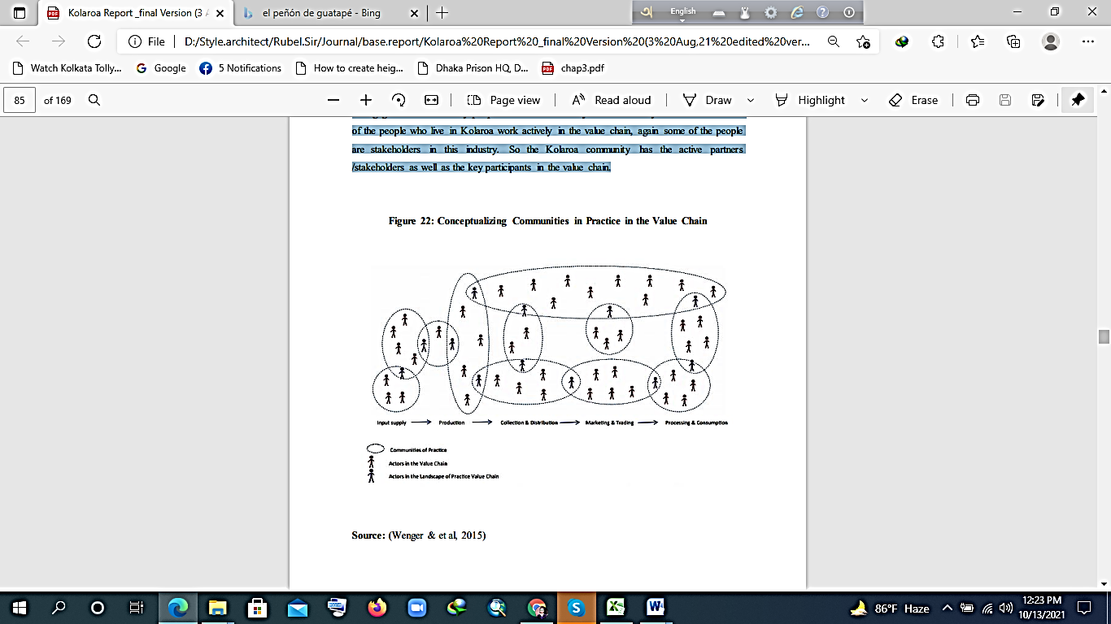
Figure 3: Conceptualizing Communities in Practice in the Value Chain, Source: (Wenger et al., 2015)
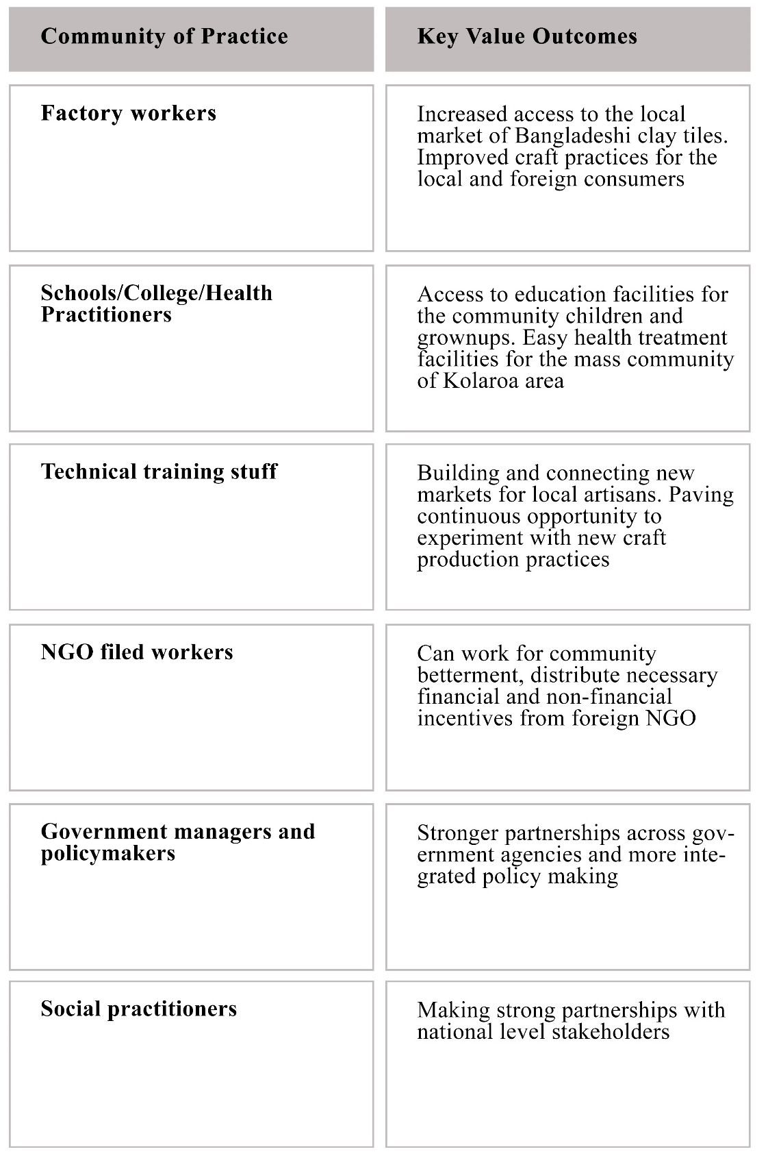
Table 1: Expected communities in practice a key-value outcome, Source: Field Research

Economic Sustainability Assessment of handmade Clay Tiles

Cost analysis of handmade clay tiles:

The success of a value chain is largely evaluated by the economic impact it makes. This is the primary concern of a business to be economically profitable for sustaining. The economic aspects of the export-oriented clay tiles value chain are elaborated in this section. Economic analysis is to determine the value-addition of the clay tiles chain. This section analyses the volume and value of export market demand of the clay tiles from the beginning to current position. The calculation is based on the sales price and the volume sold. The price of individual materials to manufacture a single clay tile is almost equal to the selling price. Thus, the manufacturers are at a loss with the business. The absence of a definite law of price-fixing seems to be the major problem for this issue. The overall manufacturing cost per tile though depends on it’s size and detail, on average ranges from 6 to 7 tk for a plain tile measuring 1 square feet during 2000-2010. This business value chain is entirely private while initiated and owned by the

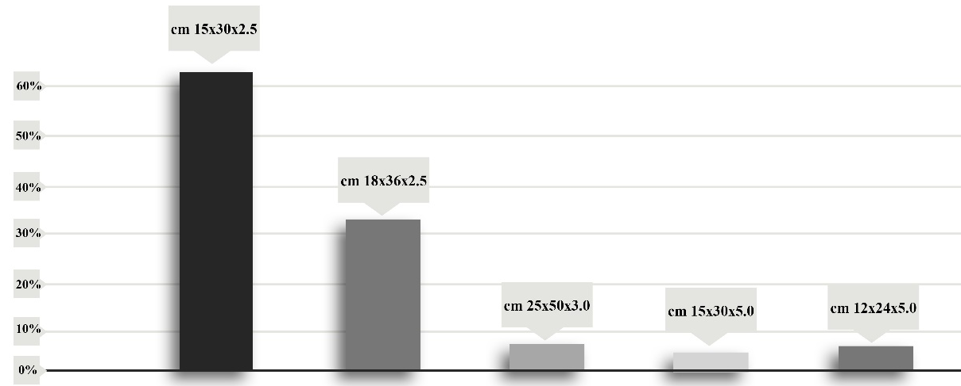
Figure 4: Market Demand of Clay Tiles According to Size: Source: Field Research

manufacturers at large. The clay tiles are generally exported in Dubai, Italy, England, and the USA, Portugal, Korea and many of the European countries. The amount of export is about 12-15 containers for one manufacturer annually. The importers often use to provide specifications of the detailed design for the tiles. The price of the product also varies with the level of detail. The more it is designed the price is higher. Also, the price depends on the finishing of the tiles being a raw or polished one. The never-ending competition to rule the market is what leads the price declination. Since they lack definite regulation on their business, to convince the buyers the easiest way was to lower the price compared to other sellers. This comparison is consequently dwindled the graph. The manufacturing cost includes costing throughout the entire process starting from the collection of soil from the field up to the packaging of tiles at the port. All the material costs, the transport and labour cost together are summed up to determine the average manufacturing cost of the tile. This detailing is demonstrated in the table 02 and shows the cost of per container. In table 03, the clay tiles manufacturing upstream value chain cost is demonstrated which includes packaging to export cost. The table 4 shows the popular sizes of five types of clay tiles. Per container consists of average 10000-15000 piece. If the size increases the pieces of clay tiles in the container decrease. Market demand is also varied according to the size of tiles. Maximum demand (60%) is found for 15cm X 30cm X2.5cm tiles (figure 04).

Raw Material | Overall Cost per container
Clay (per trolly) | 260 -300 Tk
Labor, Water | 400 - 600 Tk
Dicing and Drying yard | 400 - 600 Tk
Warehousing pre fire | 400 - 600 Tk
Pon (4 person for each pon) | 1500 Tk/person,( 8000 – 10000 Total)

Table 2: The Manufacturing Cost Detail of the Upstream Level of Export-Oriented Clay Tiles; Source: Field Research

Phases | Cost
QC (quality control) for per Container | 4000 Tk
Packing, loading and port charge | 170000 - 200000 Tk
Per container shipping cost | 55000 - 70000Tk

Table 3: The Manufacturing Cost Detail of the Downstream Level of Export-Oriented Clay Tiles; Source: Field Research

Size | Pieces In Container | Per Piece Cost
cm 15 x 30x2.5 | 15000 pc | 6 Tk
cm 18X36X2.5 | 10000 pc | 10 Tk
cm 25X50x3.0 | 4200 pc | 40 Tk
cm 15x30X5.0 | 7500 pc | 12 Tk
cm 12x24x5.0 | 13500 pc | 15 Tk

Table 4: The Manufacturing Cost (Per Piece, Size and Container); Source: Field Research

In the foreign market 2 to 3 types of sizes sell in a bulk manner in the last 2 years (2018-2020) almost 150-200 containers sold in Italy. It generally covers approximately 95% of finished clay tiles after 2010, the industry began to collapse due to discords of the factory owners and uneven competition in the business. Noticing a downtrend in the quality of the products, foreign buyers have been losing interest in buying the tiles, causing a rapid fall in their prices. Now a piece of clay tile is being sold at Tk8-Tk10 against the previous price of Tk 60. Besides, the production cost of the tiles has also become much higher than the past. The revenue from the industry has fallen to Tk 7-8 crore. The factory owners have to count heavy losses due to the sharp fall in the prices of their products (Figure 05).
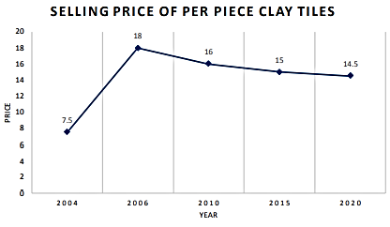
Figure 05: Selling Price Index from 2004-2020; Source: Field Research

Employment Opportunity:
There is a huge employment opportunity in this sector since it incorporates a large number of labourers in all of the manufacturing stages (Table 5). Both the male and female can equally contribute to this sector serving as a prominent employment opportunity in the rural area of its origin. The fund for the manufacturing is entirely personal, sometimes assisted by bank loans, but no evidence of any economic supplement from any non-profit organization or welfare association is spotted yet. The clay tiles production is mostly the core livelihood option for the folks, yet for the decline in the demand. The manufacturers are thinking to shift their business.
Category of employment | Approximate Income per person (BDT)
Labour for Collecting of clay from Canal, Gher and Pukur | 400-600tk (per day)
Labour for Water supply | 400-600tk (per day)
Labour for Dicing | 500-600tk (per day)
Labour for drying | 500-600tk (per day)
Labour for making firewood for burning of tiles | 1500tk per day
Labour for Packaging | 5500-7000tk per container
Personnel for QC | 4000tk per container

Table 5: Employment Generation in Every Phase of Clay Tiles Manufacturing; Source: Field Research

In most cases, they are taking agricultural and poultry farming as the other livelihood options. For the entire process lots of man power is needed. The scenario is not like that the uneducated people work for this clay manufacturing chain the educated youth simultaneously work here to earn. Many of the college and university-going youths work hereon a part-time basis.There are about 3 people from each family of that area who have been involved in this process averagely instead of the very limited opportunity of savings. The cost detailing reflects clearly that the manufacturing and selling cost is almost the same. It leaves no room for savings and further opportunity for investment. Though, there is almost no discrimination of wages except some exceptions, among the male and female workers. They are paid on basis of hours of work. A good number of workers take advance money to work whole season in the factories. They almost take 40 to 50 thousand tk individually with no documented contract. Their verbal agreement is that the factory owner would cut a small, fixed amount of money every month from their monthly wages. The employment rate has been drastically declined in the last 5 years since a huge of manufacturers left the business. That is why the advance payment systems are increased. Most of the manufacturers are seasonal nowadays; the main driver is the price declination as well as the decrement of market demand. The lack of initiatives for promoting the business by both government and non-government profit originations are catalysing the process. A pool of growth and opportunities for employment creation, this industry requires impulsive attention.

Social Sustainability Assessment of Handmade Clay Tiles
The social aspects are indispensable for the sustainable development of the export clay tiles value chain. Almost 15-manufacturerare associated with this field at present. More than 60% belong to the local community and almost 40% community is from outside the Kolaroa. There is mutual sharing, as well as livelihood similarity, results in the formation of compact social clusters. In fact, they possess some vivid sense of belongingness both to the community and the profession. Some other groups, else ways, have started manufacturing the handmade clay tiles nowadays. Along with the Paul community there are also some different communities in the industry. There is an association of the factory owners; it doesn't work effectively at all. Moreover, some political influences are affecting the regular circumstances of the export chain. In this regard. Gost Chandra Paul, one of the prominent exporters of clay tiles said,
"Since the past two years I have been thinking of closure my business. What is the use of it, if I cannot sell my products just because of the no regulation of the price and intense completion on the abroad? And now, they (the political newcomers) are forcing that, no one can buy any tiles until their products are sold out completely."
One of the clay tiles factory owners Bhutto said the middleman keep clotted the money which the owners paid advanced for selling the products to abroad. He also added “several times the agent clotted the money and we have nothing to do. They placed order but didn’t pay the fullest money of the products”. One of the factory owners Hasan said “the employers work here mostly take their advanced wages for 6 months. They almost take 40000/50000 tk in advance and cut a minimal amount from their monthly salary. We are bound to accept their condition because the regular employers have shortage here.” The common social restrain according to the community is that they do not share any common regulation, the fixed figure of valuation and goodwill. As a result, there remains a constant hidden war of price bargain and growing consensus for want of the buyer group. Which lead to the incessant declination in the price of tiles, in return shattering the entire business. This can be figured out as the most important agent to dismantle the kinship. They don’t speak up among themselves for fixation of the value. The whole community is suffering from the continuation of its ascendancy. The demographic ratio of male and female members among the workers can be denoted as 6:4 on average. Though the male is still considered to be more efficient to the manufacturer and male children are assumed to be a social asset. In risky works like burning the tiles in the furnace, layering the tiles for burning etc. the dominance of the male workers is prominent. However, women are assigned for the detailing of the tiles, dicing, inspecting etc. detailing works. These shares a great percentage of the overall livelihood means for a family. The Handmade Clay tiles industry plays a great role in women's empowerment in the Kolaroa area. And there is no discrimination in the wages for different genders. As the spatial pattern allows the overlapping of the domestic and manufacturing arena thus it's easier for the women to work simultaneously for the income as a whole family and the business as well. Women in the clay value chain engage a greater role in the development. The physical requirements may not compare with that of the male workers, as many of the tasks in the clay tiles manufacturing process is hard, heavy and ponderous. The intricate and detailed works of ornamentation of the clay-tiles with desired patterns and designs are substantially controlled by the women group. In fact, this can be enormously used to positively catalyse the development of this business. Also, teens are sometimes seemed to help the parents, though that is nothing vulnerable. Some of the college and university going boys work in the clay tiles value chain. Some of them work as the soil labour for cutting the soil in shape, most of the boys work in the port area from sorting, packaging to shipping. Thus, the industry is so inclusive in sense of engaging all the people of the family or community irrespective of age or sex. This is one of the key drivers of the continuation of this industry for ages. One of the colleges going students Faruq said, “clay tiles factory gives us a source of extra income, we can earn almost 500/1000 in a day. We start working from the early morning to mid of the day then we can go to our college easily”. So the clay tiles industry is not only confined to the Kolaroa area’s community and also not its employers are confined into uneducated person. The employment scenario is changing here.

Working Condition:
The working conditions of the labour are somehow risky and unhealthy. The Furnace they use to burn the clay tiles is operated fully through a manual process and at a very high temperature of about (1000-1200) o C. Moreover, they devoid of any safety measure as it’s completely on their own, prevailing as a domestic. The lineage for ages. Also working a long time with clay and water without any protective measures make them vulnerable to water and skin-related diseases. However, apart from physical wellbeing, the mental wellbeing of the workers is often negotiated. As the mental satisfaction of the workers considerably depend on the fulfillment of their livelihood, that is the wages they earn; most of the time it turns out to be insufficient and affects the productivity of the work in return. This leads to the shift of their occupation into other sectors like agriculture, daily workers, and migration to cities for retaining their livelihood. Nonetheless, the working environment is quite inclusive and friendly which keeps the workers motivated for the laborious works day long. On another note, there is not enough space for the safe circulation of the worker along with the heavy loads they bear manually as well as there is not enough protection or measure for the workers from any natural or sudden hazard like a storm, rain, firing etc. The lack of a proper prototype of the manufacturing stages, incompetent storage, cumbersome drying and burning process are all that affect the workers' well-being. Though the manufacturing workflow can be made smoothers with proper functional positioning of units like (furnace, storage, smash pit) etc. The ‘Kolaroa Clay Tiles Association' though founded for the betterment and cooperation of all the manufacturers of the business, but is completely ineffective at present .The head of the association himself said, "It is of no use today, I am just the chairman in the name. People are not cooperative." There is no collective control in price determination. As well as there are no complaints mechanism through which they can discuss their needs and demands to facilitate the solution. They have no collective law & regulations, neither have they covered a platform to share the knowledge and experience regarding their business with the community workers. There is massive deleterious competitiveness among them that, they don't even speak out about their chain of exporters. A key informant, 'Tapas Chandra Paul' one of the prominent manufacturers and exporters to the Italy zone has said, "There are lot of techniques to burn the tiles perfectly, with almost 0% wastage. None other than me in this community knows that and I don't want to share either. So far I am here I want to be the dominant." Although, no trace of child labor is observed, but they engage themselves in the work from around the teenage, whichis also unsuited for them. The educational quality of the children both informal and ancestral forms portray stagnancy which can be alarming in the long run.

Impact on Surrounding Communities:
The impact of the clay tiles value chain on the surrounding communities is noticeable as well as the intra-community effect. The risk of potential conflict among the political disparity is a significant issue for the regression of this business. Not only the factory owners but also the intra exporter discrepancy is worsening the scenario. Though the factory owners have no unity in themselves in regards to political influence, they are weak, which is leading to their bureaucratic suppression. The basic rights like health, education, condition of housing is negotiated and cannot be fully supplemented by the livelihood they earn. Nonetheless, the right properties of the surrounding communities are not affected by any fact of the actors of the clay tiles value chain. This export clay tiles business is both a means of income generation is and culture of the area. Most adverse impact of the clay tiles industry is the agents’ diplomacy. This tends to extinct the interest of the factory owners. The agents continuously do discrepancy and being traitor for taking the factory owners products and do not pay them their money. One of the factory owners, Mr Azad said “I am owing about 20 lakhs to 30 lakhs tk is from each of the agents.” he added that not only he is owning from the agent’s maximum factory owners are owning the same kind of amount from the agents who buys their product and works as middleman to sell directly to the abroad”. This is a current state of the clay tiles factory owners’ community, which is letting the entire system in a way of destruction. Hence the factory owners money is stuck in the market here they cannot make profit. In the other hand the workers are taking money advance, so a good amount of money also stuck in the hand of the workers. Ultimately the factory owners are now at a stage of demolished. There is no regularity body so the whole community is at stake.

Livelihood Sustainability Status of the Communities Involved in Export Oriented Clay Tiles in Kolaroa Upazila:
Marginalized populations can deal with the impacts of any transition and the growing frequency of the economy and society. They can engage in adaptation initiatives to expand livelihood choices and build more sustainable livelihoods. Failure to take economic resilient steps to foster healthy livelihoods is likely to jeopardize the protection of industry and livelihood, leading to wealth reductions and rising exploitation. To ensure sustainable community livelihoods, initiatives to promote the production of resilient value chains are crucial, considering the centrality of clay tile value chains to most rural livelihoods. This work promotes global efforts to achieve the Sustainable Development Goals, in particular the goals of eliminating hunger and poverty, supporting decent work and economic growth, and promoting responsible consumption and manufacturing practices. Systemic and interconnected initiatives requiring various initiatives must be more competitive for environmentally resilient value chain development. Multi-stakeholder platforms that foster economic, technological and operational advancement have more important and sustainable impacts than those that resolve governance and collaboration problems. Transportation infrastructure developments reduce costs and expand business ties. The implementation of information technology eliminates market information asymmetries that have historically ravaged. In the design, execution and assessment of initiatives, gender inequalities need to be especially addressed because women are disproportionately vulnerable in terms of access to property, labour, credit and infrastructure. A minimum collection of assets (not only land and financial resources, but also expertise, skills, social capital, and access to technical support) need for successful involvement in the production of clay tile value chains. Project-based initiatives are not enough, the most promising interventions have come when economic and political conditions have encouraged the growth of rural enterprises and the interventions have

Environment Sustainability Assessment of Handmade Clay Tiles
The Impact of this clay tiles value chain on the environment demands attention. Throughout the process of manufacturing the clay tiles, we can get key stages which are interdependent on the environment at large. The basic raw materials, i.e. the soil and the wood both are used in large intensity for this industry which affects adversely the environment. Though the second layer of soil is used from the fields, and they often get filled up over years of siltation from the river but in most cases the soil losses its fertility. Also being the main burning fuel, the cutting of trees for woods are at the top of environmental loss. The percentage of deforestation due to fuel supply for the burning is disastrous which in return affects the value chain. It brings an adverse environmental impact like storms and cyclones. The infrastructural, as well as social support of the value chain, are not strong enough to withstand the diversities. Thus, the possibility of shattering down is huge. The use of environment-friendly or renewable energy is absent. Here, the use of materials, threatening the environment like polythene is common. There is a very low phenomenon of water contamination since there is almost zero waste from the process, but the amount of water consumption is moderate. Nonetheless, the salinity intrusion of the water reservoirs in the Satkhira area is a fatten concern these days since the use of it results in efflorescence and decay of the tiles in the long run.
Industrial ecology is the analysis of interactions and interrelationships within industrial and ecological processes in physical, chemical and biological terms. Some scholars assume that industrial ecology requires the discovery and application of techniques to more accurate reflect harmonious, sustainable, natural environments for industrial systems. Industrial ecology is interested in examining processes and an approach to framing the relationship between industrial systems and natural systems at a higher level. For the basis of industrial ecology, this metaphor between industrial and natural environments is central. Such an industrial landscape will include businesses that manufacture waste materials that would then be used by someone else as tools in tum. No pollution would exit the manufacturing environment, and ecological environments would not be adversely affected. Industrial ecological tools such as sustainable planning, life cycle design and environmental responsibility are acknowledged. Furthermore, the relations between industrial ecology and other fields are explored, such as law, economics and public policy. Industrial ecology's primary concern is to encourage sustainable growth at national, regional and local levels. Sustainable development's core values include the sustainable utilization of energy, the protection of ecological and human well-being (e.g., the conservation of habitat structure and function), and the pursuit of environmental justice (both intergenerational and inter-societal). There are two distinct criteria that industrial ecology affects most. One is human and ecological health and another one is equity for the environment. The sustainable utilization of energy should be fostered by industrial ecology. The sustainable use of renewable resources and the limited use of non-renewable resources will be included. When concentrating on the product system level, particularly in clay tiles, it is important to analyse interactions at higher level corporate/institutional structures and at lower levels individual phases of the product life cycle. Different system levels can be selected as the subject of the analysis. It is also possible to look at how the product mechanism influences different biological environments, varying from whole ecosystems to individual species. A framework outlook encourages producers to produce clay tiles sustainably. In this framework, the intrinsic awareness of the interrelationships between industrial and natural processes is crucial to the approach to systems. Here the raw material like soil, water and energy like wood fire flow and their transformation into goods, by-products and wastes in production processes are primary principles of clay tiles industrial ecology. Resource use is recorded along with environmental releases to air, water, soil, and biota. One solution to industrial ecology is to reduce the amount of waste material and waste energy. It leaves the industrial environment adversely influencing ecological processes subsequently. In the clay tiles manufacturing process, the only waste created are product waste, raw material waste, dicing dust. Industrial ecology's task is to reduce the total environmental impact of an industrial sector that provides civilization with some operation. Hence the clay tiles process emits the smoke, which is produced by burning the trees, especially the date trees. In a dynamic network of ecological interactions, human beings are only one part, but their behaviours cannot be isolated from the workings of the whole system. Since human health depends on the health of the other ecosystem elements, the emphasis of industrial ecology should be on the structure and operation of the ecosystem. Industrial operations must not cause devastating ecological disturbances or steadily weaken their structure and work, jeopardizing the life support system of the earth. In clay tiles manufacturing there seem no harm to human health. All the process are done through in the open air and no confined atmosphere are generally seen. The waste that is created by the whole production can be used in other ways like recycling. The most possible and popular way the by-product activities production of the brick using the leftover main raw material (soil) and small pieces of broken tiles uses as a construction material. Apparently, there's no harm in human and ecological health as it is a circulating industry by nature. The attainments of intergenerational and inter-societal justice are key threats to sustainable growth. As demonstrated by the significant disparity in resource usage between developing and developed countries, inter-societal inequities still exist. In contrast with emerging countries, industrialized countries consume a disproportionate amount of capital. The systematic understanding of the relationship between human activities and environmental concerns is important to industrial ecology. One aspect of the clay tiles industry needs to be exposed that it harms the air by polluting it. Moreover, the trees use for the burning purpose also a threat to the environment. The date trees are nowadays in the extinction stage. Therefore, in the clay tiles industry, these date trees are used more than other types of trees. One of the factory owners said, "It burns well than other trees, which is effective for the clay tiles.” Thus there is two definite environmental threats causing by clay tiles manufacturing. From the above, a framework isdemonstrated to easily understand the whole ecology of the clay tiles industry (Figure 6).
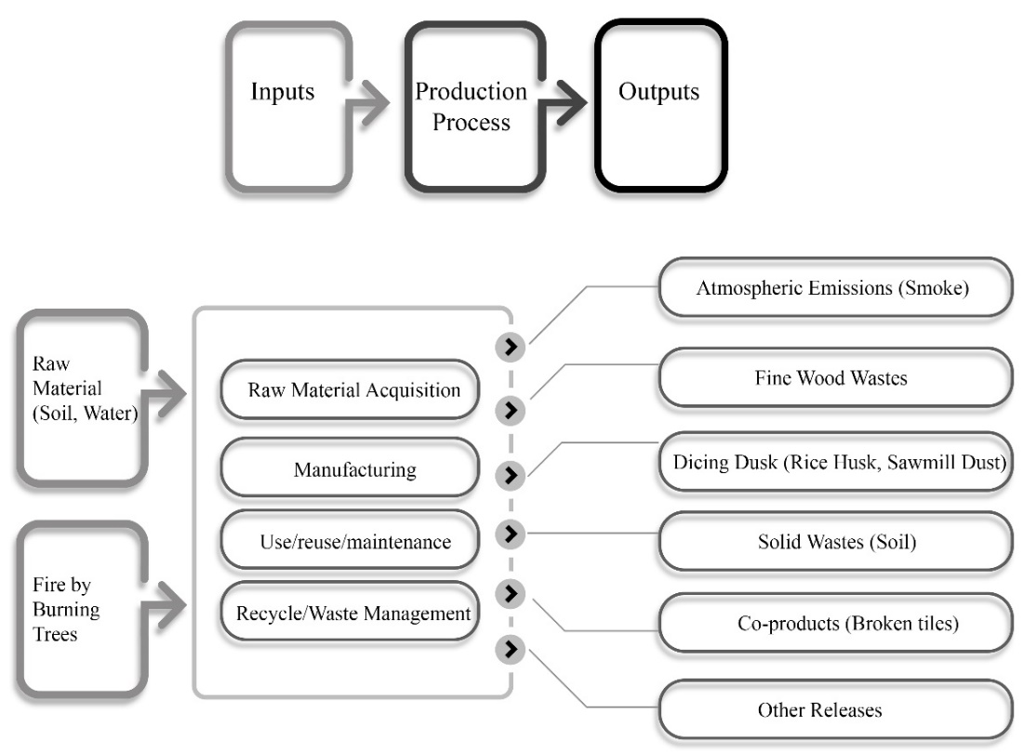
Figure 6: Industrial Ecology of Clay Tiles; Source: Authors Own Compilation

Despite the enormous environmental impact, there are larger green opportunities. There is a huge potentiality of the product's value chain to compensate differently the environmental loss. The substantial fact of this opportunity is held by the burning process. The burning process is manual and dependent on natural means makes an adverse impact on the environment, labour and the percentage of production too. While a little innovation in the burning process with technologically advanced means like electric burner or gas as a fuel can save the environmental treasures. Furthermore, the required temperature for perfect burning can be maintained properly by hazardless, safe means for the workers. Also, they are reluctant of tree plantation to compensate for the loss, which should be initiated by proper guidance and awareness. Additionally, the mixing process could be implemented and operated by machines. By these it may consume less water and soil. It can be less intensive labour and health hazards for the workers for limited exposure to soil and water in bare feet. Also, the use of chemicals as a coating to avoid efflorescence can reduce wastage efficiently.
Conclusion
Clay tiles consider the potential indigenous product of Bangladesh. Many years back, the people of Bangladesh living in the rural area use these clay tiles as the house building material. The environment-friendly material and artistic design draw the attention of the foreign market. Today 93% of clay tiles are exporting in Italy rest of them are exporting to Portugal, Korea, the UK and the USA (need ref).All key actors in the clay tiles industry and the community play a crucial role in sustaining this indigenous industry abroad. The aesthetics of the product, with much Labourite effort, make it more valuable. The livelihood mapping of Kolaroa area showed that the clay tiles industry covers a significant part of their living, economic and social aspects. The more resilient sustainable livelihood of the Kolaroa area could fulfil SDG goals, especially SDG goal 8 (decent work and economic growth), SDG goal 9 (industry, innovation and infrastructure), SDG goal 11 (sustainable cities and communities) and SDG goal16 (place justice and vital institution). The government has primarily selected three products to develop under a "one district one product (ODOP)" scheme, which has chalked out to diversify its export basket. The government's aim of the project is to reduce the country's export vulnerability. Export Promotion Bureau (EPB) of the government has selected clay tiles of Satkhira, with other export-oriented products for attaining global standards and enhancing productivity. The traders demanded government patronage and formulation of policies to bring back the good times. Satkhira's Kolaroa tile industry is losing ground day by day. There are many reasons behind it such as lack of easy access to bank loans, lack of government cooperation in creating international markets and domination of some middlemen. As a result, out of 41 factories in Murarikati and Sripatipur areas of Kolaroa Upazila, only 15 are operational. The Bangladeshi clay tiles industry fails to tap the potential because of poor networking of the factory owners, the absence of innovative products and complexities with the export market. This industry needs to shift research focus to productivity and quality improvement to have a better outcome for production. Instead of researching on product development, academic institutions limit their concerns to material behaviours. It is quite disappointing that indigenous industry does not have room for innovation in the research facilities.
In this context, the government should take initiative to impel the sustainable livelihood framework and sustainable industry framework. It would certainly make the local factory owners aware of the demand, facilitate a transparent supply chain, remove fraud intermediaries, and support them export market requirements. To sustain this industry the three pillars of sustainability namely economic, environmental, social must be managed. The government is also trying to make the clay tiles value chain straight to create many employment opportunities, industry resilience and enhance Local Economic Development and Sustainable Livelihood Development in the Kolaroa area. This research has analysed the outlook of entire clay tiles industry from the beginning of the industry till now. The paper successfully demonstrated all the sustainability indicators with a broad assessment, livelihood map of the community, propose frameworks, leakage and leverage nodes, and SLED achievable approach. This research can assuredly be a milestone for the concerned authority, government and policymaker in this clay tiles industry.

References
Anne, & Mason, M. (2009). Economic develooment framework. WALGA.
Beugelsdijk, S. P. (2009). Is there a trendtowards global value chain specialization? An examination ofcross border sales of US foreign affiliates. J. Int. Manage. , 15(2), 126---141.
Braun, V., & Clarke, V. (2021). To saturate or not to saturate? Questioning data saturation as a useful concept for thematic analysis and sample-size rationales. Qualitative Research in Sport, Exercise and Health, 13(2), 201-216.

Buyukozkan, G., & Feyzioglu, .. (2004). A fuzzy-logic based on decision-making approach for new product development. International Journal of Production Economics(90, 27-45.).
BUIJS, J. (2008). Action planning for new product development. Creativity and Innovation Management,, 17(4), 319-333.
Carswell, G. (1997). ‘Agricultural intensification and sustainable rural livelihoods: a think piece’, IDS. Working Paper 64, Brighton: IDS.
Conway. (1985). Agroecosystems analysis’, Agricultural Administration,.
Del Mar Alonso, M., Llach, J., & Marimon, F. (2014). A closer look at the ‘Global Reporting Initiative’sustainability reporting as a tool to implement environmental and social policies: A worldwide sector analysis. Corporate Social Responsibility Environment Management, 21, 318–335.
Emmanuelides, P. .. (1993). Towards an intregative framework of performance in product development. Journal of Engineering and Technology, 10(4), 363-392.
Folke, C. H. (2005). governance of social-ecological systems. . Annual Review of Environment and Resources,, 30, 441–473.
Haque, B. P. (2000). Analysing organisational issues in concurrent new product development. International Journal of Production Economics, 67(2), 169–182.
Hearn, S. &. (2009). Communities of practice: Linking knowledge, policy and practice. Overseas Development Institute.
Jones, J. E., & Smith, J. E. (2017). Ethnography: challenges and opportunities. Evidence-Based Nursing, 20(4), 98-1000.
Kamali, M., & Hewage, K. (2017). Development of performance criteria for sustainability evaluation of modular versus conventional construction methods. . journal of clean production, 142, 3592–3606.
Lesser, E. &. (2001). Communities of practice and organisational. performance. IBM Systems Journal, , 40(4), 831–840.
Matheson, D. M. (1998). The Smart Organization Creating Value Through Strategic R&D. Harvard. Boston.: Business School Press,.
Pain, A. a. (2003). Addressing livelihoods in Afghanistan’. Issues Papers Series. Kabul;. Afghanistan Research and Evaluation.
Pissourios. (2013). An interdisciplinary study on indicators: A comparative review of quality-of-life, macroeconomic, environmental, welfare and sustainability indicators. . ecological indicators, 34, 420–427.
Reinmoeller, P. &. (2005). The link between diversity and resilience. MIT Sloan Management Review, , 46(4), 61–65.
Singhal, P., Ahonen, S., Rice, G., Stutz, M., Terho, M., & van der Wel, H. (2004). Key Environmental Performance Indicators (KEPIs): A new approach to environmental assessment. In In Electronics Goes Green; Curran Associates, (pp. 6–8). Inc.: New York, NY, USA.
Vasileiou, K., Barnett, J., Thorpe, S., & Young, T. (2018). Characterising and justifying sample size sufficiency in interview-based studies: systematic analysis of qualitative health research
Wenger, E. (2006). Communities of practice: A brief introduction.
Wenger, T. F., & et al. (2015). Learning in landscapes of practice. New. York, NY: Routledge Press.: Learning in landscapes of practice. New.

