Challenges of Accessibility of a Disaster-prone Island: Experience of Hatiya, Bangladesh.
Tasfin Aziz*
Lecturer,
Department of Architecture, Brac University
66, Mohakhali, Dhaka 1207.
Email: tasfin.aziz@bracu.ac.bd
Phone number: 01781870811

Huraera Jabeen, Ph.D
Independent Consultant
Email: huraera@gmail.com
Phone number: 01920242574

Challenges of Accessibility of a Disaster-prone Island: Experience of Hatiya, Bangladesh.
Abstract
Accessibility of Hatiya, one of the most disaster-prone islands in Bangladesh, has many layers of challenges. Institutional arrangements guide the availability and quality of transports while islanders make travel decisions based on the geophysical character of the estuary and weather conditions. All of these factors contribute to increasing disaster risks in transportation. The paper assesses accessibility using both primary and secondary data. Semi-structured interview responses helped in determining the Level of Services and Accessibility Indicators and generating Modal Suitability Matrix. Triangulating the findings with existing knowledge on geophysical dynamics and institutional arrangements illustrate, socially and politically constructed anthropogenic process to exacerbate risks arising from exposure to natural hazards in transportation. Furthermore, the supervision and monitoring of operation demand accountability and transparency. Thus, an integrated transport system can reduce disaster risks in the accessibility of the island. The system needs to be culturally appropriate and use both technical and non-technical approaches.

Keywords
Accessibility; Resilience; Hatiya island; Transport system; Disaster risks.

Introduction
Hatiya is one of the most remote and disaster-prone islands in Bangladesh. The island is connected to the mainland only through a very limited water-based transport system. The islanders’ travel decisions primarily depend on weather conditions and the availability of transports. However, the availability of transports depends on the geophysical character of the island as well as institutional arrangements under which the local government, transport authorities, and private owners operate. The 0.47 million islanders either remain stranded or take high risks to access the mainland during any extreme events and disaster conditions. Accessibility between Hatiya and the mainland has many layers of challenges contributing to increased disaster risks in transportation.
Several studies on Hatiya explored coastal land dynamics (see Sarwar and Woodroffe, 2013; Ghosh, Kumar and Roy, 2015; Ahmed, Drake, et al., 2018; Ahmed, Nawaz, et al., 2018), some examined the disaster risks of vulnerable people from socio-economic perspectives (see Ahamed, 2013; Parvin and Shaw, 2013; Rahman and Rahman, 2015; Sharifuzzaman et al., 2018). Only one examined the issue of accessibility - the relative ease of reaching a particular location or area (Litman, 2019) – which becomes challenging or disrupted during different weather conditions, seasonal change, and natural disasters in Hatiya. This paper examines the challenges of accessibility that the island faces from the point of view of the islanders. The variables of exploration include the modal choice of passengers, availability of services, the time that one may have to spend to get to any destination in the mainland, and regulatory frameworks guiding the availability of services. The aim is to assess how limited accessibility increases risks in transportation for the islanders.
The paper frames the conceptual framework in section two from reviewing literature for compiling factors that affect the degree of accessibility between an island and the mainland. The following sections three and four describe the research objectives, methodology, and study area. Section five discusses the findings and analysis around challenges of accessibility for islanders from Hatiya to the mainland. They include discussions on geophysical dynamics, modes of transportation, socio-economic factors, and institutional arrangements. The paper concludes by summarizing the findings and discussing some policy recommendations for reducing disaster risks in transportation for Hatiya.

Factors affecting the degree of accessibility between an island and the mainland
Accessibility denotes diversified meaning among different disciplines. For example, transport planners focus on mobility of vehicular traffic, land use planners focus on geographic accessibility by distances between activities, social service planners focus on accessibility options for specific groups to specific services (Guers & Wee, 2004; Litman, 2019). Guers and Wee (2004) reviewed accessibility measures across different disciplines and suggested that finding an operational and theoretically sound concept of accessibility is quite difficult and complex. Nevertheless, the concept plays an important role in policymaking related to transport planning, urban planning, and geography. Summarizing from classical definitions from others (for example, Hansen, 1959; Burns, 1979), they opined that accessibility should be “related to the land-use and transport systems in a society which ‘will allow individuals or groups of individuals to participate in activities in different locations” (ibid:22). Thus, accessibility can be measured as the extent ‘to which transport system enables (groups of) individuals to reach activities or destinations by means of a (combination of) transport mode(s)’ (ibid:22).
Accessibility on the island is a special case (Karampela et al., 2014). The islands are conceptualized as a small area of land bounded by water, situated away from the mainland, isolated and detached. The measuring factors of accessibility for an island are not only influenced by its "boundedness" but also its need for "connectedness" (Mehmood, 2009). For example, Spilanis, Kizos, and Petsioti (2012) suggest that “if a transport service is not provided on the island, the cost and the time required to access it may be disproportionally high compared to that on the mainland” (ibid:201). The reasons for disproportionately higher cost are the services on an island support a smaller group of population and theoretically, accessibility is calculated as if all transportation is available any time of any day of the week (Farrington, 2007). Therefore,
“dependence on public transportation compared to mainland areas, the cost of travel to and away from an island, the availability of connections to access services required to cover the needs of residents that may not be available locally, the different destinations where these services may be available, and the availability of overnight return from these destinations” (Royle, 2001 cited in Karampela, Kizos and Spilanis, 2014:201)
all these factors are considered for an island which usually is not considered in conventional measures of accessibility (CPMR, 2002 cited in Karampela, Kizos and Spilanis, 2014).
Four types of components can be used to measure accessibility: land-use, transportation, temporal, and individual (Guers & Wee, 2004). The land-use component reflects the spatial distribution of economic opportunities, social and recreational facilities - their demand and supply. The transportation component describes the transport system which includes the distance to cover, the amount of time, costs, and effort (including reliability, level of comfort, accident risks, etc.). The temporal component reflects the availability of opportunities at different times of the day and seasons. The individual component reflects, among others, abilities based on income and the travel budget of passengers, concern, and perception about safety and reliability (ibid). These four components cannot be considered in isolation, rather they are inter-related to each other. This paper focuses more on transportation and individual components concerning the other two to measure the degree of accessibility.
A common way to describe accessibility about the transport system is through assessing the Level of Service (LOS). LOS is a system of evaluating service variables of public transport and is easy to interpret as the variables describe free flow, delayed and congested states as clearly distinct and disjoint classes (Brunauer et al., 2018). LOS concerning accessibility can have four different levels (World Bank, 2001) which may apply to an island as well. They are a) no access - defined as no service by vessels across the island and mainland, b) partial access where access is interrupted during a substantial period of the year, c) basic access defined as all-season access for the prevailing means of transport, with a limited period of inaccessibility; and d) full access where high quality and uninterrupted services are available all the year-round. There can be temporal variation in modal choice based on tide levels within a day or weather conditions of different seasons. Nevertheless, LOS does not incorporate individuals' points of view. Spilanis, Kizos, and Petsioti (2012, p.201) argue that incorporating the islanders' point of view can add more layers to the discussion on accessibility.
One of those layers is disaster risks as a perception of risks as well as motivations for anticipatory and reactive actions are formed through individual or a group of individuals’ experience and ability to take actions. The risks are integral to exposure to hazards and the capacity to reduce risks. The process of increasing the ability to reduce the risks itself is an anthropogenic process. These processes are constructed socially and politically, thus very few ‘natural disasters’ exist (Kelman, 2017). To illustrate, service providers who are guided by an institutional framework determine reliability, accident risks, the amount of time, the frequency of service of a transport system. If the framework is not effective enough, the providers may operate in an environment with higher risks. Theoretically, the disaster risk reduction approach suggests focusing on understanding and tackling the root causes of disasters to explain why people make choices that increase risks (ibid). This paper attempts to identify the root causes that increase the risks of accessibility from Hatiya.
Such exploration of accessibility to disaster-prone islands is more needed in the context of changing climate. Communities living in the islands are at higher risks from the impacts of environmental hazards and hazard drivers (IPCC, 2014). One may argue that environmental hazards and hazard drivers have always been part of island life so as the challenges of accessibility (Kelman, 2017); nevertheless, recent trends of changes in climate predict that navigation to islands will experience loss of navigability, gradual low flow conditions resulting in economic losses, large variations, and reduced water depth, an increase in frequency in the wet and stormy period implying higher costs due to weather disturbances and safety, a sharp increase in the frequency of increased costs, damage to infrastructure from cyclone and storm surges (IUCN, 2002). The islanders may not have the capacity to cope with these exacerbated risks.

Research objectives and methodology
The research was based on the premise that accessibility between an island and the mainland can be significantly improved through better transport systems. Thus, the experience of Hatiya is examined as a case to examine possible factors that contribute to increasing both natural and anthropogenic disaster risks. The research had three specific objectives:
- to explore the existing geographical context;
- to assess the temporal variations of modal choice and their subversive paradigms; and
- to evaluate the institutional arrangements
The methodology followed the conceptualization of the problem linkages. Personal experience of one of the researchers living on the island, secondary data from literature aided in the conceptualization of the problems.
Study Area Selection
The following characteristics of the island guided the choice of Hatiya as the case study:
- one of the most distant islands from the mainland,
- with about half a million islanders significantly dependent on the mainland for services,
- having high exposure to multiple natural hazards, for example, river erosion, storm surge, high tide, and flooding,
- with limited and unsafe water-based transportation as the only option for accessing the mainland, and
- presence of a local government administrative unit for the island.
[Insert Figure 1: Map of the coastal zone of Bangladesh]
Data Collection
Both primary and secondary data supported the exploration of this research. Some thirty respondents were interviewed using semi-structured questionnaires, specifically emphasizing on passengers' travel choices and behaviour between the island and the mainland. The interviews were conducted between June and July of 2015. Data and information from different maps, socio-economic study, modal operation, ordinances, rules, and regulations acted as secondary data.
Data Processing and Analysis
Primary and secondary data were screened based on the research focus before analysing; their authenticity was checked by multiple sources analysis. Secondary data mostly formed the basis of the analysis of existing geographical context and the institutional frameworks. Spatial analysis used GIS. Also, LOS was used to assess the temporal variations of modal choice. The criteria to assess LOS was determined based on the context and applicability of the services. Those criteria were rated using a Likert scale based on users’ perceptions (Table 1).
To examine the subversive paradigms, it was important to integrate the Accessibility Indicators (AI) for individual trips. The World Bank (2001) and ILO (2003) suggested equations to measure AI for rural transport infrastructure development and planning. However, those equations are based on the number of households seeking access to services which requires a survey of all the population of the island. Since this research focused on passengers’ choices from one specific location, a working equation was developed replacing the number of households with the ratio between passenger capacity of individual transport types (vessels) and the average number of passengers seeking access to service (see Table 2). These factors introduced qualitative considerations (for example, concerns of safety and reliability) into the quantitative data (for example, travel time, availability, and frequency) to incorporate findings on both perception and experience of risks.
Table 1: Criteria for the Modal Choice Decision
Criteria | Likert Scale: A description of the score
Safety, Availability,  Frequency, Reliability | 1: Very low  2: Low  3: Moderately high | 4: Noticeably high  5: Extremely high
Cost, Travel time | 1: Extremely high  2: Noticeably high  3: Moderately high | 4: Low  5: Very low
Table 2: Working Formula of Weighted Accessibility Indicators (AI)
According to ILO (2003) | According to the World Bank (2001) | Working formula
AI = #HH x TT x MT  Where,  AI = Accessibility Indicator for a specific sector/service  #HH = Number of households seeking access to a specific service  TT = Average travel time to reach a specific service  MT = Score for the means of transport used | AI = N x T-Tm x F  Where,  AI = Accessibility Indicator for a specific sector/service  N = Number of households seeking access to a specific service  T = Average travel time to a facility  Tm = Acceptable/target travel time  F = Frequency of travel | AI = (VPC/ANP) x TT x MT  Where,  AI = Accessibility Indicator for a specific service  ANP = Average Number of passengers seeking access to a specific service in a trip  VPC = Vessel Passenger Capacity  TT = Average travel time to reach a specific service  MT = Score for the means of transport used

Limitations of the Research
One of the limitations of this research is the number of respondents interviewed. Although following the theoretical suggestion, the sample size for half a million islanders needed to be at least 192, interviewing 30 may seem inadequate. However, considering those interviews had to be conducted by local data collectors with remote guidance from the researcher and the time constraints to conduct the primary data collection, the number was decided to be representative for the purpose. Also, the researcher had to depend on data from government organizations and different agencies ' websites and reports. The accuracy of those data was difficult to triangulate.

The study area
Hatiya is one of the largest among 32 islands located in the southern-most part of Bangladesh. The Meghna River flows along the north and west side of the island while the Bay of Bengal forms the eastern-south boundary. About 470,000 people live within 1500 sq.km. of Hatiya Upzilla (BBS, 2015) where the core Hatiya island with human habitation covers approximately 466 sq.km. (Ghosh et al., 2015). The average length of the island in north-south direction is about 48 km and the average width (east-west) is about 15 km and the average elevation is approximately 2.4 m above the mean sea-level (Ghosh et al., 2015; Kumar & Ghosh, 2012). The nearest mainland towards the north-east is Noakhali. The history of accessibility between Hatiya and Noakhali is four hundred years old; the modes of transport and travel time, safety, and stress of travel in this route have changed over the years.
The islanders depend on three river ports or ghats to access mainland and neighboring islands through waterways (see Figure 2). They are Nolchira ghat, Tamaruddin ghat, and Charchanga ghat. Most islanders use Nolchira ghat located 11 km away from the center of the island to cross the estuary where the Meghna river meets the Bay of Bengal to go Chairman ghat in Noakhali, 20 km away. From Chairman ghat they have to travel further 32 km to reach any major destination in the mainland. Four types of water-based transports ply in the route - launch, sea-truck, the engine propelled local boats, and speed boats. The publicly-owned Bangladesh Inland Water Transport Corporation (BIWTC) operates the sea-truck service while private owners operate the others.
[Insert Figure 2: Map of Hatiya with the location of ghats]

Challenges of accessibility: Findings and Analysis

Risks arising from geophysical dynamics
The location of the island makes it exposed to different types of hazards due to geographical characteristics. The Meghna River along the northern and western edge of the island carries all the discharge from hundreds of tributaries and distributaries originating from the Himalayas that flow down to the Bay of Bengal. A study found that the maximum flow in the Hatiya channel at North Hatiya during a flood tide (High tide) varies from 121,601 cubic meter/second in the dry season to 154,490 cubic meter/second during the Monsoon season (Bangladesh Inland Water Transport Authority, 2016). Tidal currents can be as fast as 3 m/s in Hatiya channels (Ahmed, Nawaz, et al., 2018). Naturally, the river remains very turbulent with strong current and rolling waves. Climate change is expected to increase the level of discharge through the rivers (Parvin & Shaw, 2013). Any water-based transport needs to withstand the force of the current; also skilled operators are essential for safe operation in these routes.
[Insert Figure 3: Coastline Change of Hatiya between 1989 to 2010]
The dynamic river system results in rapid coastline changes due to erosion and accretion in Hatiya (Ghosh et al., 2015). Monitoring coastline changes of the island from 1989 to 2010 using integrated techniques of remote sensing and geographic information system (GIS) results showed that erosion was severe in the northern and western parts of the island, whereas the southern and eastern parts of the island gained land through sedimentation (Ghosh et al., 2015; Kumar & Ghosh, 2012)(see Figure 3). Over the study period, the island witnessed an erosion of 64.76 sq.km of land; in contrast experienced an accretion of 99.16 sq.km (Ghosh et al., 2015) The northern edge, where the main access point Nolchira ghat is located, eroded around 6.5 km during this time (ibid:140). Although the ghat is closest to the mainland, no permanent port facilities with jetty and pontoons were built due to severe erosion patterns and absence of an embankment. As shown in Figure 4, temporary access facilities to the vessels are highly risky for passengers. Also, the port cannot operate during extreme conditions without any shelter.
[Insert Figure 4: Images of ghat facilities]
Apart from the regular phenomenon of high tide, strong winds, and turbulence in rivers, the Bay of Bengal's geographical characters along Bangladesh exposes the coastal regions of the country to cyclones and storm surges. Because of the natural funnel shape, on average 12 to 13 depressions are formed annually and at least one powerful cyclone hits the country each year (Abedin & Shaw, 2015). Heavy rainfall during the monsoon with seasonal storms increases the risks of flooding, riverbank erosion, and tidal waves. The Hatiya Noakhali route remains suspended for days during the forecast of high tide, tidal waves, and storms. For example, on May 3rd, 2019 all movement of ships and steamers were suspended as a precautionary measure for an extremely severe cyclonic storm (Special Correspondent, 2019). During another cyclone in 2013, the route was officially suspended for three weeks while smaller boats operated with risks after two weeks to meet the islanders’ demand. Transporting disaster relief was also challenging after the cyclone.
In general, prices of daily necessities are higher on the island compared to the mainland; any disruption of the route increases the price of essentials. Only basic health services are available on the island, any critical condition necessitates a visit to the mainland which becomes impossible during any extreme conditions. Table 3 lists the seasonality of the main hazards of Hatiya and the coastal regions of the country. The islanders lived with natural hazards for generations believing surrounding rivers and the sea not only give them everything but also take everything away. However, the intensity and frequency of those natural hazards are exacerbating with climate change in such a manner that they are becoming challenging to cope with traditional knowledge and practices.
Table 3: Seasonality of Natural Hazards
Hazards | Jan |  |  | Feb |  | Mar | Apr | May | Jun |  | Jul |  | Aug | Sep |  | Oct | Nov |  | Dec
Riverbank
erosion
High temp
Heavy
rainfall
Cyclone
Tidal surge
Heavy fog
Flood
Hailstorm
Source: CDMP, 2009

Modes of transportation
Mode of transportation, which includes types of transports and their level of service, only adds to the risks in the accessibility of Hatiya to the mainland. As mentioned before, there are three ghats on the island. Among them, Nolchira and Tamaruddin ghats are connected to the routes of major destinations on the mainland. The only direct connection to the capital city is through a private launch service from Tamaruddin ghat that usually takes 12 to 18 hours to travel based on the tide. Thus, the most frequent and active connection to the mainland is through Nolchira ghat. BIWTC operates sea-trucks once a day to Noakhali from this ghat. Some privately-owned engine propelled boats, small launch, and speed boats make two to six trips per day in this route depending on weather conditions and seasons. Table 4 describes the details of travel time, cost, and conditions using these types of transports.
[Insert Figure 5: Different types of transport]
Table 4 compiles the findings on the Level of Service (LOS) of passengers using different types of water-based transports. Of the four levels identified in the literature review in section two, only partial and basic access are available in Hatiya by these four types of transports.
Speed boats and launch provide partial access denoting access to their services are interrupted for a substantial period of the year; they operate only around the winter season when the river is calm. The number of passengers of these two types of transport varies significantly - speed boats carry only eight costing BDT 500 per passenger per trip, which are not affordable for all. However, crossing by speed boats in comparison to launch during the beginning and end of their operating season becomes unsafe for high waves and strong currents. Launch carries 600 passengers or more and can provide service for BDT 130 per passenger per trip. Travel time by launch is almost double that by speed boats as the launch has to follow a certain route for navigability. Despite the higher risks, often passengers who can afford or with urgency choose speed boats as they operate throughout the day while the launch operates only twice a day.
Engine propelled boats and Sea-trucks provide basic access; they operate almost all the year round except during extreme weather conditions and disasters. Although sea-truck provides service once a day, it can carry 1000 passengers or more at a time. Since the government subsidize the service, the cost per passenger per trip becomes halves in sea-truck. On the other hand, small engine propelled boats carry around 80 passengers on a single trip, but their number of trips is demand-driven. The fare in engine propelled boats is not fixed, the operators manipulate the fare depending on availability and demand for services. Since sea-trucks follow a route cleared by the BIWTA and designed as a marine vehicle, it is safer to travel even during high tides and turbulence. The engine propelled open boats experience difficulties withstanding strong currents and turbulence during the monsoon; also, passengers are not protected from rain or storm surge.
Table 4: Level of Service between Nolchira ghat, Hatiya and Chairman ghat, Noakhali
Vessel  type | Service Description | LOS
Engine Propelled Boat | - Local wooden motor propelled boats, frequently used for fishing, converted to carry passengers.  - A boat can carry around 60 passengers and more.  - Around 25-35 boats ply in a day during favorable weather conditions.  - The number of boats is reduced during monsoon seasons.  - Privately-owned service.  - Costs approximately BDT 100 per passenger per trip.  - Approximate travel time 80 minutes | Basic Access
Speed Boat | - Small speed boats with steel bodies and strong motor and propellers.  - One boat can carry 8 passengers at a time.  - The service is only available from September to February.  - Their services are also interrupted by bad weather conditions.  - Privately-owned service.  - Costs approximately BDT 500 per passenger per trip.  - Approximate travel time 25 minutes | Partial access
Sea-truck | - Large designed marine vessel.  - A sea-truck has a capacity for 1000 passengers but usually carries twice or more.  - Service is available all year-round.  - Operated by BIWTC.  - The service costs BDT 50 per passenger per trip.  - Approximate travel time 80 minutes | Basic Access
Launch | - Locally built water vessels.  - Each can carry around 600 passengers, but often carry more.  - Seasonal service is available from November to February.  - Privately-owned service.  - Costs approximately BDT 130 per passenger per trip.  - Approximate travel time 60 minutes | Partial access
Assessment of LOS in Hatiya corresponds to the theoretical arguments that because the services are provided for a smaller group of the population, the cost of service from Hatiya to the mainland is disproportionately high. Besides, services by these four types of transport only available on a specific time of the day or days of a week. More passengers depend on public transport considering the cost. Options of destinations are limited because of the travel time, and transports usually do not operate at night, hence need to return to the island before nightfall. All of these factors influence the degree of accessibility.
The descriptions of accessibility from LOS were combined with passengers' responses from interviews on questions related to safety, cost, travel time, availability, reliability, and frequency to understand the subjective choice of a mode of transport. Table 5 illustrates the weighted modal suitability matrix that indicates the reasons for choosing certain types of transport over others.
Table 5: Modal Suitability Matrix
Criteria | Weight  (%) | Transport Types
Criteria | Weight  (%) | Engine Propelled Boat | Speed Boat | Sea-truck | Launch
Criteria | Weight  (%) | Score/ weighted score
Safety | 25 | 2 / 0.50 | 2 / 0.50 | 4 / 1.0 | 2 / 0.50
Cost | 25 | 3 / 0.75 | 1 / 0.25 | 4 / 1.0 | 3 / 0.75
Travel time | 15 | 3 / 0.45 | 4 / 0.60 | 3 / 0.45 | 3 / 0.45
Availability | 10 | 3 / 0.30 | 2 / 0.20 | 2 / 0.20 | 1 / 0.10
Frequency | 15 | 3 / 0.45 | 3 / 0.45 | 2 / 0.30 | 1 / 0.15
Reliability | 10 | 2 / 0.20 | 3 / 0.30 | 4 / 0.40 | 2 / 0.20
Total Score |  | 16 | 15 | 19 | 12
Weighted score |  | 2.65 | 2.3 | 3.35 | 2.15
Ranking |  | 2 | 3 | 1 | 4
The respondents interviewed gave higher priority to the concern of safety and cost (25 percent each) while making decisions about the choosing types of transport, the frequency of service and travel time (15 percent each) followed while availability and reliability of getting service were last in their considerations. The matrix indicates that the most suitable transport is sea truck considering all the five weighted criteria, more than half of the respondents prefer sea-truck followed by an engine propelled boat, a speed boat, and launch. Speed boat and launch are not available throughout the year, belonging to a category of partially accessible in LOS, which impacts in the preference of choice. Although a engine propelled boat is available almost all year-round, with ranking basic access in LOS; nevertheless, in comparison to the sea-truck it receives significantly less preference from the concern of mostly safety and cost.

Table 6: Weighted Accessibility Indicators (AI) for Single Trip
Component | Transport Type
Component | Engine Propelled Boat | Speed Boat | Sea-truck | Launch
Average Number of Passengers (ANP) | 80 | 10 | 1230 | 700
Vessel Passenger Capacity (VPC) | 60 | 8 | 1000 | 600
(VPC/ANP) | 0.75 | 0.80 | 0.81 | 0.86
Travel Time (TT) in minutes | 80 | 25 | 80 | 60
Means of Transport (MT) | 2 | 3 | 1 | 4
Accessibility Indicators (AI) | 120 | 60 | 64.8 | 206.4
Accessibility Indicators (AI) were calculated from the data for research and illustrated in Table 6. In theory, a larger value of AI indicates higher challenges (World Bank, 2001) and travel time makes a significant difference in calculating challenges. Sea-truck, the most preferred transport type according to the modal suitability matrix, has one of the least values in AI since it also experiences some challenges, for example, less frequency of operation. Although engine propelled boats are the second preferred, yet their challenges are twice of sea-trucks. The speed boat got the lowest score in AI because of less travel time, hence, experiences fewer challenges. However, according to the modal suitability matrix, they are one of the least preferred types of transport considering their partial accessibility. Launch faces extreme challenges because of the limited operation time, longer travel time, and higher costs.
Summarizing the above analysis, sea-truck as a type of transport seems to be the most preferred one irrespective of the time of the year. Nevertheless, BIWTC does not invest in increasing the number of services as the service is not commercially viable, it is operating the service only under the Public Service Obligation clause. Therefore, islanders are forced to use other types of transport with higher risks for accessing the mainland, thus increasing their risks in transportation.

Socio-Economic factors
Hatiya developed as an offshore island depending on natural fisheries stock, natural forest, and fertile alluvial agricultural lands. About 63 percent of the residents are engaged in an occupation based on agriculture that includes fisheries (BBS, 2011). About 100,000 people are directly or indirectly dependent on fishing (Sharifuzzaman et al., 2018). At the same time, the island is highly exposed to natural hazards. Any disasters or extreme climate conditions severely impact the fishing and crop production; thus, the livelihood of the islanders. The average annual income of the Noakhali district including Hatiya is USD180 which is lower than the average of coastal regions (USD 234) (ibid). A study reported about 81 percent of the islander to earn up to BDT 5,000 per month (approximately USD 71) (Parvin & Shaw, 2013). It is argued that the minimum level of transport infrastructure service is essential to sustainable socio-economic development for any community (World Bank, 2001). The islanders’ restricted access hinders their opportunities to diversify their livelihood and develop other skills to improve their economic conditions. Traveling to the mainland for health care, education and business add to the already higher living costs on the island. Poor islanders are often left without any choice but to access the mainland with higher risks and costs for transportation.

Institutional arrangements
Three government agencies are responsible for the management of river ports, routes, and vessels in Hatiya. BIWTA, under the Ministry of Shipping, is supposed to be responsible for the management and administration of the ports and landing stations. However, the District Commissioner Office - the regional level executive body under the Ministry of Public Administration manage both Nolchira ghat and Chairman ghat. They lease out the operation of the ghat and monitoring port activities. The government of Bangladesh has specific guidelines for leasing out ghat; nevertheless, the rules are often violated. The option of leasing out the operation to the private sector under private-public partnership creates possibilities of external influence, mostly from political leaders and muscle men. Two politically powerful local families influence the leasing procedure, control activities in the ghat in Hatiya to ensure their financial benefits.
The Inland Ship Safety Administration (ISSA), a department within the Ministry of Shipping, is responsible for ensuring safety, provisioning regulatory frameworks, training the staff, enforcement of safety rules, managing environmental aspects, etc. The department lacks enough staff to monitor and enforce rules. Although BIWTA staff are often present in the ghat and working under the same ministry, they cannot exercise any executive power to ensure safety for lack of authority from ISSA. As a result, vessels carry passengers and goods beyond their capacity increasing the risks of drowning in turbulent rivers.
Inadequate services by the government for limited trips have encouraged private boat owners to invest and provide services. The smaller engine propelled boat owners have their associations without any affiliation with BIWTA or local authorities. The association with financial support from the members has set up some landing facilities to ensure, maintain some order in operation to maintain discipline, but they have no coordination with public authority. Often passenger safety and affordability are not prioritized due to financial constraints arising from operating for a limited time. The owners and operators complain about harassment from the police and local administrations as they do not have any government registration. As mentioned in the literature review, in the absence of an effective institutional framework, the providers operate in a higher risk environment.
BIWTA takes care of other operational activities, for example, providing navigational aid, route clearance for vessels to avoid wrecks and obstacles, and determining route tariffs. The Upazilla Executive Officer Office, similar to the District Commissioner Office, often permits private operators to provide services in the route. Thus, there is an overlapping of responsibilities creating gaps in safety controls. BIWTA is also responsible for announcing the time table of operation which they do with a hand microphone. Most passengers are unable to access information when needed and may have to wait for hours. Despite their authority, BIWTA cannot determine route tariffs. Private operators change the fare citing fuel cost and weather conditions in different seasons. Islanders have no other options, but to pay any fare they charge.
The institutional arrangements around transport pose additional challenges for an overall transport planning for the island. In Bangladesh, two separate ministries are responsible for road and waterways - Ministry of Road Transport and Bridges and Ministry of Shipping. It is almost impossible to coordinate among them to formulate any integrated transport policy or planning. Often there are overlaps of responsibilities resulting in indecisions. Secondly, Hatiya as an island is historically deprived of regional budgetary allocation, especially for infrastructure development. Thirdly, Bangladesh Water Development Board (BWDB) is responsible for the construction of embankments to protect any area from erosion and flooding. For Hatiya, there are gaps in coordination between BWDB and BIWTA. As a result, BIWTA is unwilling to construct any permanent facilities in unprotected areas as riverbank erosion is severe in Hatiya.
Examination of the institutional arrangements around transport to access the mainland from Hatiya indicates that natural disasters are exacerbated by socially and politically constructed anthropogenic processes.

Conclusion
The relative ease of reaching the mainland from Hatiya island has many layers of challenges contributing to increasing disaster risk in transportation. Although the islanders have lived in the island and remained connected to the mainland for years amidst natural hazards and disasters, assessment of accessibility through the limited water-based transports illustrate that risks in transportation can be argued to move away from the prevalence of and higher exposure to natural, environmental hazards, and drivers, towards vulnerability exacerbated by the anthropogenic process. The socio-economic conditions restrict islanders to choose safer transport types; affordable public transports preferred by them from the concern of safety is not adequate because of regional and national political and power dynamics. A serious disruption of the functioning of the community occurs through these combined exposures and vulnerability that leads to human, economic, and environmental impacts. Disaster risks remain higher in transportation with the potential for the loss of life and injury.
Examination of modes of transportation, socio-economic factors, and institutional arrangement identified several limitations on the part of government and policymakers in addressing the accessibility of the islanders of Hatiya. Firstly, since the typology of water-based transport is one of the key factors of increasing risks, policy directives are necessary for the selection of appropriate types. More vessels designed for plying in a turbulent estuary should be encouraged to be used both by the government and private service providers. Such a change in modes of transportation can increase the sense of safety and reliability of the islanders. Secondly, while considering the types, their affordability from the socio-economic conditions should be taken into account. Also, the access facilities need to incorporate locally appropriate technical and non-technical approaches considering the local geophysical dynamics. Lastly, lack of supervision and monitoring in operation through public-private partnership demands an integrated transport system that connects the daily needs and interests of the islanders as well as the service providers to improve accountability, transparency, and safety of services.
Climate change is predicted to expose coastal communities like islanders of Hatiya to changing frequencies, intensities, and extents of potential hazards. Increasing their adaptive capacity through diversified skills and livelihood opportunities for disaster risk reduction will largely depend on a safe transport system that can connect the islanders to the activities in the mainland. The future planning for the transport system, thus, needs to shift the focus from managing risks by suspending services towards reducing risks.

Acknowledgment
This paper is an edited version of a student paper titled ‘Exploring Pitfalls to Mainland Accessibility: A Perspective of Hatiya Island, Bangladesh’ submitted by Tasfin Aziz as part of his graduate studies in the Technische Universität Dortmund, Germany in 2015.

Bibliography
Abedin, M. A., & Shaw, R. (2015). The role of university networks in disaster risk reduction: Perspective from coastal Bangladesh. International Journal of Disaster Risk Reduction, 13, 381–389.
Ahamed, M. (2013). Community based approach for reducing vulnerability to natural hazards (cyclone, storm surges) in coastal belt of Bangladesh. Procedia Environmental Sciences, 17, 361–371.
Ahmed, A., Drake, F., Nawaz, R., & Woulds, C. (2018). Where is the coast? Monitoring coastal land dynamics in Bangladesh: An integrated management approach using GIS and remote sensing techniques. Ocean & Coastal Management, 151, 10–24.
Ahmed, A., Nawaz, R., Drake, F., & Woulds, C. (2018). Modelling land susceptibility to erosion in the coastal area of Bangladesh: A geospatial approach. Geomorphology, 30, 82–97.
Bangladesh Inland Water Transport Authority. (2016). Bangladesh Regional Waterway Transport Project: Environmental and Social Impact Assessment. Ministry of Shipping, Government of Bangaldesh.
BBS. (2015). Population & Housing Census 2011 Community Report: Noakhali. Government of Bangladesh.
Brunauer, R., Schmitzberger, N., & Rehrl, K. (2018). Recognizing Spatio - Temporal Traffic Patterns at Intersections Using Self - Organizing Maps. Proceedings of ACM Sigspatial Conference (SIGSPATIAL’18), 10.
Burns, L. D. (1979). Transportation, Temporal and Spatial Components of Accessibility. Lexington Books.
CDMP. (2009). Situation Assessment Report in S-W Coasta Region of Bangladesh. Food and Agriculture Organization of the United Nations (FAO) and Department of Agricultural Extension (DAE).
CPMR. (2002). Off the Coast of Europe: European Construction and the Problem of the Islands. Islands Commission of the Conference of Peripheral Maritime Regions (CPMR).
Farrington, J. H. (2007). The new narrative of accessibility: its potential contribution to discourses in (transport) geography. Journal of Transport Geography, 15(5), 319–330.
Ghosh, M., Kumar, L., & Roy, C. (2015). Monitoring the coastline change of Hatiya Island in Bangladesh using remote sensing techniques. ISPRS Journal of Photogrammetry and Remote Sensing, 101.
Guers, K. T., & Wee, B. van. (2004). Accessibility evaluation of land-use and transport strategies: Review and research directions. Journal of Transport Geography, 12, 127–140.
Hansen, W. . (1959). How accesibility shapes land use. Journal of the American Institute of Planners, 35(2), 73–76.
ILO. (2003). Integrated Rural Accessibility Planning Modular Training Package. International Labour Organization.
IPCC. (2014). Summary for policymakers. In Climate Change 2014: Impacts, Adaptation, and Vulnerability. Cambridge University Press.
IUCN. (2002). Climate Change and Inland Navigation in Bangladesh. IUCN.
Karampela, S., Kizos, T., & Spilanis, I. (2014). Accessibility of islands: Towards a new geography based on transportation modes and choices. Island Studies Journal, 9(2), 293–306.
Kelman, I. (2017). How can island communities deal with environmental hazards and hazard drivers, including climate change? Environmental Conservation, 44(03), 244–253.
Kumar, L., & Ghosh, M. K. (2012). Land cover change detection of Hatiya Island, Bangladesh, using remote sensing techniques. Journal of Applied Remote Sensing, 6(1), 063608.
Litman, T. (2019). Evaluating Accessibility for Transport Planning: Measuring People’s Ability to Reach Desired Goods and Activities. Victoria Transportation Policy Institute.
Mehmood, A. (2009). Understanding spatial development and interactions in small islands. Proceedings of Annual Regional Studies Association Conference.
Parvin, G. A., & Shaw, R. (2013). Microfinance institutions and a coastal community’s disaster risk reduction, response, and recovery process: a case study of Hatiya, Bangladesh. Disasters, 37(1), 165–184. https://doi.org/1
Rahman, S., & Rahman, M. A. (2015). Climate extremes and challenges to infrastructure development in coastal cities in Bangladesh. Weather and Climate Extremes, 7, 96–108.
Royle, S. A. (2001). A Geography of Islands: Small Island Insularity. Routledge.
Sarwar, M. G. M., & Woodroffe, C. D. (2013). Rates of shoreline change along the coast of Bangladesh. Journal of Coastal Conservation, 17(3), 515–526.
Sharifuzzaman, S. M., Hossain, M. S., Chowdhury, S. R., Sarker, S., Chowdhury, M. S. N., & Chowdhury, M. Z. R. (2018). Elements of fishing community resilience to climate change in the coastal zone of Bangladesh. Journal of Coastal Conservation, 22, 1167–1176.
Special Correspondent. (2019, May 3). Cyclone likely to hit Bangladesh today. The Independent. http://www.theindependentbd.com/post/197917
Spilanis, I., Kizos, T., & Petsioti, P. (2012). Accessibility of peripheral regions: evidence from Aegean islands. Island Studies Journal, 7(2), 199–214.
Uddin, A. M. K., & Kaudstaal, R. (2003). Delineation of the Coastal Zone. Program Development Office for the Integrated Coastal Zone Management Plan.
World Bank. (2001). Design and Appraisal of Rural Transport Infrastructure (No. 496; World Bank Technical Paper).

Figure 1: Map of Coastal Zone of Bangladesh
Source: Uddin and Kaudstaal, 2003
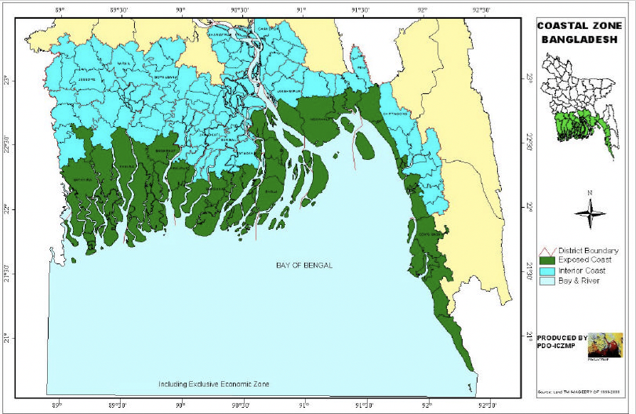

Figure 2: Map of Hatiya with the location of river ports (ghats)
Source: Author
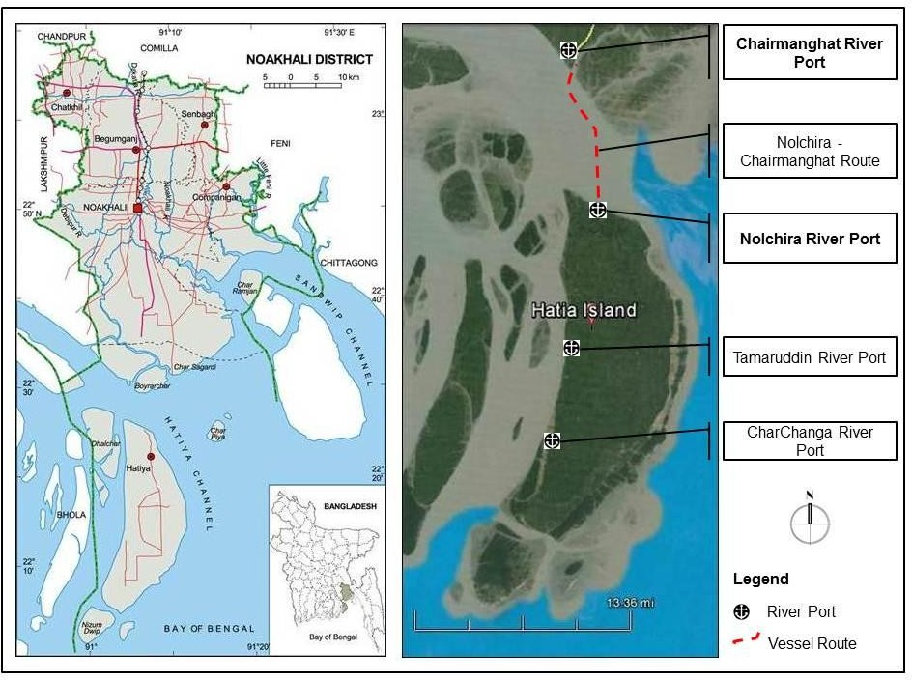

Figure 3: Coastline Change of Hatiya between 1989 to 2010
Source: Ghosh, Kumar and Roy, 2015
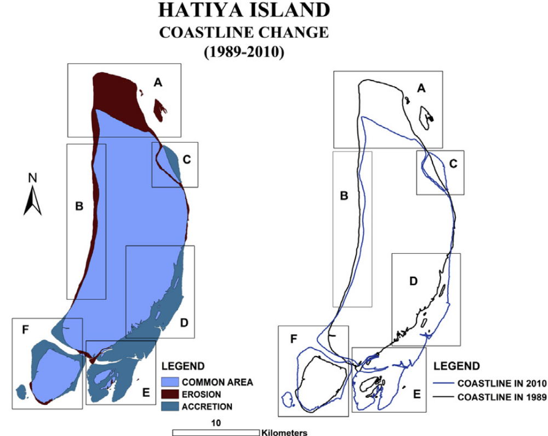

Figure 4: Images of ghat facilities: A. Passengers waiting to board sea-truck, B. Passengers getting off from the sea-truck, C. Temporary access to get off and board.
Source: Tasfin Aziz 2014
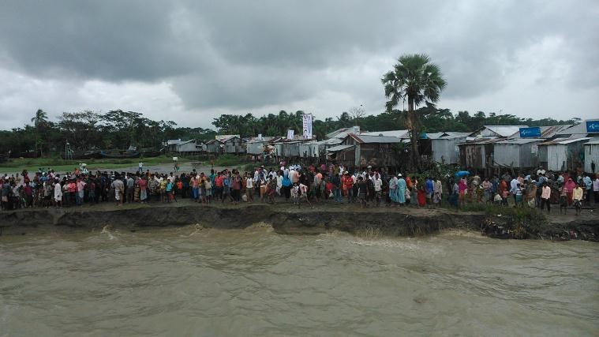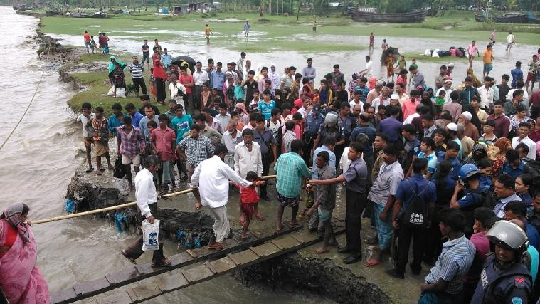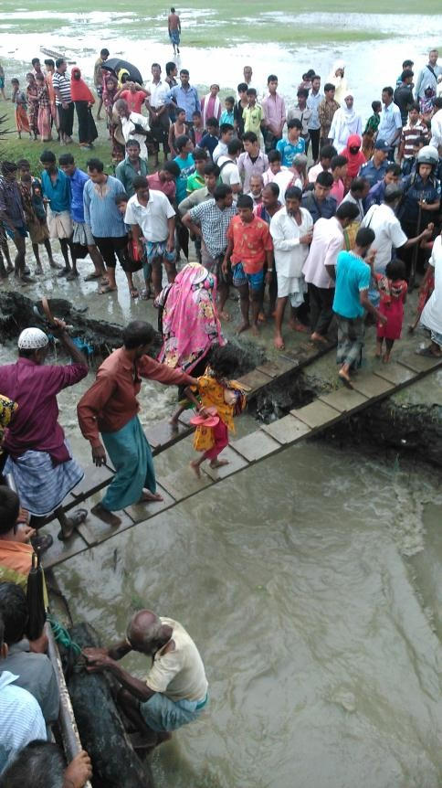
A
B
C

Figure 5: Different types of transport: A. Sea-truck, B. Launch, C. Engine propelled boat
Source: Tasfin Aziz 2014
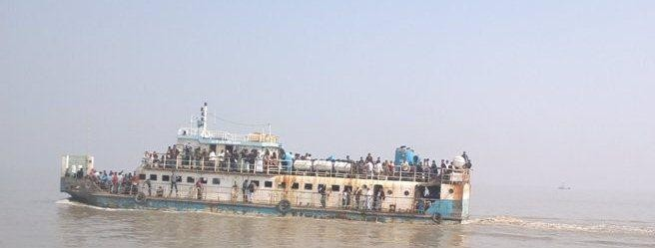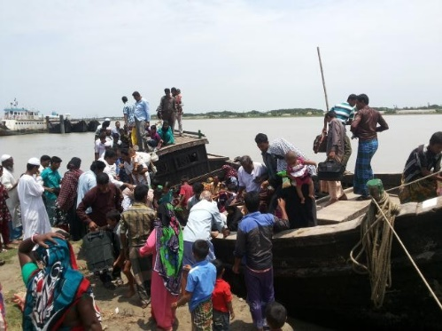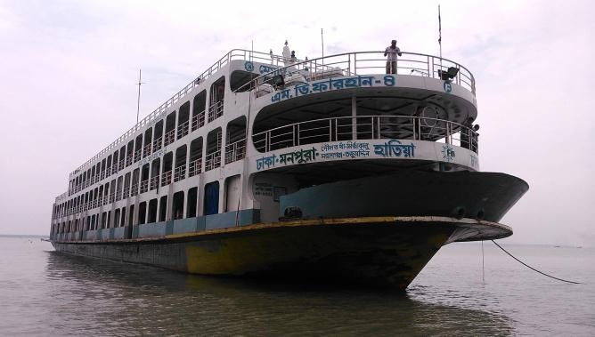
A
B
C

Following the formula to determine a sample size n= {X2*N*P(1-P)}/[{(ME2*(N-1)}+{X2*P*(1-P)}] where n= sample size, X2= chi-square for the specified confidence level at 1 degree of freedom N= population size, P= population proportion, ME= desired margin of error (0.5 considering 5%), for half a million population sample size should be 384. However, Hatiya has two ghats to cross the river to reach the mainland and this research is considering only one, the sample can be half of the number that is 192.
Ghat is a port or landing station with docking facilities.

